Viola Jones Object Detection
ECE579 Intelligent Robotics II
Colin Moffitt
moffitt@pdx.edu
2/22/2014

Introduction
The purpose of this project is to explore Viola Jones object detection algorithms. Harr Cascade detection is used for this purpose and leverages pre-existing OpenCV algorithms. Facial recognition is used as the first study and later nested classifiers are used for eyes and glasses. Several facial types are considered under different conditions and the advantages and disadvantages to Viola Jones are discussed.

Framework
The framework used for this project was OpenCV 3.0 compiled in Visual Studio 2013 and running on windows. Frame processing times were well under 15ms, even when many faces appeared in the frame at once, and the code ran smoothly on a modern laptop with an attached webcam.

Training
The Cascade Classifier Training used by the Harr object detection functions were pre-built using the OpenCV opencv_traincascade function. Three classifiers were used, one for faces, one for eyes, and one for glasses. The eyes and glasses classifiers are used in a nested-cascade setup where the search space is inside the already detected face.

Implementation
Once loading the desired classifier xml files, the OpenCV code enters a loop to pull frames from the attached camera and runs CascadeClassifier.detectMultiScale() on each frame. The results (faces in this case) are then passed to the nested classifier if one is chosen. For each feature found, a circle is drawn around that feature.

Results
Following are screenshots of the results. Clearly having a large beard made detecting my own face more difficult, but surprisingly the Harr classifier did well. Testing on other faces worked almost always, with a few undetected faces and a few false positives.

Figure 1 and 2: Single face detection, no nested classifiers
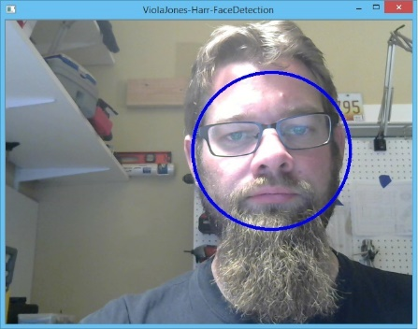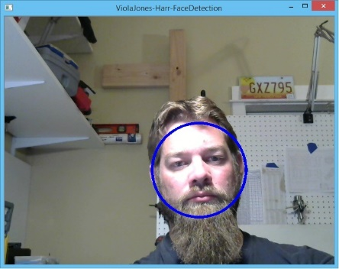

Figures 3, 4, 5, 6: Multiple face detection
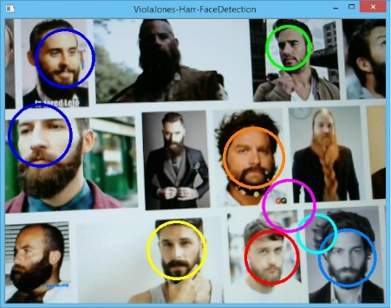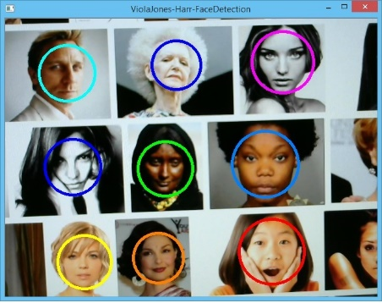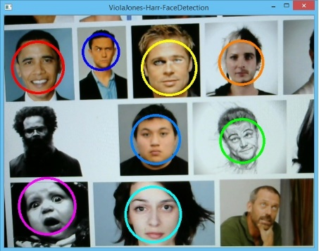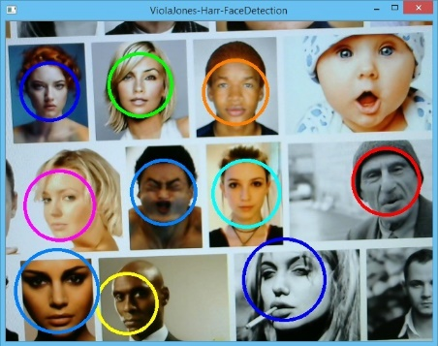

As can be seen in the above figures 3-6, several faces were not detected at oblique angles or because of obstructions. Also figure 3 has two false positives in the lower left, and the baby face was missed in fig. 6.
Figures 7, 8, 9: Nested eyes classifier detections
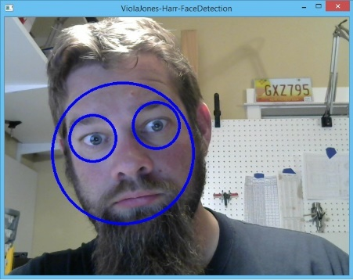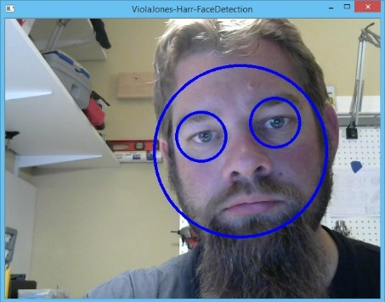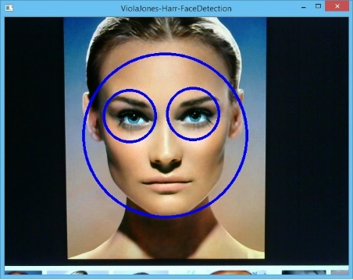
In the nested classifier for eyes the results worked well for front facing subjects. Figure 7 shows the maximum angle that was achieved while still correctly classifying the face with both eyes.

Figures 10, 11: Nested glasses classifier
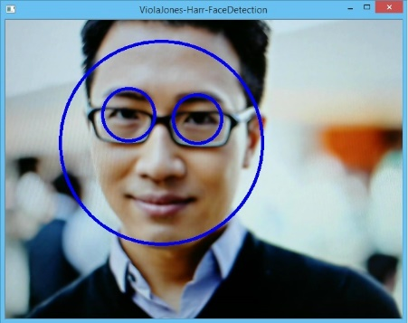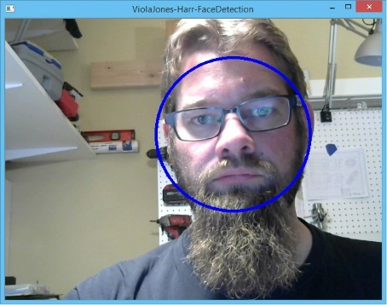
The nested glasses classifier was less of a success. Although it worked at times the contrast of the glasses frames needed to be very pronounced and the subject very front-facing and vertical. I was unable to get any nested detection using my own face with this classifier (fig. 11), but in some rare cases was able to get correct detection (fig. 10).
Conclusion
The OpenCV implementation of the Viola Jones algorithm using Harr Object Classification and Detection proved to be a powerful tool in the right circumstances. Some subjects were not recognized and some false positives were generated though. Since the algorithm simplifies the search by only looking for forward facing upright faces, subjects that did not fit this pose or that were partially obscured were not recognized. False positives may be reduced by increasing or changing the classification training to better suit specific scenarios.
Appendix: Source Code
#include "opencv2/objdetect.hpp"
#include "opencv2/imgcodecs.hpp"
#include "opencv2/videoio.hpp"
#include "opencv2/highgui.hpp"
#include "opencv2/imgproc.hpp"
#include "opencv2/core/utility.hpp"

#include "opencv2/videoio/videoio_c.h"
#include "opencv2/highgui/highgui_c.h"

#include <cctype>
#include <iostream>
#include <iterator>
#include <stdio.h>

using namespace std;
using namespace cv;

static void help()
{
cout << "\nThis program demonstrates the cascade recognizer.\n"
"This classifier can recognize many kinds of rigid objects, once the appropriate classifier is trained.\n"
"Usage:\n"
"./facedetect [--cascade=<cascade_path> this is the primary trained classifier such as frontal face]\n"
" [--nested-cascade[=nested_cascade_path this an optional secondary classifier such as eyes]]\n"
" [--scale=<image scale greater or equal to 1, try 1.3 for example>]\n"
" [--try-flip]\n"
" [filename|camera_index]\n\n"
"see facedetect.cmd for one call:\n"
"./facedetect --cascade=\"../../data/haarcascades/haarcascade_frontalface_alt.xml\" --nested-cascade=\"../../data/haarcascades/haarcascade_eye.xml\" --scale=1.3\n\n"
"During execution:\n\tHit any key to quit.\n"
"\tUsing OpenCV version " << CV_VERSION << "\n" << endl;
}

void detectAndDraw(Mat& img, CascadeClassifier& cascade,
CascadeClassifier& nestedCascade,
double scale, bool tryflip);

string cascadeName = "../../data/haarcascades/haarcascade_frontalface_alt.xml";
string nestedCascadeName = "../../data/haarcascades/haarcascade_eye_tree_eyeglasses.xml";

int main(int argc, const char** argv)
{
CvCapture* capture = 0;
Mat frame, frameCopy, image;
const string scaleOpt = "--scale=";
size_t scaleOptLen = scaleOpt.length();
const string cascadeOpt = "--cascade=";
size_t cascadeOptLen = cascadeOpt.length();
const string nestedCascadeOpt = "--nested-cascade";
size_t nestedCascadeOptLen = nestedCascadeOpt.length();
const string tryFlipOpt = "--try-flip";
size_t tryFlipOptLen = tryFlipOpt.length();
string inputName;
bool tryflip = false;

help();

CascadeClassifier cascade, nestedCascade;
double scale = 2;

for (int i = 1; i < argc; i++)
{
cout << "Processing " << i << " " << argv[i] << endl;
if (cascadeOpt.compare(0, cascadeOptLen, argv[i], cascadeOptLen) == 0)
{
cascadeName.assign(argv[i] + cascadeOptLen);
cout << " from which we have cascadeName= " << cascadeName << endl;
}
else if (nestedCascadeOpt.compare(0, nestedCascadeOptLen, argv[i], nestedCascadeOptLen) == 0)
{
if (argv[i][nestedCascadeOpt.length()] == '=')
nestedCascadeName.assign(argv[i] + nestedCascadeOpt.length() + 1);
if (!nestedCascade.load(nestedCascadeName))
cerr << "WARNING: Could not load classifier cascade for nested objects" << endl;
}
else if (scaleOpt.compare(0, scaleOptLen, argv[i], scaleOptLen) == 0)
{
if (!sscanf(argv[i] + scaleOpt.length(), "%lf", &scale) || scale < 1)
scale = 1;
cout << " from which we read scale = " << scale << endl;
}
else if (tryFlipOpt.compare(0, tryFlipOptLen, argv[i], tryFlipOptLen) == 0)
{
tryflip = true;
cout << " will try to flip image horizontally to detect assymetric objects\n";
}
else if (argv[i][0] == '-')
{
cerr << "WARNING: Unknown option %s" << argv[i] << endl;
}
else
inputName.assign(argv[i]);
}

if (!cascade.load(cascadeName))
{
cerr << "ERROR: Could not load classifier cascade" << endl;
help();
return -1;
}

if (inputName.empty() || (isdigit(inputName.c_str()[0]) && inputName.c_str()[1] == '\0'))
{
capture = cvCaptureFromCAM(inputName.empty() ? 0 : inputName.c_str()[0] - '0');
int c = inputName.empty() ? 0 : inputName.c_str()[0] - '0';
if (!capture) cout << "Capture from CAM " << c << " didn't work" << endl;
}
else if (inputName.size())
{
image = imread(inputName, 1);
if (image.empty())
{
capture = cvCaptureFromAVI(inputName.c_str());
if (!capture) cout << "Capture from AVI didn't work" << endl;
}
}
else
{
image = imread("../data/lena.jpg", 1);
if (image.empty()) cout << "Couldn't read ../data/lena.jpg" << endl;
}

cvNamedWindow("ViolaJones-Harr-FaceDetection", 1);

if (capture)
{
cout << "In capture ..." << endl;
for (;;)
{
IplImage* iplImg = cvQueryFrame(capture);
frame = cv::cvarrToMat(iplImg);
if (frame.empty())
break;
if (iplImg->origin == IPL_ORIGIN_TL)
frame.copyTo(frameCopy);
else
flip(frame, frameCopy, 0);

detectAndDraw(frameCopy, cascade, nestedCascade, scale, tryflip);

if (waitKey(10) >= 0)
goto _cleanup_;
}

waitKey(0);

_cleanup_:
cvReleaseCapture(&capture);
}
else
{
cout << "In image read" << endl;
if (!image.empty())
{
detectAndDraw(image, cascade, nestedCascade, scale, tryflip);
waitKey(0);
}
else if (!inputName.empty())
{
/* assume it is a text file containing the
list of the image filenames to be processed - one per line */
FILE* f = fopen(inputName.c_str(), "rt");
if (f)
{
char buf[1000 + 1];
while (fgets(buf, 1000, f))
{
int len = (int)strlen(buf), c;
while (len > 0 && isspace(buf[len - 1]))
len--;
buf[len] = '\0';
cout << "file " << buf << endl;
image = imread(buf, 1);
if (!image.empty())
{
detectAndDraw(image, cascade, nestedCascade, scale, tryflip);
c = waitKey(0);
if (c == 27 || c == 'q' || c == 'Q')
break;
}
else
{
cerr << "Aw snap, couldn't read image " << buf << endl;
}
}
fclose(f);
}
}
}

cvDestroyWindow("ViolaJones-Harr-FaceDetection");

return 0;
}

void detectAndDraw(Mat& img, CascadeClassifier& cascade,
CascadeClassifier& nestedCascade,
double scale, bool tryflip)
{
int i = 0;
double t = 0;
vector<Rect> faces, faces2;
const static Scalar colors[] = { CV_RGB(0, 0, 255),
CV_RGB(0, 128, 255),
CV_RGB(0, 255, 255),
CV_RGB(0, 255, 0),
CV_RGB(255, 128, 0),
CV_RGB(255, 255, 0),
CV_RGB(255, 0, 0),
CV_RGB(255, 0, 255) };
Mat gray, smallImg(cvRound(img.rows / scale), cvRound(img.cols / scale), CV_8UC1);

cvtColor(img, gray, COLOR_BGR2GRAY);
resize(gray, smallImg, smallImg.size(), 0, 0, INTER_LINEAR);
equalizeHist(smallImg, smallImg);

t = (double)cvGetTickCount();
cascade.detectMultiScale(smallImg, faces,
1.1, 2, 0
//|CASCADE_FIND_BIGGEST_OBJECT
|CASCADE_DO_ROUGH_SEARCH
//| CASCADE_SCALE_IMAGE
,
Size(30, 30));
if (tryflip)
{
flip(smallImg, smallImg, 1);
cascade.detectMultiScale(smallImg, faces2,
1.1, 2, 0
//|CASCADE_FIND_BIGGEST_OBJECT
|CASCADE_DO_ROUGH_SEARCH
//| CASCADE_SCALE_IMAGE
,
Size(30, 30));
for (vector<Rect>::const_iterator r = faces2.begin(); r != faces2.end(); r++)
{
faces.push_back(Rect(smallImg.cols - r->x - r->width, r->y, r->width, r->height));
}
}
t = (double)cvGetTickCount() - t;
printf("detection time = %g ms\n", t / ((double)cvGetTickFrequency()*1000.));
for (vector<Rect>::const_iterator r = faces.begin(); r != faces.end(); r++, i++)
{
Mat smallImgROI;
vector<Rect> nestedObjects;
Point center;
Scalar color = colors[i % 8];
int radius;

double aspect_ratio = (double)r->width / r->height;
if (0.75 < aspect_ratio && aspect_ratio < 1.3)
{
center.x = cvRound((r->x + r->width*0.5)*scale);
center.y = cvRound((r->y + r->height*0.5)*scale);
radius = cvRound((r->width + r->height)*0.25*scale);
circle(img, center, radius, color, 3, 8, 0);
}
else
rectangle(img, cvPoint(cvRound(r->x*scale), cvRound(r->y*scale)),
cvPoint(cvRound((r->x + r->width - 1)*scale), cvRound((r->y + r->height - 1)*scale)),
color, 3, 8, 0);
if (nestedCascade.empty())
continue;
smallImgROI = smallImg(*r);
nestedCascade.detectMultiScale(smallImgROI, nestedObjects,
1.1, 2, 0
//|CASCADE_FIND_BIGGEST_OBJECT
|CASCADE_DO_ROUGH_SEARCH
//|CASCADE_DO_CANNY_PRUNING
//|CASCADE_SCALE_IMAGE
,
Size(30, 30));
for (vector<Rect>::const_iterator nr = nestedObjects.begin(); nr != nestedObjects.end(); nr++)
{
center.x = cvRound((r->x + nr->x + nr->width*0.5)*scale);
center.y = cvRound((r->y + nr->y + nr->height*0.5)*scale);
radius = cvRound((nr->width + nr->height)*0.25*scale);
circle(img, center, radius, color, 3, 8, 0);
}
}
cv::imshow("ViolaJones-`-FaceDetection", img);
}

