ECE 478 Team 2
Project Report

12/13/2009
Jeremy Booth - jbooth7@gmail.com
Maher Hawash - gmhawash@gmail.com
eric.casler - eric.casler@gmail.com
Forrest Koran - syme4284@gmail.com
nomura takuya - takuya_n_acm@hotmail.com

For our ECE 485 Intelligent Robotics project we were to design a robotic system incorporating a grasping arm, a mobile base, and a given ESRA based puppet. This system was required to be capable of self-directed navigation of a closed course WHAT DO YOU MEAN BY CLOSED COURSE?, proceeding to a pre-determined destination and returning to the start point, while avoiding stationary obstacles of varying location. The system was further specified to be capable of grasping an object at the destination, and conveying it back to the start point. Throughout the task, the system was to convey its state via emotive action and performance of the attached ESRA puppet.
I will use red to ask question and I will use blue to show terms that should be better explained, and/or defined more formally or with references to books, papers or webpages.
The mobile platform consisted of a TETRIX chassis, giving modularity and ease of construction, arranged with 3 horizontal levels. The platform changed incrementally throughout the project to adapt to needs as they arose. The most significant changes were mounting 4 wheels instead of 3 to enhance stability, and raising the rear platform to accommodate both the laptop and the grasping arm.
In the final configuration, the mobile platform had the uppermost level in the rear as a mounting for a rearward-facing laptop, being the primary control system. The middle level was the most forward, and this is where the ESRA puppet was located. The ESRA puppet was to appear to be the "driver" for the system, implying both control of the movement of the base, and also of the grasping arm. The grasping arm was mounted securely along the chassis, and projected forward from just below the ESRA puppet. The lowest level was used for attachment of wheels, the NXT unit (secondary control) and the batteries for DC drive wheel and servo power. The wheel configuration was 2 forward DC drive wheels with optical encoders and 2 rear free "wheels", in actuality ball casters.

Chassis

The chassis of the mobile platform was constructed primarily of standard TETRIX beams and fasteners, with a few additional hand-crafted aluminum structural components. WHERE PURCHASED, HOW CALLED, WHAT COST, ADDRESS OF SHOP The chassis was designed to provide a lightweight, structurally rigid, and very durable body, upon which the motors, batteries, controls, sensors, arm and emotive puppet would all be attached.
Initial chassis configuration was based upon the assumption that the robot as a whole would be controlled via the NXT unit, with the arm mounted foremost, and the ESRA based puppet above and to the rear. It soon became clear that the NXT would not be sufficient, the arm mounting would be significantly different from the initial proposal, and a laptop would be included upon the platform. Further, the battery space requirements were significantly larger than first estimated.
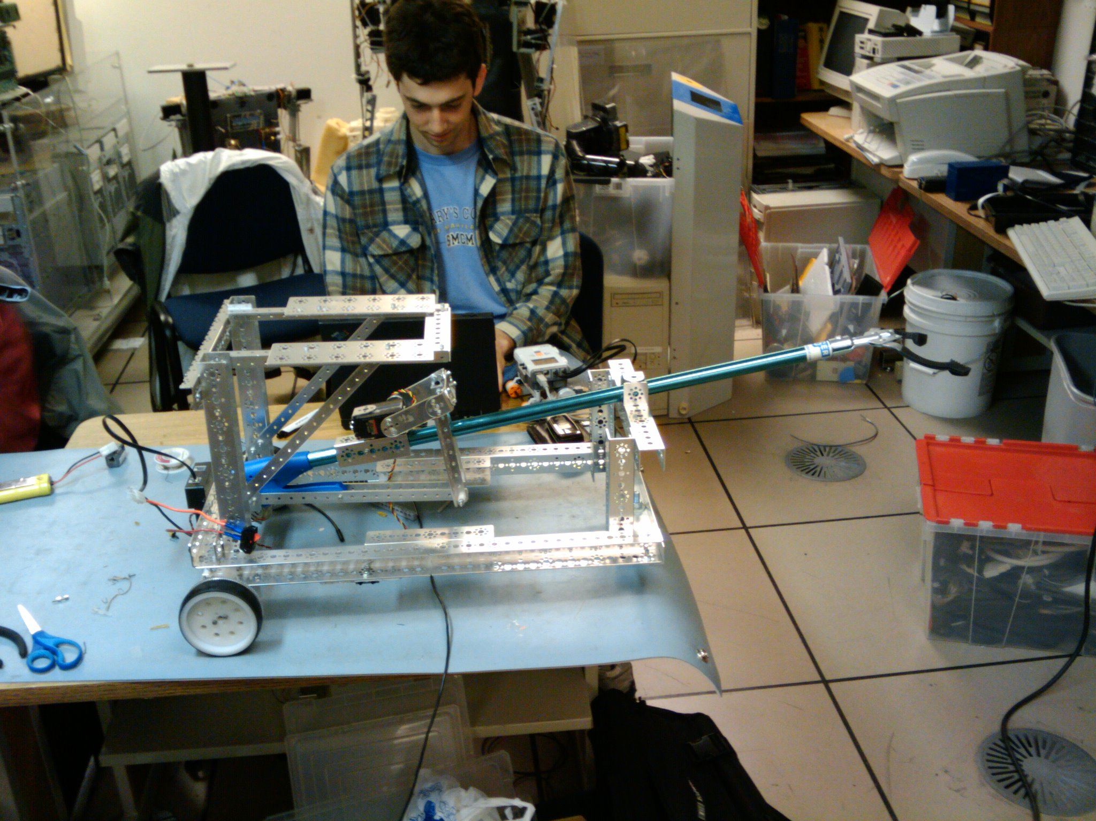
To gain the needed additional space the platform was lengthened, the back platform raised significantly, and an additional platform was added at a medium height in the forward portion of the chassis. The laptop computer was to occupy the rearward platform, and the puppet moved to the new forward platform. Further, the arm was to now mount at a vertical angle of roughly 25 degrees within the platform, projecting forward from just beneath the puppet, and batteries and the arm motor apparatus would now be mounted in the new space in the bottom rear provided by lifting the rear platform.
This configuration provided sufficient capacity and rigidity for the chassis, but the base was found to be unstable. The 3 wheel configuration left the unloaded chassis susceptible to tipping if an unbalanced load was placed at the front of the robot, or if the front half of the robot experienced any significant side-load. This problem was expected to be much worse once the robot was loaded, where the battery weight would provide some compensation, but the center of gravity would still be much higher with the laptop and ESRA puppet in place. To compensate for this instability, a decision was made to move from 3 wheels to 4, discussed further below.

Wheels
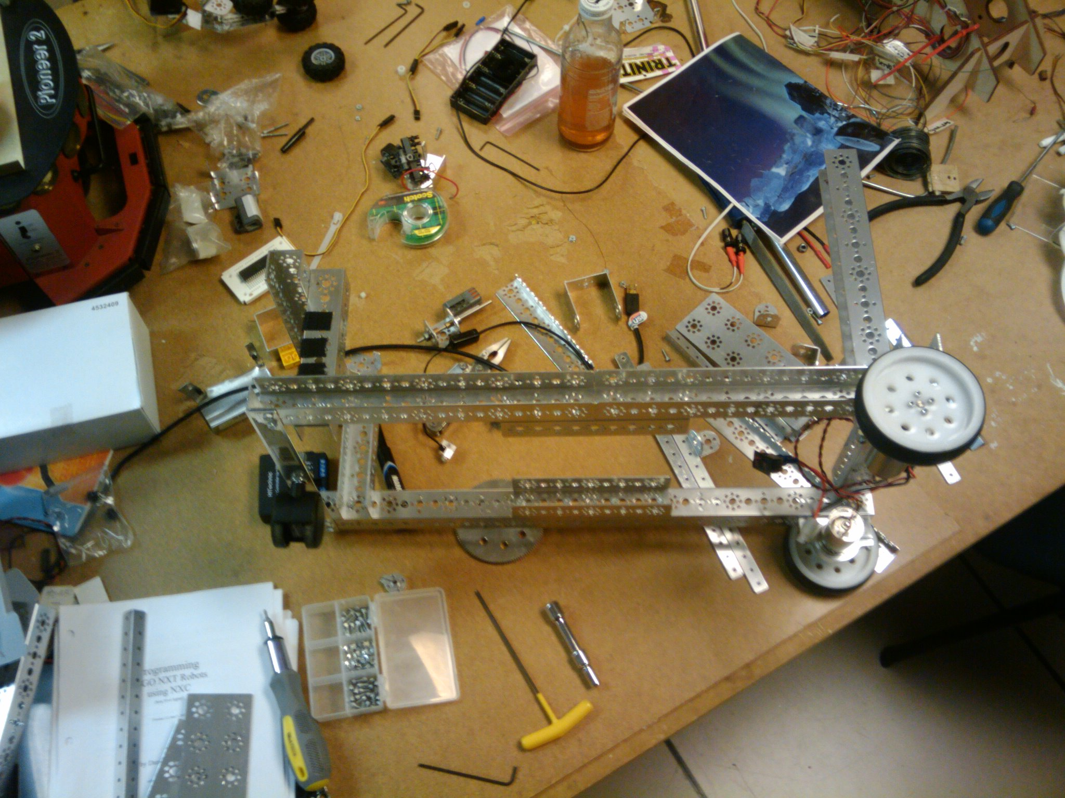
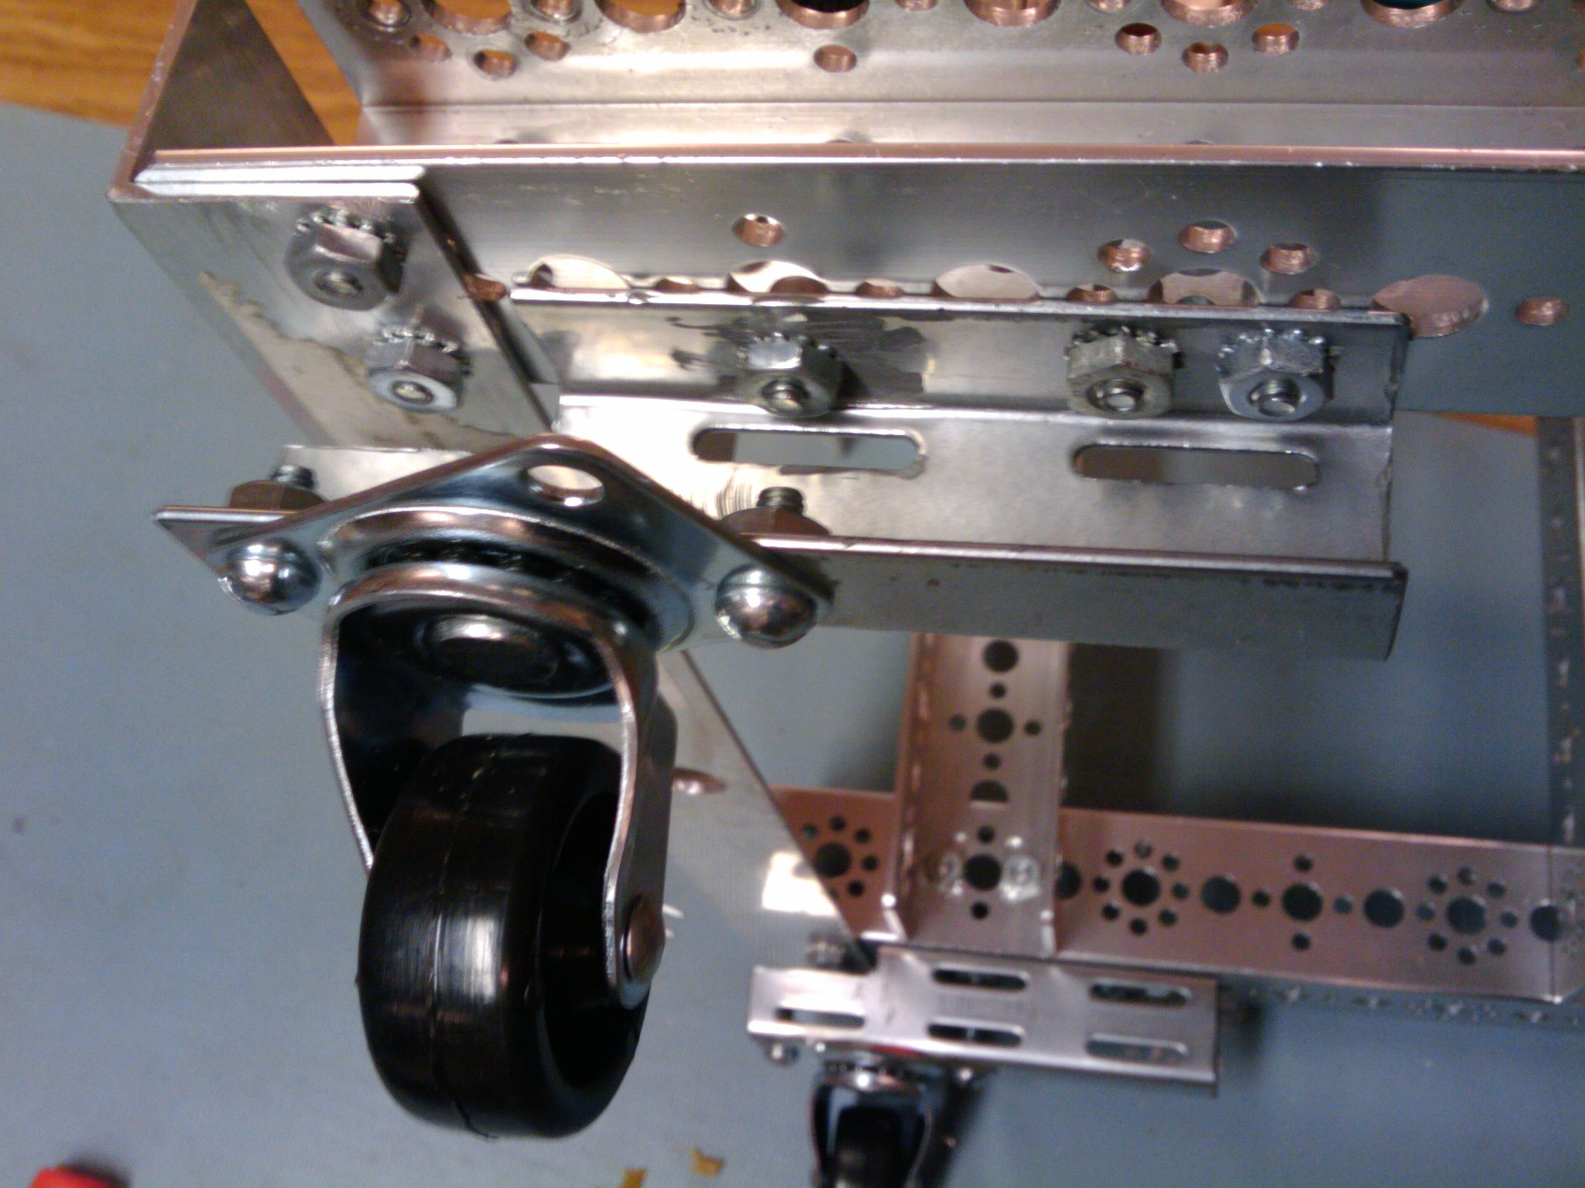
The design and selection of wheels and their related apparatus was surprisingly complex. Our initial assumption was that the only significant obstacle in locomotion was going to be timing and simultaneous logical control of two independent drive wheels. While this was in fact the primary challenge, the actual wheel selection, configuration and mounting played a far greater role than we expected. Our initial configuration of 2 rear drive wheels and a single forward caster (wheel on horizontal axis with eccentric vertical axis for turning) was not sufficiently stable, and the caster was significantly worn and had far too much resistance for our purpose. The next iteration was the replacing of the single caster with two forward casters. While this did increase stability sufficiently, and did provide small enough straight line rolling resistance, the casters provided significant initial resistance if they were not aligned in the direction of new motion at the start of a motion. This was manageable in straight lines, but became a significant hindrance to turning.
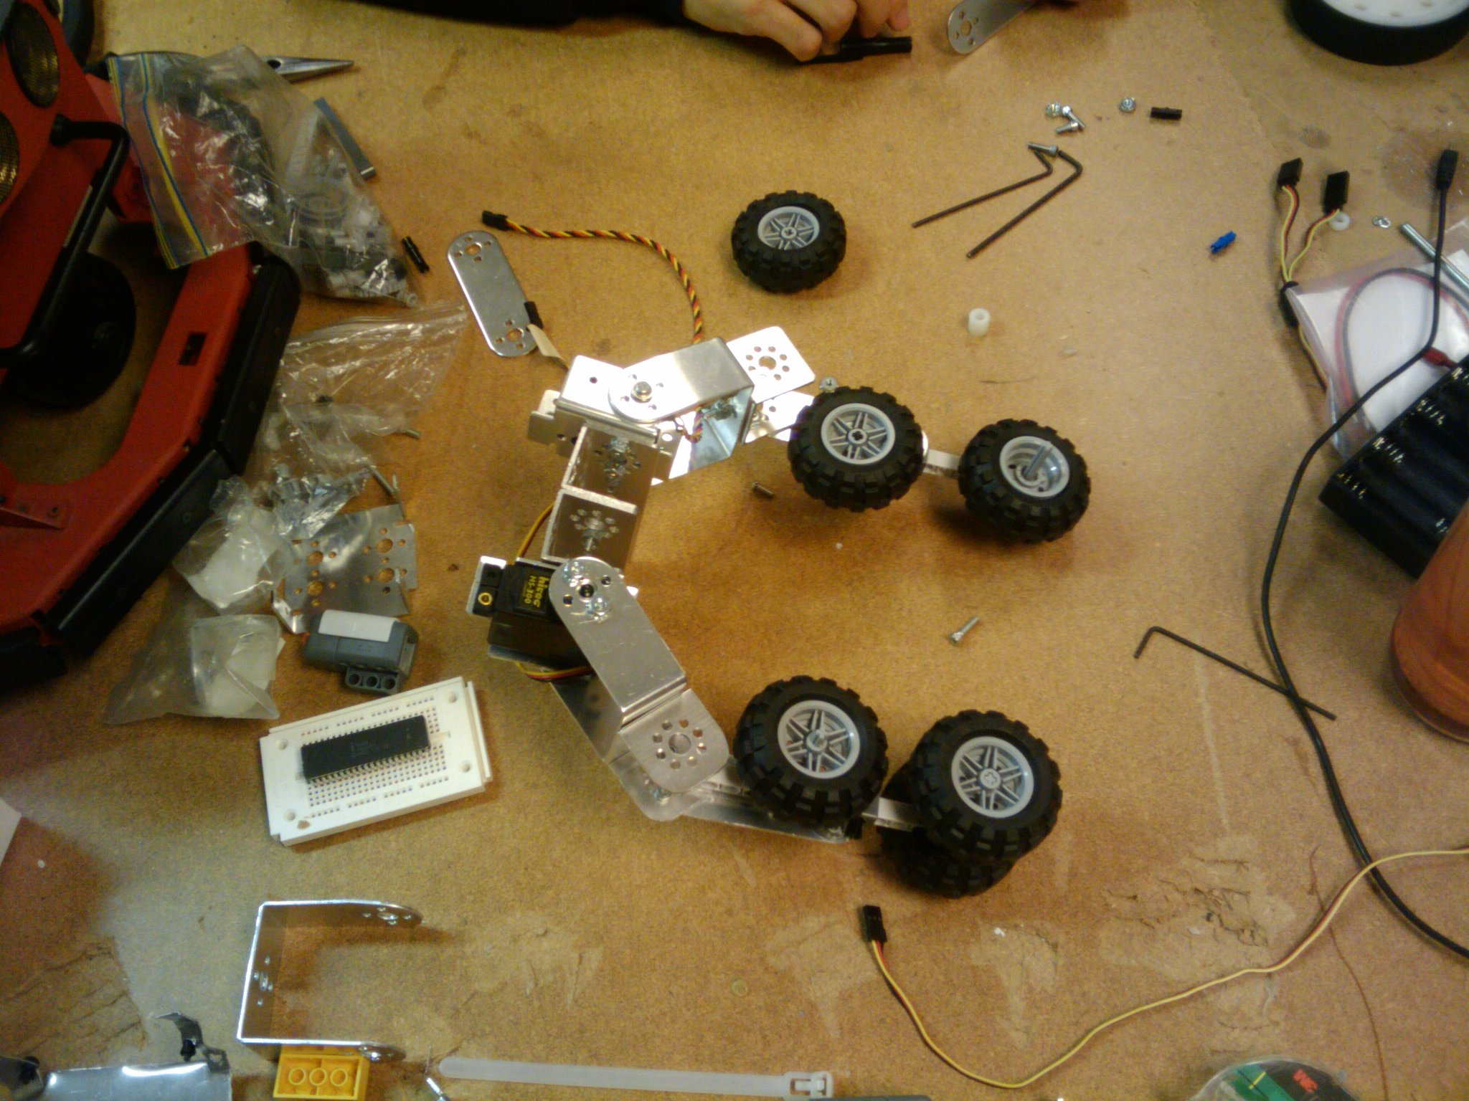
It was also noted at this time that the mounting of the drive wheels had significant flex. This meant that the tops of the drive wheels canted inwards proportionate to the load they bore. This was corrected by the inclusion of two friction-fit wooden blocks, inserted to bear the compression of the load and prevent flex in the aluminum wheel brackets. The next action taken to provide for smooth turning was to swap the drive wheels to the front. This was held to provide a noticeable increase in smoothness and success of turn, but was still insufficient for our goals. The final solution was found to be the replacement of dual axis casters for truly omnidirectional ball casters.
Arm

We began developing the arm and gripping mechanism for the robot by investigating several different designs in search of one that would be simple and robust. Our criteria required the mechanism be able to grasp an object, such as an empty pop can or bottle, hold the object while the robot traversed some distance and then to place the object in another location.
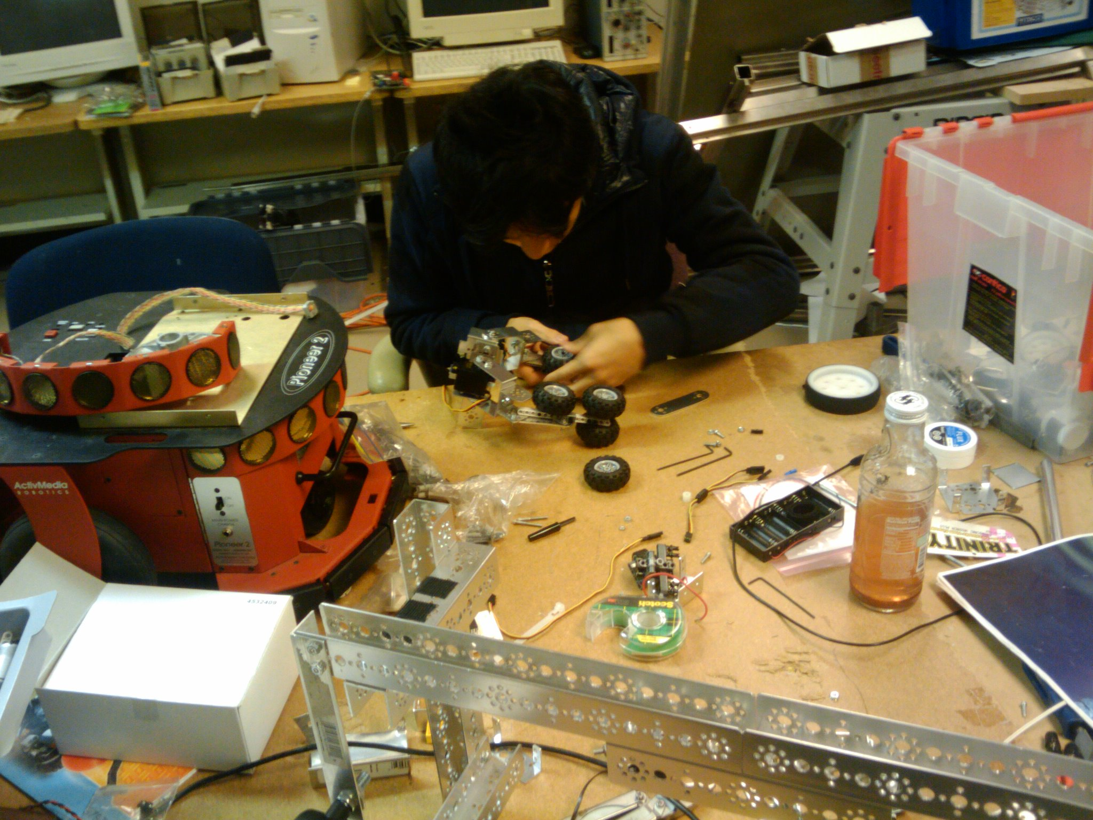
The initial implementation was taken from examples on the TETRIX website give link and consisted of TETRIX components and servos being used in the gripping mechanism and to extend or rotate the “arm” out from the robot. We built several prototypes of the gripper based on this design and tested them on their ability to grab and hold a can.

The servos that controlled the arm did not have enough power, given the weight of the gripping mechanism. We determined that we would have to either reduce the gripper weight, or obtain larger servos and deal with their larger power requirements.
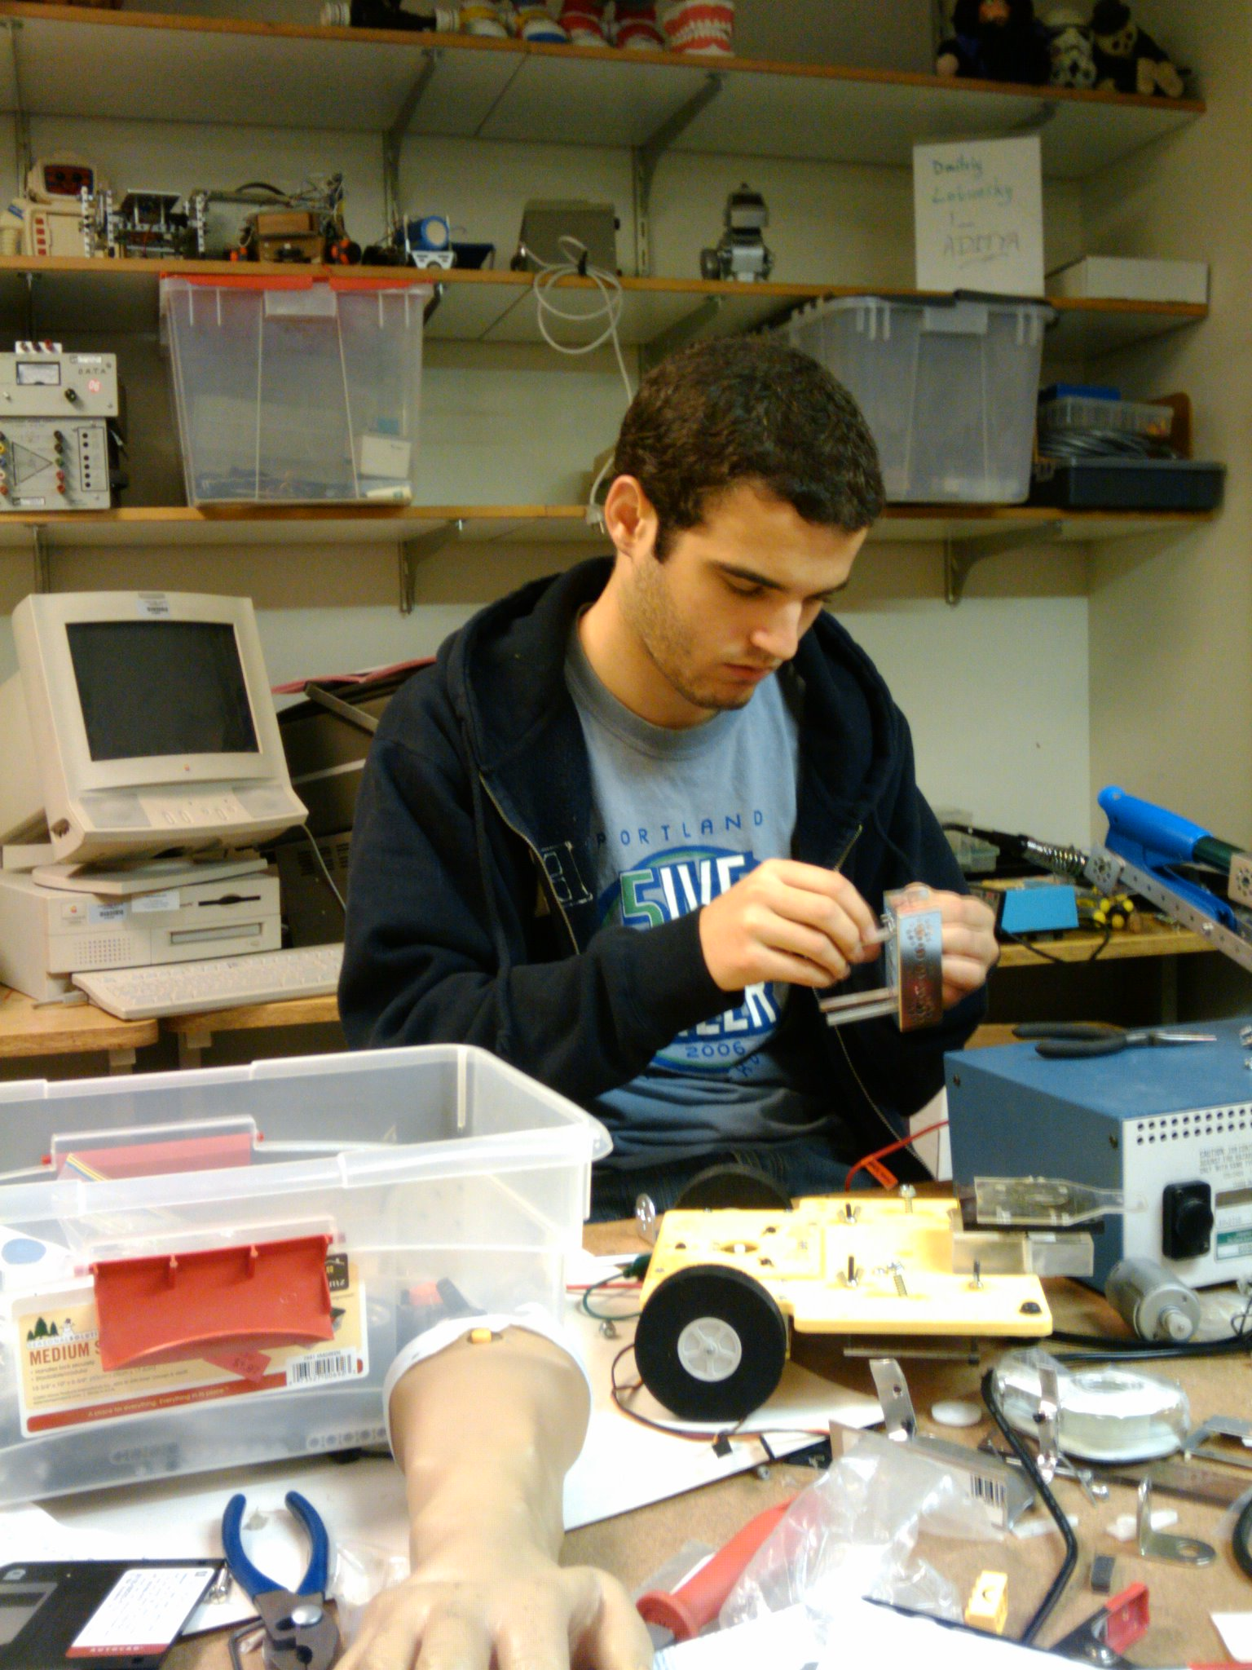
We decided the better course of action was to redesign our prototype to make the gripper lighter. Due to leverage, small changes in gripper weight would reduce work required of the servo supporting the arm significantly. We were using two servos on the initial prototype gripper, and we removed one resulting in a very significant weight reduction.
However, we had difficulty designing a gripper that solidly holds a object under restriction of weight because the TETRIX kits do not have much flexibility in arrangements of connection for small devices. I either do not agree or I do not understand. Be clear. This is important. It was believed that a gripper powered by a servo at the base of the arm, like a human hand, would be rather complicated and would likely not provide enough gripping force for the task in even very good cases.
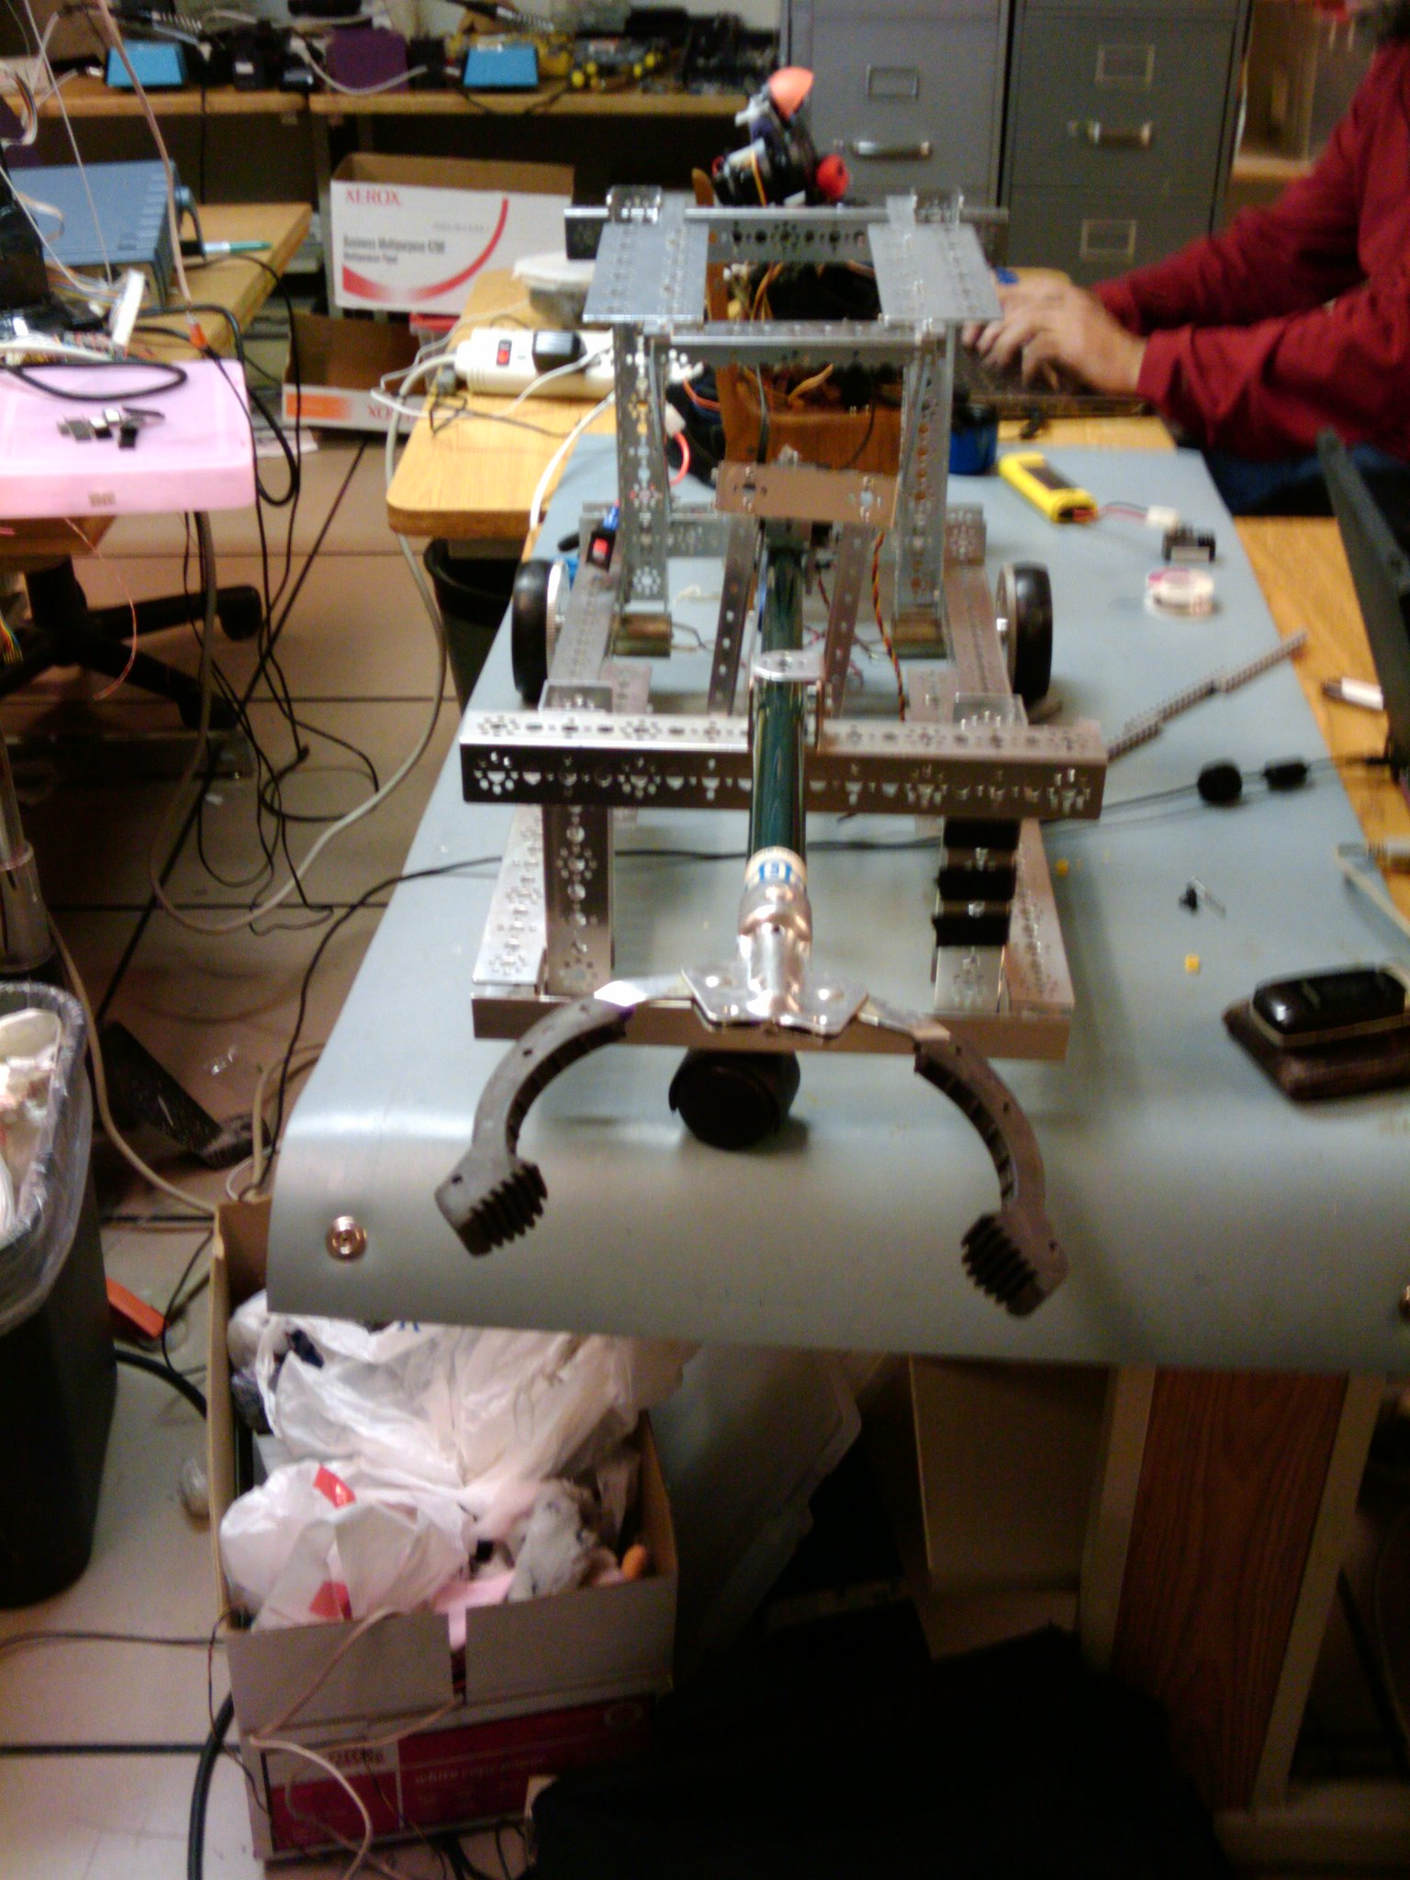
As we were reducing the weight of the gripping mechanism by eliminating any unnecessary features, we discovered a device in the lab (the Unger Nifty Nabber) that had a gripping mechanism on the end of a long metal tube and a controlling handle at the opposite end. We found it amusing, but immediately discarded it as an unrealistic option.
At this point we were considering a design setting the arm at stable position while the robot is moving, then projecting the arm linearly in some way to reach for the can. We considered using a parallel linkage to move our gripper forward in an arc-motion while the gripper stays level, or instead of using a parallel linkage, slide out the arm from the platform to reach the can.
Encountering technical difficulties controlling the slider using TETRIX, we built an arm prototype using a parallel linkage. It was found that in this design greater torque is required than is available from the servos at hand. Running into the issue of insufficient servo power at the arm base for the second time, we started to develop another design which would become our final gripping arm.
We returned to the Unger Nifty Nabber, a device in the lab which has a gripper on the end of a metal tube about 3 feet in length and a controlling handle at the opposite end. We decided to use this device for our arm because it already had the nice gripping mechanism and a long rod that allowed the gripper to project from the base. The gripper is actuated by a length of steel tape which is connected to the handle through the rod. The handle is mounted much as a bicycle break lever, giving mechanical advantage to the gripper actuation. This was mounted via TETRIX parts on the handle and a linkage was built which applied the rotational motion of the servo to the handle.
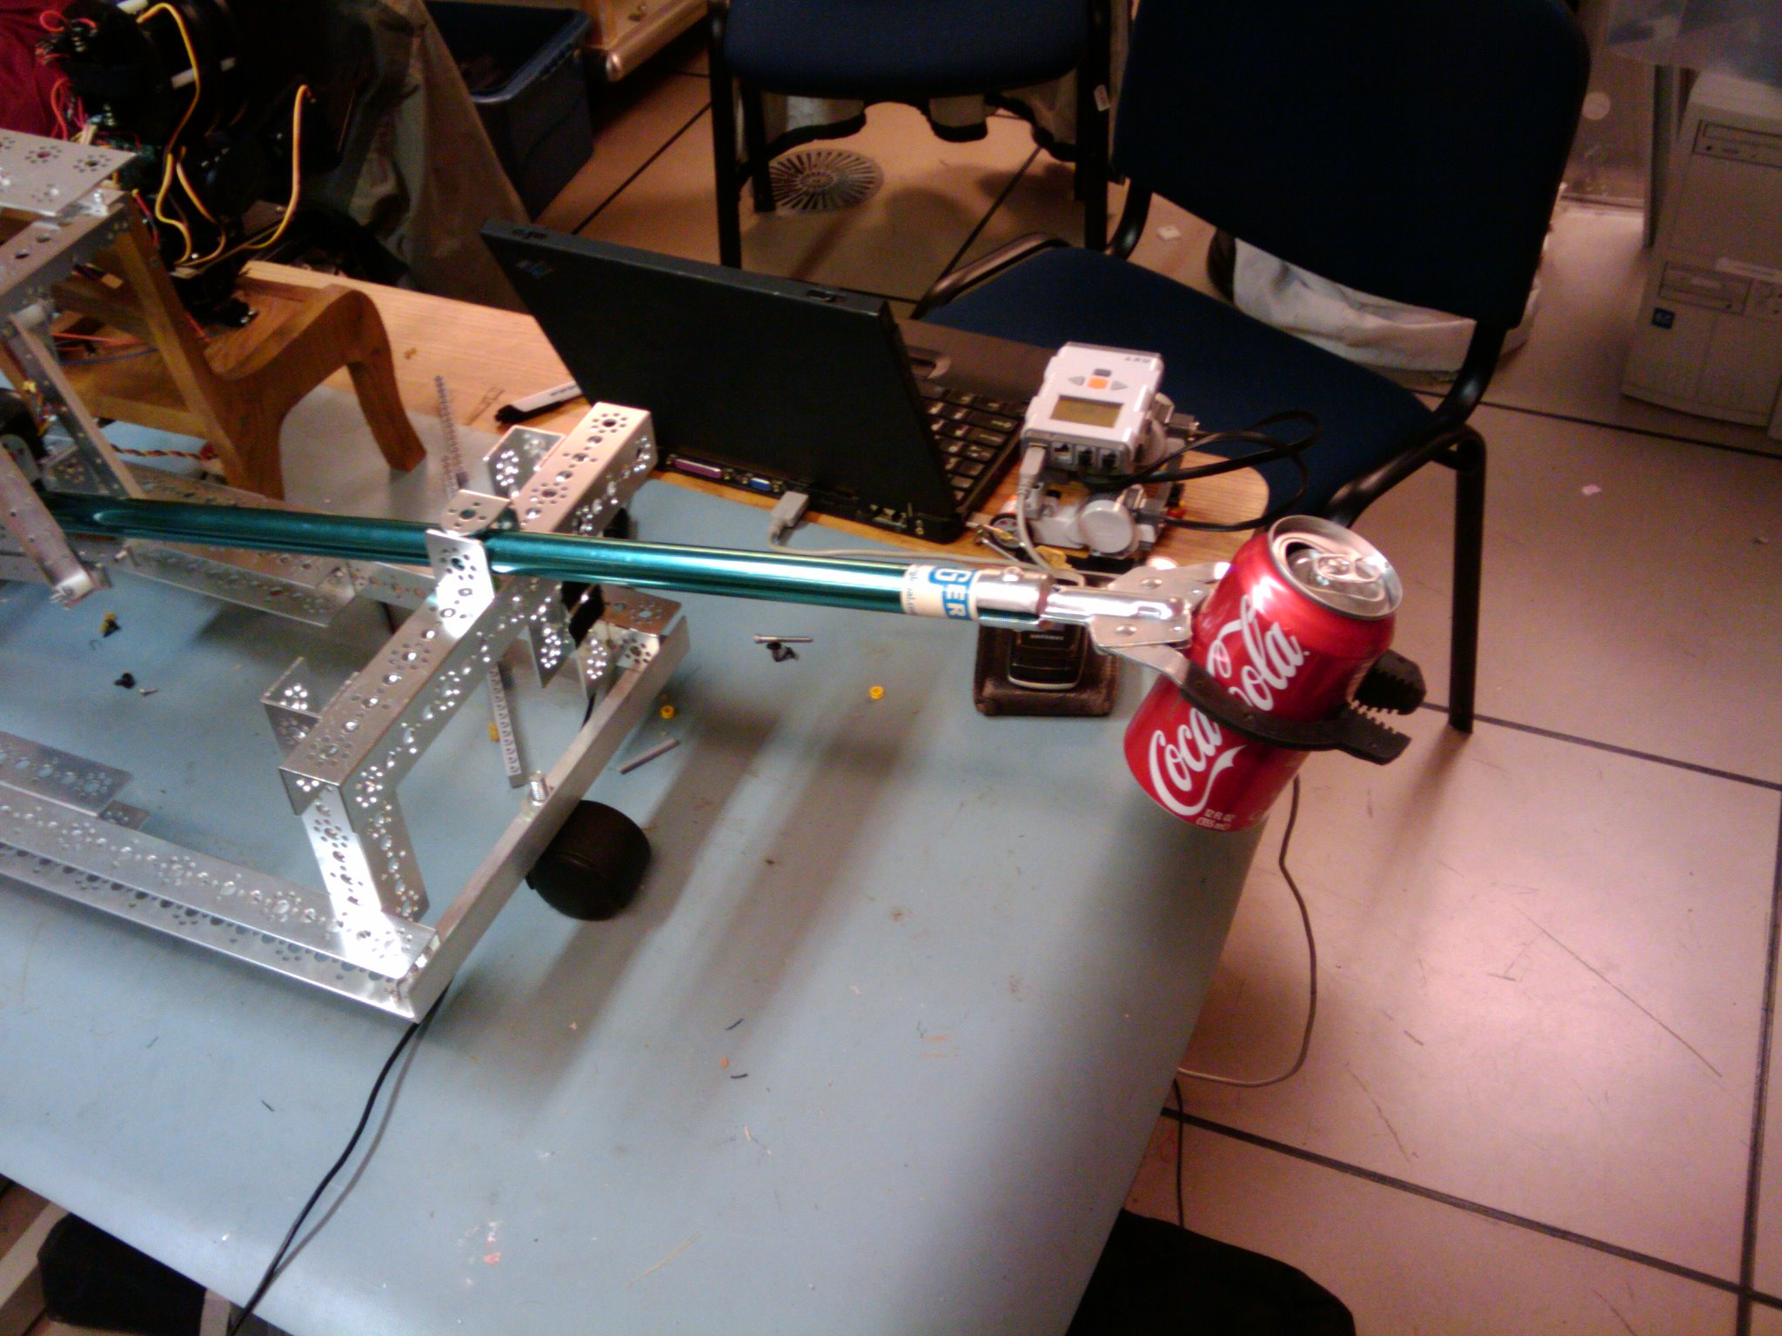
In order to gain additional leverage, and reduce required torque on the servo, the handle was extended. The linkage to the servo was connected to the end of this extended handle. In this way the distance from the axis of the handle to the joint of the linkage was increased, so the servo could actuate the handle with a reduction in the required torque. All of the connections and extensions were constructed of TETRIX parts. However, it was found that the torque requirement was still great enough that we were required to replace the servo initially used with the largest one available to ensure reliable control.
At this point our mobile platform had only three wheels, and in consideration of stability we decided not to implement horizontal arm motion. Therefore we fixed the arm in place on the base using TETRIX parts. Gripper servo control was provided by an used port on the ESRA puppet, simplifying channels of control, as well as allowing the gripper to be easily integrated into the puppet's emotive gestures.

Computational Control Structure

Our initial assumption was that we would be able to program the NXT unit, via a PC, to drive the device, and to provide the computational control structure. Almost immediately we ran into significant complications. The foremost being that the NXT unit had no sufficient method to control the ESRA puppet and related audio files. Further, if one was found or generated, it was determined that the I2C bus that the NXT device utilizes would likely have insufficient bandwidth for the task. GIVE SOME NUMBERS
The next clear option was to mount the laptop PC used for NXT programming on the robot chassis. The new structure would then have the laptop as the primary logical controller, directing the NXT and ESRA controller.
The NXT would send information downstream to the HiTechnic DC motor controller, and receive optical encoder information back from it. The NXT would also receive information from the ultrasonic rangefinders and convey it back to the PC. The PC would operate on this feedback, and the current state of the application to further direct the action of the robot. With such a configuration, the PC was capable of providing synchronization of DC motor and servo control, with timely response to servo input. Draw the figure of the whole robot control systems with blocks

Logical / Software Structure
The high level control software is implemented as a state machine which transitions states based on multiple factors. ENGLISH ! The state machine attempts to implement the project scenarios outlined above with a simple C++ case construct and a periodic timer. Upon each time tick, the application checks for the state of the vehicle and if it encounters an event, it would respond to the event and transition states accordingly. The ESRA puppet was to provide emotive output (happiness, displeasure, etc.) based on the current state. Comment the code below in more detail. Variables, their meaning.

case SM_INIT:  InitializeNXT()  InitializeESRA()  EsraTalk(EsraSecene(SM_INIT))  m_State = SM_DRIVE;  case SM_DRIVE:  DriveDistance(Distance::Track)  m_State = SM_DRIVING;  case SM_DRIVING:  EsraTalk(EsraSecene(SM_DRIVING))  status = CheckStatus();  if (status == MS_REACHED_SONAR) {  m_State = SM_OBSTACLE;  m_Traveled= Position();  }  else if(status==MS_REACHED_TARGET)  m_State = SM_TABLE1; | case SM_OBSTACLE:  EsraTalk(EsraSecene(SM_OBSTACLE))  Maneuver();  m_State = SM_DIVERSION;  case SM_DIVERSION:  status = CheckStatus();  if(status == MS_REACHED_TARGET) {  TurnTowardTarget1();  case SM_TABLE1:  EsraTalk(EsraSecene(SM_TABLE1))  status = CheckStatus();  if (status == MS_REACHED_SONAR){  m_State = SM_FIND_OBJECT;  m_distanceLeft -= Position();  if(WithinRange())  CenterOnTarget(true);  elseif (NearTarget())  DriveDistance (m_distanceLeft);  } else if(status==MS_REACHED_TARGET)  m_State = SM_FIND_OBJECT;

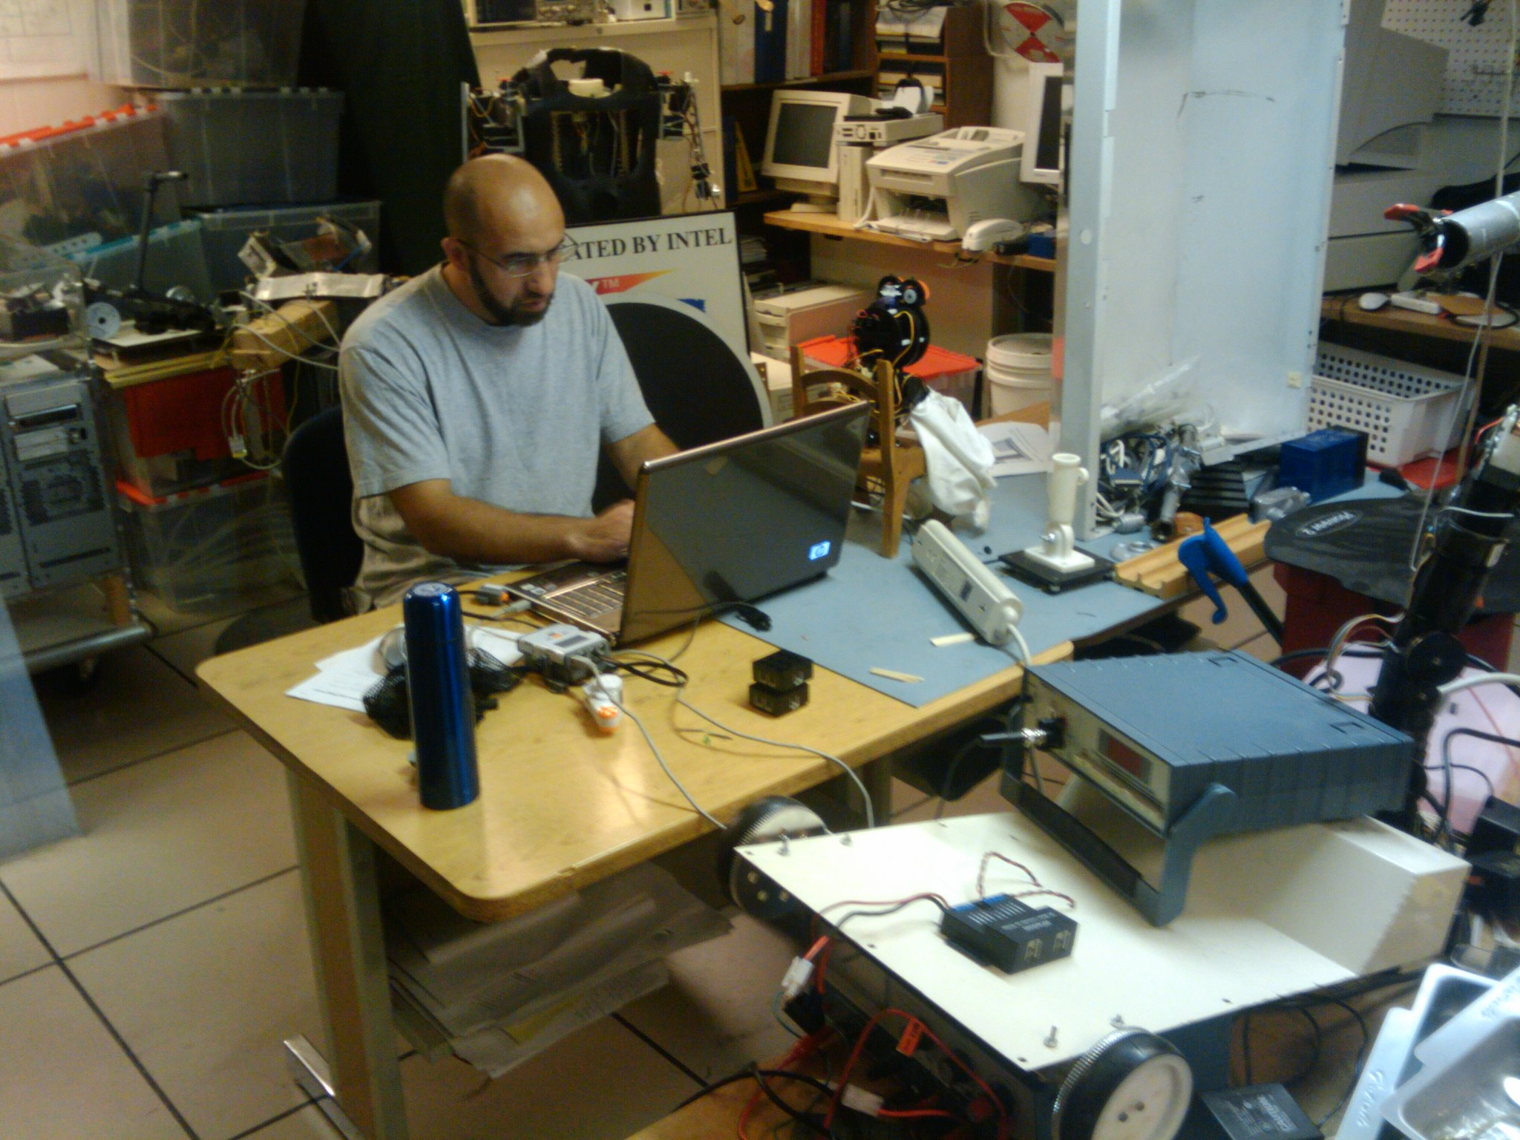
For path planning and obstacle avoidance, we initially looked into using heuristic search techniques. It was found that A* search was the most widely used and relatively easy to implement. A* would be used to recalculate an optimal route after avoiding obstacles in the path of the robot. We have included the basic algorithm below. The A* algorithm is a greedy algorithm that recursively evaluates nodes in order to find the optimal solution, by summing the cost of the path to the node and the estimated cost to the goal node. The heuristic function that estimates the cost to the goal state must be admissible and cannot overestimate the cost or a suboptimal path may be returned.
Noting the time cost of programming such routines, and that implementation would be dependent upon having the chassis and sensors complete, we instead chose a trigonometric method that would be sufficient and would be much faster to implement. This trigonometric method is as follows. Once the vehicle encounters the obstacle, it maneuvers around it by turning to the right side, and then correcting course towards the table. In our implementation we initially used the left front wheel, in a front wheel drive configuration, to estimate our directional correction. The initial rigid mathematical implementation failed to direct the vehicle towards the target all the time as the wheels slipped, or other physical problems biased the outcome. Thus the vehicle performed basic mapping and localization via the known course information, and the encoder feedback.
Goal seeking was implemented via sonar edge detection, taking a sonar samples at incremental angles from a point believed to be near the goal, and then proceeding toward the center of the edges found. The target was initially too far to be sensed by the sonar, and the odometery feedback was chaotic at best. As a result, we used the trigonometric method described to give us a general orientation towards the target to which we partially followed. We then stopped and swept around for our target and headed towards it if within range. If it was not found to be within range we traveled a reduced distance and scanned again for our target. This process was repeated until we found the target or we reached our odometric limit.

The robot's dynamic physical system consisted of two major components, ESRA and the NXT, and involves three separate digital controllers: Mini SSC1 controller which controls the ESRA robot, the NXT Brick which controlled the various sensors and provided an interface to the HiTechnic DC Motor controller. The NXT controller is programmable in a construct similar to the C language which allows for controlling the DC motors and responding to sensory input. Y<??

The NXT proved to be the more challenging of the two to control directly through the laptop. The NXT communicates with the host through the USB port or wirelessly through Bluetooth. Robot C and a set of other packages allow for easy programming of the NXT by controlling and interrogating a variety of devices plugged into it. However, such programs have to be downloaded to the NXT's memory to be executed independently from the host laptop. We were fortunate to find a set of programming libraries, NXT++, created by Cory Walker, providing interfaces to all NXT components including the sonar, compass, Tetrix servos, touch switch and more. Although the libraries were provided in both Linux and Windows flavors, the Linux version appeared to lack features proved necessary for controlling the DC motors through the HiTechnic controller, discussed below.
The NXT++ suite is fully documented with sample applications and an online forum. It consists of a set of singleton methods easily invoked within any C++ application. For example, the following code is used to query the distance of the nearest object to the sonar.
This third controller provides an interface for manipulating the two Tetrix DC motors used to maneuver the vehicle. This controller connects to one of the ports on the NXT and communicates through an I2C serial interface which is a two wire interface used for transmitting information in both directions. In order to communicate with this controller, our application would eventually use some of the functionality of the NXT++ libraries to direct the NXT Brick to relay commands to the HiTechnic controller. Discovering the sequence of such instructions proved to be the ultimate hurdle to cross which was exasperated by the surprising lack of sample code and the tersely provided documentation.

HiTechnic FIRST Motor Controller Specification provides a technical layout of the internal registers of the controller along with the type of commands supported by the device. In order to communicate with the HiTechnic controller, the NXT must first be instructed to act a relay through the Raw mode. Once the NXT is in this passive mode, we can communicate with the HiTechnic through the I2C interface where we would send and receive information from the appropriate registers. This controller provides its register in a memory mapped addressing scheme as shown in the table below.

Address | Type | Contents
00 – 07H | chars | Sensor version number
08 – 0FH | chars | Manufacturer
10 – 17H | chars | Sensor type
18 – 3DH | bytes | Not used
3E, 3FH | chars | Reserved
40H – 43H | s/long | Motor 1 target encoder value, high byte first
44H | byte | Motor 1 mode
45H | s/byte | Motor 1 power
46H | s/byte | Motor 2 power
47H | byte | Motor 2 mode
48 – 4BH | s/long | Motor 2 target encoder value, high byte first
4C – 4FH | s/long | Motor 1 current encoder value, high byte first
50 – 53H | s/long | Motor 2 current encoder value, high byte first
54, 55H | word | Battery voltage 54H high byte, 55H low byte

The controller's mode commands (44H & 47H) determine the mode of control over the two motors. The lowest two bits of this byte allow for four modes of operation as follows:

Sel | Action
00 | Run with power control only
01 | Run with constant speed
10 | Run to position
11 | Reset current encoder

The Run with Constant Speed and Run to Position modes rely on the set of optical encoders to operate. In the constant speed mode, the HiTechnic controller consistently adjusts the two motors such that the two encoders count the same number of ticks, and hence, allows the vehicle to go straight - in theory. The Run to Position mode allows for instructing the HiTechnic controller to rotate the DC motors until the target encoder reading is reached, allowing for traveling an exact distance - useful for turning corners.
In our project, we initially struggled to figure out how to communicate with this controller, and once we conquered the former obstacle, we struggled with the vehicle going straight. Our initial trials of going straight using the constant speed mode were futile: the vehicle steered to the left no matter what we tried. We tried changing the power level between the two motors, switching the DC motors and finally replacing the motors. We then conducted a simple experiment to determine how many ticks each encoder is seeing for every turn of the wheel. The experiment demonstrated that the left wheel was always short on ticks per revolution averaging 1080 ticks per revolution compared to the 1445 estimated ticks per revolution for the right wheel. A quick disassembly and examination of the encoder's reflective disc manifested a small scratch on the left encoder which was not a satisfactory answer. However, upon cleaning both encoders and replacing them on the wheel, our fortunes have turned awesomely. Although the scratch sill had an impact, 1390 vs. 1440, the vehicle was now heading in the right direction. Very good, This should be a part of troubleshooting manual.

The Mini Serial Servo Controller (SSC) uses an RS-232 serial interface to communicate with the host computer. The controller is capable of controlling eight (8) servo motors and can be daisy chained to control up to sixteen servos. Programming the servos from the laptop proved to be a simple task of writing a three byte sequence to the controller. A start code of 255 (FF) initiates the communication with the SSC. The second byte is a zero based address to the servo to control followed by byte indicating the radial position of the shaft from 0 to 254 corresponding to the angles of 0 and 180± respectively. For example, assuming the mouth of the ESRA robot is connected to port 1, the following Visual Basic commands brings a smile to ESRA puppet's mouth:

Although this basic level of programming proved to be easy, it was found to be far more difficult to incorporate an audio stream and attempt to synchronize the puppet's mouth movements with the voice. A readily available solution is the Visual Servo Automation software package which allows for graphically orchestrating a digital reel of the audio stream synchronized with each servo at the appropriate time in the audio stream. The application allows you to setup and quickly verify the motion of the various bodily parts of the robot and their correlation to the voice at a particular time. The entire scene is then saved to a file which is used for playback at will.
This system provided a convenient interface for the scene construction, but the production of coherent and visually appealing scenes was still quite labor intensive, and required access to the ESRA puppet for iterative testing. Constructing scenes that utilized the full range of motion available, and had movements that appeared reasonably natural required roughly 30 minutes per minute of animation. WHY SO LONG? WHAT KIND OF TOOL CAN HELP ?
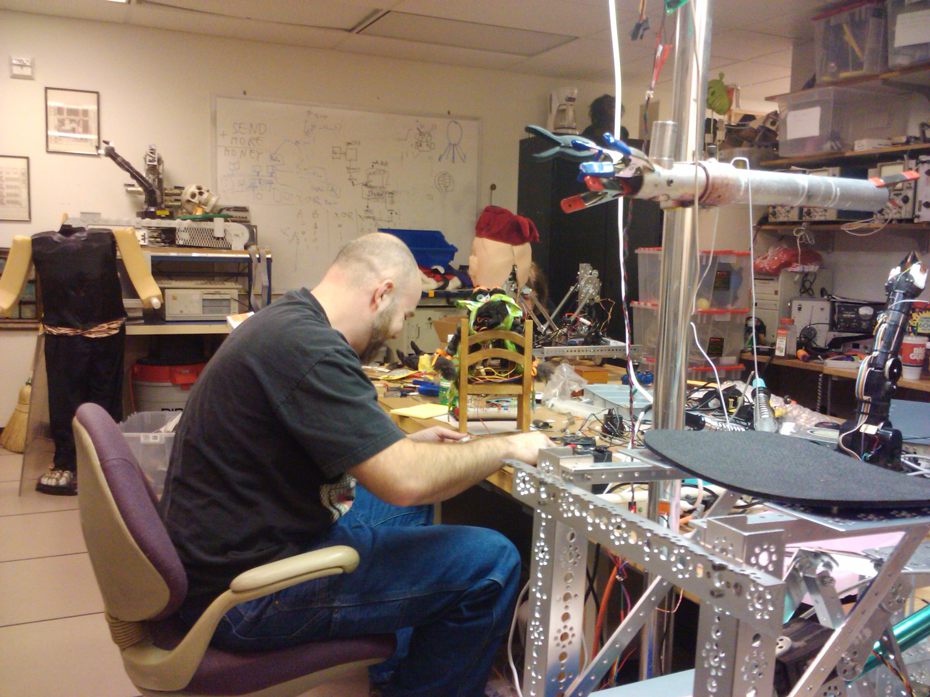
Attention was placed on slowing extremities as they approached a static position, and ensuring that limb movement would not cause the puppet to buck or rotate in a way that could cause it to fall over or damage itself. Movements were checked to ensure that servos were not driven out of their operational range, and that limbs did not collide. Lastly, and fairly important from an aesthetic standpoint, much focus was put upon synchronization of limb movement, but with some slight phase shift. Multi limb motions started with one limb or part, and was paralleled slightly later with the other limb giving a more natural "imperfect" synchronicity. Single limb movements were followed by echoes of following movements made throughout the robot, much as a natural arm movement would involve movement of the torso, head, and or eyes.
Sound editing was done with the open source Audacity package. Voice acting was performed by one of the group members, and required significant sound editing to normalize volume and remove unwanted artifacts of the recording process. Sound recording and editing was also found to take significant time to achieve a good product, again at nearly 30 minutes for 1 minute of usable audio. Sound obtained from open license sources was significantly faster to integrate, but incurred additional research time, and had limited utility. Roughly 20 minutes of audio representing various emotive states and responses was produced, of which approximately 10 minutes had emotive physical behaviors created for them. Good

In this project we required an additional software component which allowed us to play the saved scenes programmatically along with the ability to query the status of the playback at any time. Again, VSAConsole, a readily available ActiveX control, allowed us to easily incorporate the ability to control the scene from within our C++ application running on the laptop. The ActiveX provides an inter-process communication interface allowing our application to send instructions to another application, VSA.EXE, which renders the scene in a separate process. Such an interface is asynchronous in nature which presented few challenges to overcome. One of the main issues related to timing the interaction with the other process which was resolved by adding artificial software locks and delays to ensure proper operation. For example, in order to establish a connection to the VSAConsole, a Create() method is invoked which launches the VSA.EXE application, and return immediately. The new process running VSA.EXE would then, asynchronously, load the indicated scene from the file system. As a result, an immediate invocation of Play(), within our application, would surely fail as the VSA.EXE would still be busy trying to load the scene. GIVE FULL REFERENCES TO EACH TOOL. This problem is clumsily remedied by the introduction of delays between the two invocations, as follows:

In our project, we created a set of VSA files using the Visual Servo Automation software where the motion of the servos are synchronized with the recorded audio stream. We then embedded the VSAConsole control within our C++ application to playback the appropriate scene at the appropriate time.
WHERE ARE ALL THESE SOFTWARE PIECES LOCATED? WHAT IS THE STEP BY STEP PROCEDURE FOR A NEW STUDENT?

ESRA Puppet

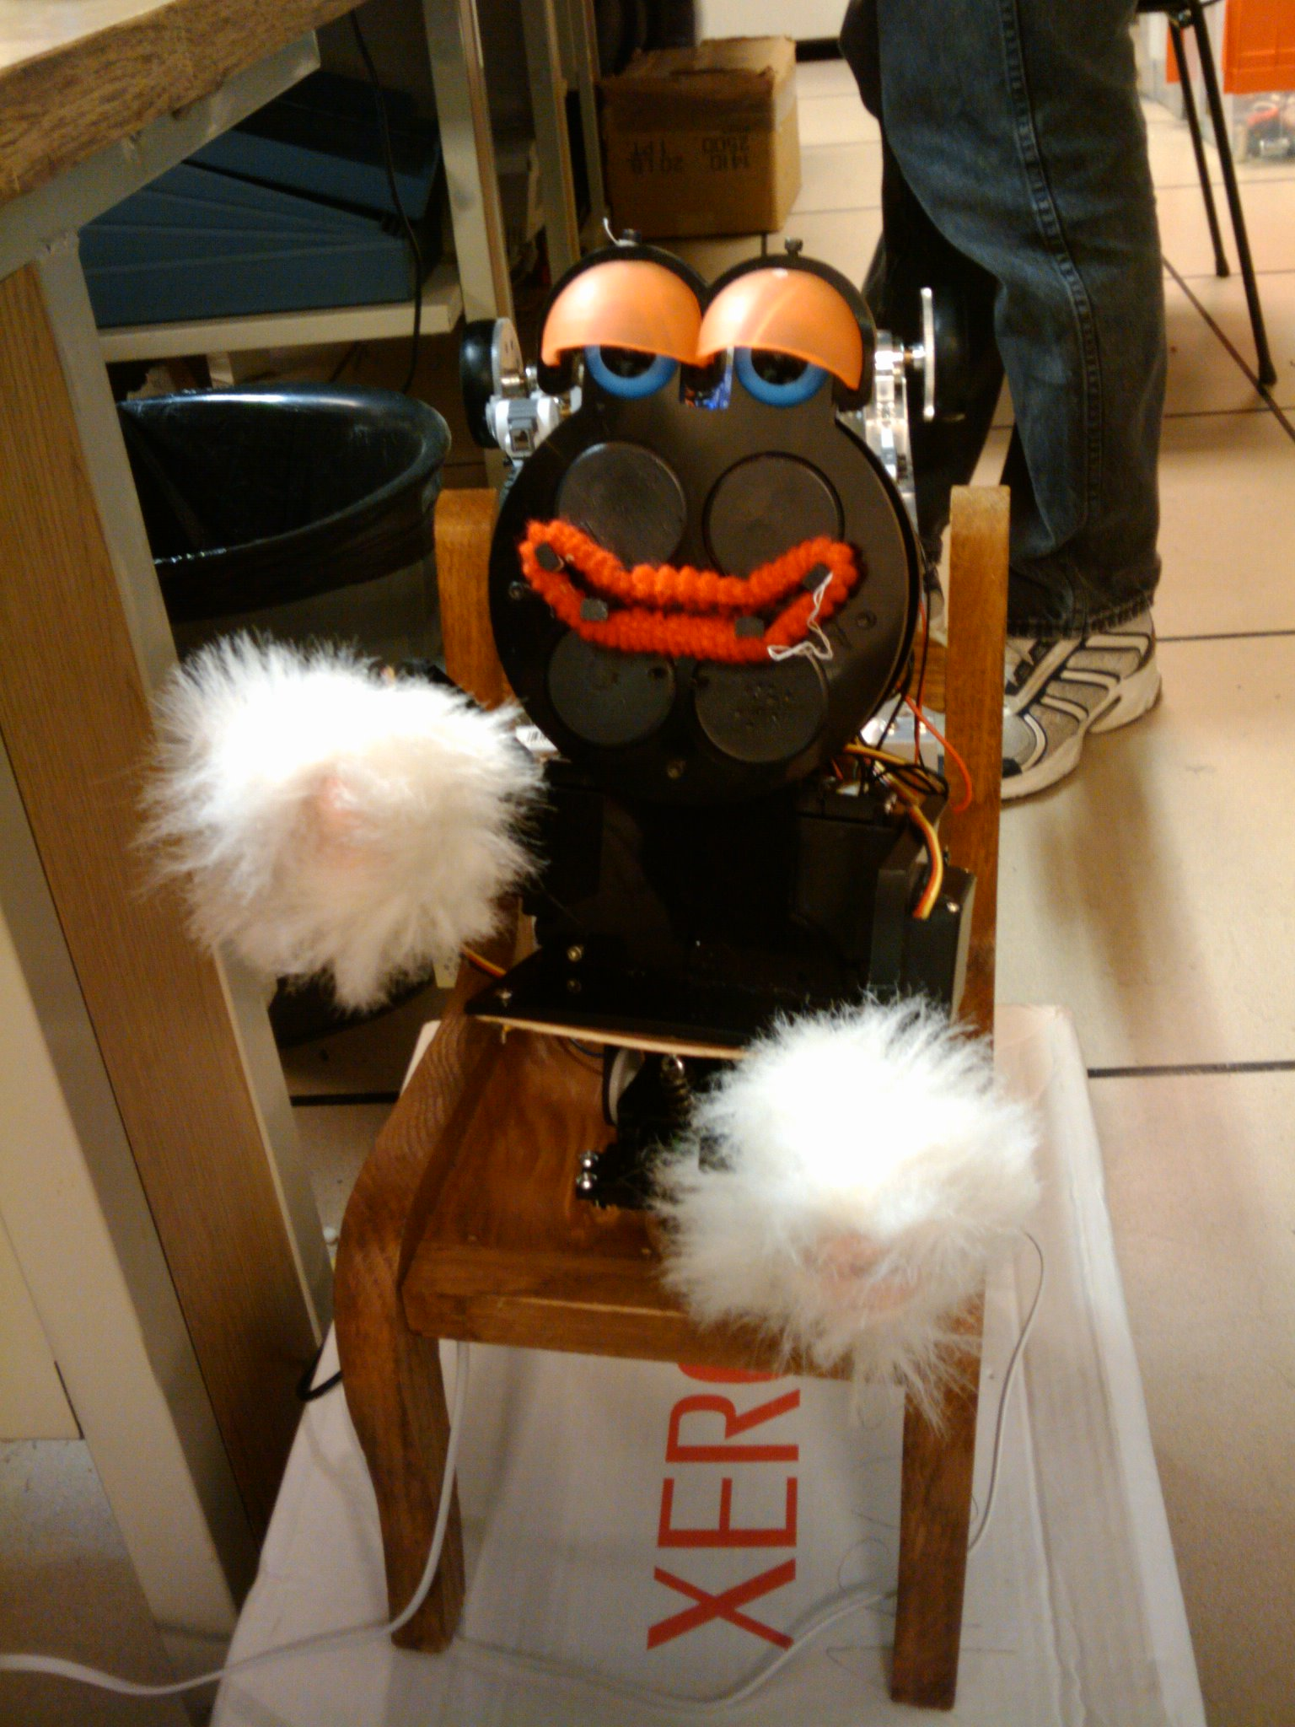
The ESRA puppet was the emotive character that would act as the driver and "emotional interface" for the device. This puppet would act out pleasure or frustration, depending on the environment and the task currently undertaken. For example, while waiting without command, the puppet might act bored, and while encountering obstacles, the puppet might express frustration. Upon completing the task successfully, the puppet might act out joy or pride. The puppet was a lightly modified ESRA II unit, mounted upon a proportionately sized chair, with controllers hidden beneath the chair and on the ESRA unit's back.
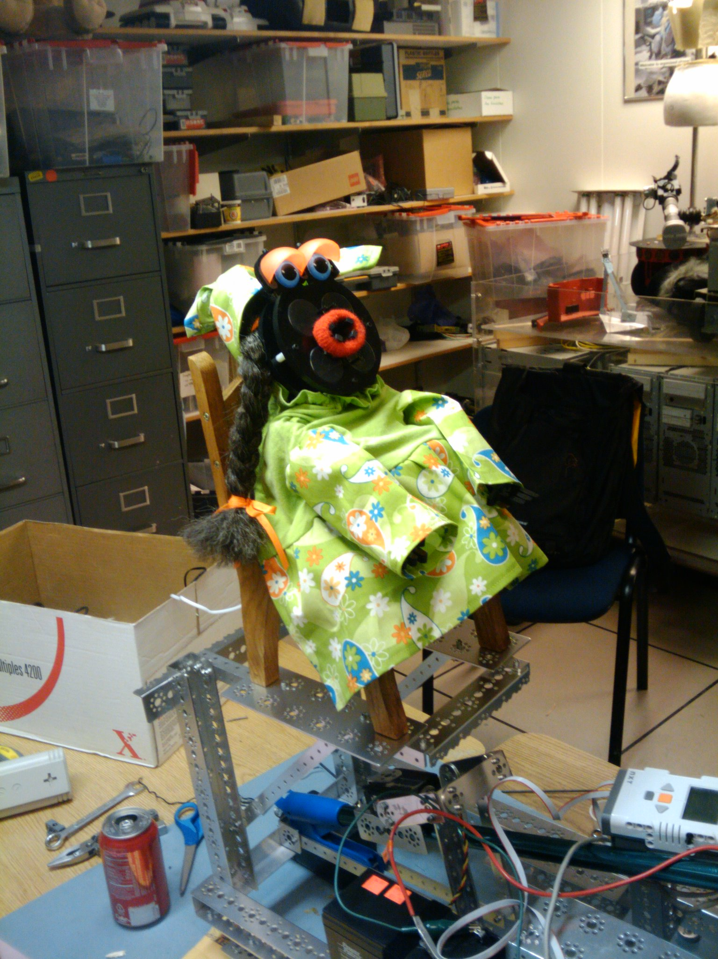
The costume for the ESRA puppet was provided gratis by an individual outside of the team. The aesthetic benefit of a costume was considered significant, although the specific costume was considered to be inconsequential in most cases. It was assumed that a more doll or toy-like appearance would make the robot more approachable. The emotive aspects were considered to be a major portion of the project, and as such this approachability was a significant concern. It was determined that a produced costume with a nice and coherent appearance was important enough that we should seek someone with specific skill in that area, rather than attempting to craft such a costume ourselves. An individual was found who had sufficient skill and aesthetic vision to produce a textile costume that met the projects needs and was willing to provide it gratis, much to our appreciation. GIVE HER NAME SO I WILL INCLUDE HER TO THE AUTHORS OF THE BIG PAPER THAT I AM WRITING. I WANT TO INCLUDE ALL PAST AND NEW STUDENTS>.

Sensor Selection
We decided the sensor structure was to be comprised of the drive wheel encoders, and two ultrasonic rangefinders. While this does not provide the robot with a comprehensive interface with its environment, it was felt that these would be sufficient for a closed course, and would allow us to keep the number of NXT peripheral devices we would need to interface with to a manageable number.
The encoders are heavily utilized to allow for speed control, directional orientation calculations, and distance calculation. As used for localization, they are only capable of providing dead reckoning type data, but this should be sufficient on a closed course. It was found that the encoders were providing inconsistent and inaccurate data. The encoders were disassembled, and upon close inspection it was found that the optical surface had been smudged on one encoder. The encoder wheel was cleaned, and the results became reasonably consistent.
The ultrasonic rangefinders are arranged on the front of the robot in a far forward high center (on the grasping arm) and low front center (on the front of the chassis) configuration. These allow the robot to determine the distance of obstacles, and the height and shape of some obstacle configurations.

Conclusions and Thoughts on Further Research
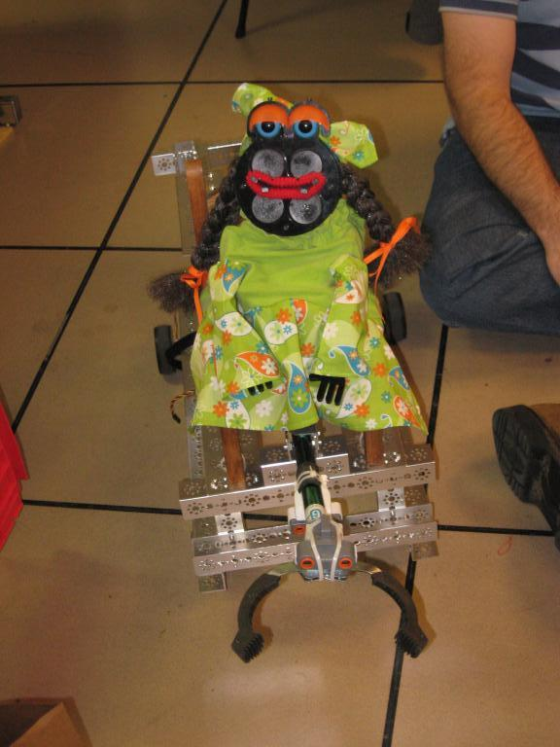
While we were not able to meet all of the proposed goals for this project, we were able to complete a significant number of them. We did achieve obstacle avoidance, and were able to successfully have the robot express emotive states. We were also able to perform some localize seeking behavior, although this was not entirely successful.

We learned a lot about the Lego NXT system, the ESRA system, and the challenges with integrating multiple proprietary systems together. We gained a lot of knowledge of system control and autonomous path planning.
While we did not implement such a system, we feel that constructing and controlling an arm with multiple degrees of freedom is possible, and could be a beneficial improvement to our arm design. This would likely involve inverse kinematics for planning the movement, which is an area that we researched initially.
Obstacle avoidance and path planning was a successful area, but also the one with the most room for improvement. Our use of trigonometric methods in order to calculate the correct turning angles for our robot to avoid obstacles and continue on its original path was very reliable, but limited to only one turning direction, and a single angle of correction. It would be interesting in future experiments to implement the A* algorithm, or perhaps a variant called D*-lite. The D*-lite algorithm combines incremental and heuristic search and has been used at other institutions in mobile robot navigation.
The software development is still in very early stages with most of the results based on trial and error. The software needs to be made more robust for varying environment conditions, such as surface friction, and this may require making some of the hardware improvements suggested above. Additionally, though we investigated path-planning and search techniques, our system currently relies on obstacle avoidance to return to a straight-line path. More work is necessary before we could tackle more advanced scenarios, such as multiple trajectories, let alone vision or multiple robot coordination.
One of the more obvious hardware improvements would be equipping the system with a netbook or a compact pc such as the CM-iAM and reducing the weight of the robot, and potentially the size of the base. A wireless link to a server, using the campus WiFi network, could provide us with computing power without adding expensive and bulky hardware to the robot itself. The Oregon State Aerial Robotics Team used a similar
approach with a flying robot. (http://oregonstate.edu/groups/osurc/aerial/)
The gripping mechanism, while effective, is quite rudimentary and could be developed with more degrees of freedom and additional sensors. These could include a camera, or tactile feedback in the grip. The system would then have the potential to complete more complex and delicate tasks that require more precision and flexibility of movement and force feedback when gripping fragile objects.
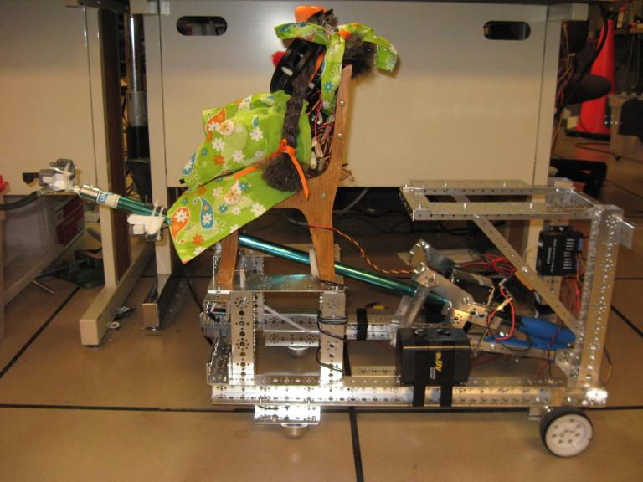
We experienced problems with navigation and localization due to our use of only wheel encoders and sonar. We might improve its reliability by adding stereo vision, chassis push plate sensors, a skirting of ultrasonic or laser rangefinders, or possibly GPS if the robot is to function outdoors.
Drive issues were a significant hurdle with this project. It was difficult to have the robot move precisely forward, or to turn at consistent angles. It is possible that the robot was pressing into the carpet, providing a significant, yet inconsistent resistance. Larger wheels may compensate for this issue, but would provide less granular encoder information. The power-train of the robot was designed as a rear-wheel drive system with independent control of each wheel and floating wheels in the front. This setup clearly resulted in difficulties driving in a straight line due to issues with the synchronization of the drive wheels. A different design, such as having a fixed axle rear-wheel drive vehicle and steering control in the front, may alleviate this problem.

References

NXT
http://mindstorms.lego.com/
http://www.nxtprograms.com/

ESRA
http://www.robodyssey.com/Resources/ESRA2%20V1.pdf

D*-Lite
http://idm-lab.org/bib/abstracts/papers/aaai02b.pdf

Audacity
http://audacity.sourceforge.net/

VSA
http://www.brookshiresoftware.com/

