Foreword 2
The Computer 3
Image Acquisition 4
Basic Image Manipulation 6
Resizing/Rotation 6
Color Space Conversion 7
Image Analysis 9
Thresholding 9
Edge Detection 10
Hough Transform 11
Color Segmentation 12
Structural Analysis 14
Contour Processing 14
Polygonal Approximation 17
Appendix 19

Foreword

Up until recently it was rather unusual to enable small embedded computing devices to work with images due to relatively high computation demands. However, latest advances in technology allow manufacturers to begin including image processing on even the smallest computers, such as Personal Digital Assistants (PDA). It is possible already to purchase a cellular phone that has a miniature camera attached to it, so a user can send a picture attachment with the message. With such developments in the market, we believe this is an appropriate time to take this technology further, and incorporate vision in mobile robotics. However, the task before us is more grand than those accomplished by the majority of consumer products: besides acquiring the image and making it available to other resources on the network, our goal is to accomplish extensive image processing right on the mobile computing device.

A great variety of experiments and tests that were conducted using the latest products in processing technology and state-of-the art computer vision software support our conclusion that embedded technology has developed well enough to meet high computing demands of computer vision in mobile robotics. We will show and discuss the experiments that support our claim, as well as describe several possible robots that demonstrate successful coupling of vision software and embedded hardware. Moreover, as the result of our project, we have compiled and made available on the Internet an extensive list of software modules that in combination will allow solving a wide variety of problems involving vision on mobile robotics. This compilation was designed with the ease of use in mind, so that, with further distribution of vision-grade computing hardware for mobile robots, the software will be easy to install by both professionals and amateurs alike. We hope that providing the open source community with software for good vision performance will help further popularize robotics.

The present report is organized in two parts. The first describes the software that has been ported to the particular embedded computing platform that we used. The most representative tests that describe successful image processing are also described in this part. The second part provides concrete code examples that can be used as part of construction of actual robots. These can serve as demonstration of capabilities of vision packages that we offer as well as models for using them in other projects.

In this part we focus on discussion of software that has been made available to the open source community interested in computer vision. We show what operations are well suited for the embedded computing devices based on Intel XScale processor, what are not as efficient and why. The exposition will begin with the description of the computing device that we utilized in our work, and then proceed to the particulars of image acquisition using that device, basic image operations, and image analyses.

The Computer

Our explorations were conducted using a single-board computer (the Computer) that was developed by the Robotics division of Intel Research as part of the “Stayton” project, and provided to the Intelligent Robotics Laboratory of PSU for evaluation. This Computer is an original design that utilizes the same microprocessor that is used in some of the latest PDA’s, cell phones, as well as many embedded devices. It has been designed especially for applications in mobile robotics, and features many convenient input and output interfaces.
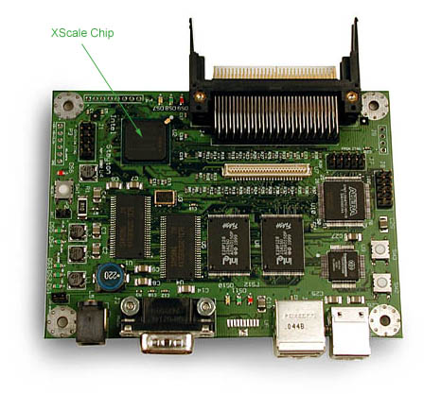
Figure 1. Stayton development board (the Computer). Photo: Acroname, Inc.
The following is the list of technical specifications of the Computer:

- 400 MHz Intel® XScale processor (PXA-250)
- 64 MB SDRAM
- 32 MB Flash EPROM
- 2 USB host and 1 slave interfaces
- 2 PCMCIA slots
- Serial port
- Berkeley Mote interface

We were really excited to have a chance to use this device: a single board only 3½ by 4½ inches that had enough computing capability to run a full version of the Linux operating system, in addition to quite advanced computer vision algorithms as we are about to show.

Image Acquisition

Universal Serial Bus (USB) makes it possible to connect a variety of devices to the PC’s, and since its introduction in 1996 has become a standard component of computer systems. Many cameras that use this interface were developed and by now have become quite inexpensive. For our work, we had to choose a camera that was of high enough quality to support our special purposes, inexpensive enough so that it would be accessible to amateur groups as well as professionals, and well supported by the Linux operating system. In our collaboration with the Stayton project team at Intel Corp., we have converged on using Logitech QuickCam 4000 Pro.

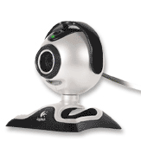
Figure 2. Logitech QuickCam 4000 Pro. Photo: Logitech

We found the following specifications suitable for our applications:
- Video capture: Up to 640 x 480 pixels (VGA CCD)
- Still image capture: Up to 1280 x 960 pixels, 1.3 megapixels
- Digital Zoom
- Built-in Microphone

The most appealing feature of the camera was the CCD video sensor (by Phillips) that supports good video resolution. This camera is supported by the popular pwc Linux driver, starting with OS kernel version 2.4.19.

The XScale processor is especially well suited for image acquisition because of built-in support for USB. The two pins on the processor package, UDC- and UDC+, can be connected directly to a USB slave (client) connector and enable USB connectivity of the device. However, in order to enable the Computer to connect to other USB clients like cameras, a host interface was implemented using TransDimension UHC124 host controller. The drivers for this part are under development by the Intel team. Currently, the Computer has the first version of these drivers installed, and, while they work just fine, the image acquisition speed is not yet optimal. Since most of the experiments described henceforth rely on the rate of incoming video data, we expect that with later versions of USB controller drivers, the performance numbers for our tests will be even better.

Initially we created experiments to test the achievable frame rates using the camera alone, without doing any processing on the video data that we get. These and the following tests have been conducted at two different camera resolutions: 352 by 288 (this is an optimal resolution that we found represents a good tradeoff of the amount of information in the image and the speed of processing), and 640 by 480 (the maximum supported by the camera). Similarly, in most of the tests, the performance of the 400MHz XScale based Computer is compared to a desktop computer with a Pentium II running at 366MHz (Desktop). The reason for this comparison is our interest in knowing whether and by how much the efficiency of a generic desktop system exceeds that of our mobile Computer. Most of the software libraries that we considered have been successfully tested on desktop computers. It is in its relationship to power efficient XScale that our task is novel, so we will regard the performance of the Desktop as a benchmark for our tests.

The table below shows the results of continuous reading of the camera with no processing

 | 352 by 288 | 640 by 480
Computer | 3.33 fps | 0.60 fps
Desktop | 10.0 fps | 10.0 fps

Table 1. Comparison of image acquisition frame rates.

The difference in the affect of resolution on frame rate in both computers can be explained with the following observation. It was noted that basic copying operations take much longer on Computer than on Desktop: for example, if we consider one operation the copying of a 352 by 288 image in YUV420P color mode (152,064 bytes), then Desktop can perform roughly 3,100 such operations per second, while Computer does only 260. For comparison, an iPAQ (from handhelds.org ipaq cluster) accomplished 270 operations per second, and a 2.4GHz server in the lab did 37,037. Thus, since basic memory copying takes longer on Computer, it seems reasonable that increasing image area would produce a perceivable slow down. At the same time, however, we noticed that both methods of acquiring an image as supported by Video4Linux specification, the read system call and mmap, produced very much identical frame rates on both systems.

Basic Image Manipulation

Resizing/Rotation

Now we will proceed to the discussion of basic image operations and see how well the Computer is suited for them. We have conducted many tests using various software libraries that were successfully made to work on the Computer. Among all of the tests, only those are mentioned here and below that exceed all the other ones in performance. For this particular group of operations we chose to show the results with OpenCV. Resizing and especially rotation are complex image operations as well as very computationally expensive especially if applied to full color images.

In the present experiment, we again have to restrict our discussion to two image resolutions: 352 by 288 and 640 by 480. The images we have used we full color 24-bit RGB images. An example is reproduced below.

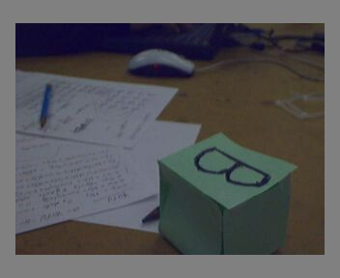

Figure 3. An example of the image with various objects in the field of view. Such images are often the view of a mobile robot.

The results we found are presented below:

 | 352 by 288 | 640 by 480
Computer | 0.63 ops | 0.20 ops
Desktop | 40.83 ops | 13.69 ops

Table 2. Comparison of resizing/rotation (in operations per second)

Here “ops” stands for “operations per second”, where each operation consisted of rotating the image by 30 degrees and reducing its size by about 10%. As we can see, the performance of Computer is only about 1.5% of that of Desktop in this case. It has to be noted, however, that OpenCV itself heavily relies on floating point arithmetic, which in general is the weakest part of the XScale processor as it doesn’t support floating point in hardware for power consumption reasons. Therefore, all such operations are emulated in software, and hence the slow-down.

It is important to note the correlation of calculation speed to the area of the image. The image at the resolution of 352 by 288 pixels contains the total of 101,376 pixels, whereas the image at 640 by 480 contains 307,200, which is about 3.03 times greater. Interestingly enough, here and in the further test cases, it takes almost exactly 3 times longer to process the bigger size image versus the smaller one. In this experiment, this is best visible with operations per second value for the Computer: it is 3.15 less for the larger size.

Regardless of slower performance of Computer on this particular operation, we believe that this functionality can still be a part of a successful vision system based on this platform. Most of the time, it is not necessary to process the entire image, but rather a much smaller region of interest (ROI). The latter is usually obtained by preprocessing stages that eliminate unwanted image information. Then, say for example, that our ROI was reduced to a square of 100 by 100 pixels (which is still a generous estimate). Then the new ROI area will be 10,000, which is roughly 10 times less than the area of a 352 by 288 image. If the computational performance will continue to be inversely proportional to image area, then we should be able to achieve the speed of 6.3 ops on Computer. This is a sufficient speedup to consider this particular functionality as a tool in the arsenal needed to create a successful implementation of a mobile computer vision system.

Color Space Conversion

Another task that requires a great deal of floating point arithmetic is conversion between color spaces. The popular and probably most intuitive is the Red-Green-Blue color space (RGB). In this space, each color pixel is represented by three numbers that give the pixel’s value of red, green, and blue colors. However, in some areas of video technology it is most useful to use other color spaces. One very popular one is called YUV, also denoted by BrCrCb, where Y or Br stands for brightness, and the others for two separate components of color. In particular, a wide variety of video capture hardware, including our Logitech camera, captures images in YUV color space. It was designed this way simply because it makes it easier to implement in current electronics technology.

When the driver for the Logitech 4000 camera instructs the camera to capture the image, the camera returns this image in one specific format, called YUV420P. The first width times height pixels of the image in this format contain all the Y (brightness bytes), that is a separate Y values (bytes) for each pixel. After that follow U data bytes, and their total number is four times less than Y bytes. Thus, each square block of four adjacent pixels shares the same U byte value. After that, there are V bytes, in the same number and manner as the U bytes. Besides convenience in hardware implementation, this video format is beneficial in that it compresses the image by saving on storage required for U and V channels. At the same time, the choice of representing the brightness (Y) channel in its entirety is not coincidental. Through experiments on human and animal visual perception, it has been determined that brightness plays a far more important role in perceiving color, than chrominance (i.e. U and V values). Thus, these findings were utilized in computer technology through implementing video formats that allow fair data compression without losing its quality.

In addition, this format is especially convenient if we only need to obtain the grayscale image, and color doesn’t matter (quite a few popular image recognition algorithms fall into this category). In this case, we do not need to perform any expensive conversion operations, and instead can grab the first chunk of the image, i.e. all its brightness values, and acquire a fairly accurate representation of the whole image.

However, when the task at hand calls for obtaining RGB color information, such as to store the image and display it on a monitor, YUV420P to RGB conversion has to be made. Again, we have designed experiments to determine which approach for this task is most efficient for the Computer. Below is the report of conversion performance which was obtained by using one of the color space conversion functions offered as part of the Video4Linux implementation.

 | 352 by 288 | 640 by 480
Computer | 14.29 ops | 3.23 ops
Desktop | 55.25 ops | 17.89 ops

Table 3. Comparison of YUV420P to RGB conversion (in operations per second)

Here, the performance of Computer is quite good. This observation is important in the design of vision on robotics systems. Very often it is convenient to visualize either the whole field of view of the robot, or a particular region of interest. This result indicates that for smaller to average image sizes, it is possible to insert image visualization steps (primarily useful for debugging) quite liberally without taking significant penalties in performance.

Image Analysis

Thresholding

Thresholding is one of the simplest and most popular image analysis operations. It usually operates on grayscale images, although can easily be extended to more color channels. The essence of this technique lies in locating in the image the regions of particular brightness. The method discards all pixels that fall outside a predefined threshold (sets their values to 0, i.e. black color), and indicates the pixels that meet the criteria (sets them to some defined color, for example white). An example of this operation is presented below.

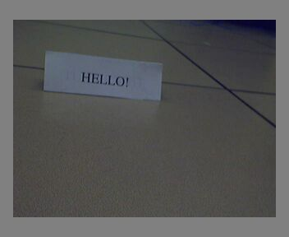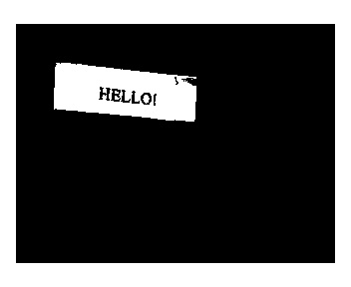

Figure 4. Image thresholding: before and after.

As can be seen from the pictures, this operation removes unwanted elements of an image and leaves in only those regions that fit within the predefined threshold. This operation is very useful in pre-processing, when the image is prepared for further work by other algorithms. In this case, if, say, we wanted to implement optical character recognition, then we could use thresholding above to enhance the contrast of the text.

The experiments with thresholding used its implementation in OpenCV. Below we provide the numerical results.

 | 352 by 288 | 640 by 480
Computer | 212.77 ops | 70.92 ops
Desktop | 376.36 ops | 104.17 ops

Table 4. Comparison of thresholding (in operations per second)

Thus, this operation is clearly quite inexpensive on both types of computers. Our Computer does pretty well here: for smaller resolution, it speed is 56% of Desktop, and for the larger resolution it is the whole 68%. We believe that one of the reasons for this success is the fact that thresholding as implemented in OpenCV operates on grayscale images, so there is less data to process. More importantly, it is a simple operation that does not require floating point operations; by seeing that Computer is quite fast compared to Desktop when there is no need for floating point reaffirms the fact that as long as these operations are avoided, Computer will perform just about as well as a Desktop.

Edge Detection

This operation is more complicated than the previous one as it locates the transitions between areas of the similar color. This technique is especially useful in low contrast images as it enhances the edges between the objects. Most implementations of this method require a lot more calculations than in the previous example, including the floating point.

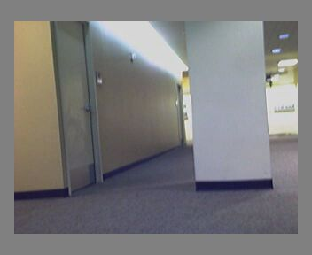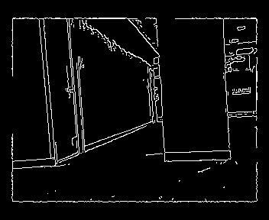

Figure 5. Edge detection: before and after.

Any variation in color that meets preset parameters is regarded as an edge between the regions; such edges are highlighted in the output image. Clearly, this is another useful tool for pre-processing, and can be used as part of the vision system for a mobile robot that roams the halls of a building.

OpenCV library implements Canny’s algorithm for edge detection, and again was chosen for our experiments with this operation. Below follow our results:

 | 352 by 288 | 640 by 480
Computer | 8.28 ops | 2.35 ops
Desktop | 18.15 ops | 6.21 ops

Table 5 Comparison of edge detection (in operations per second)

This routine clearly is quite a bit more computationally demanding than the previous one. However, regardless of greater use of floating point, performance of Computer is still not far behind from a Desktop computer of the same clock frequency, and constitutes slightly less than 50% of that. This is a very encouraging result, as it indicates that we can do edge detection on a full frame image at quite reasonable frame rates.

Hough Transform

This is an extension of previous examples and is considered as one of the most advanced building blocks in machine vision. The Hough transform is designed to locate straight lines in an image (e.g. the edge detection output above), and to return an algebraic equation for each line it finds. Needless to say, this is an incredibly important tool, as it transfers recognition task from the raster image to the vector domain, thereby greatly simplifying the task.

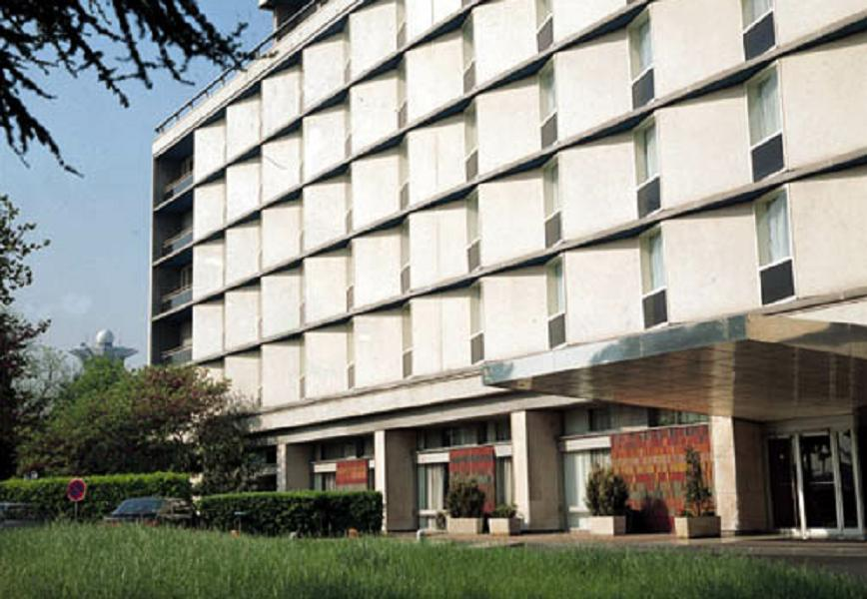

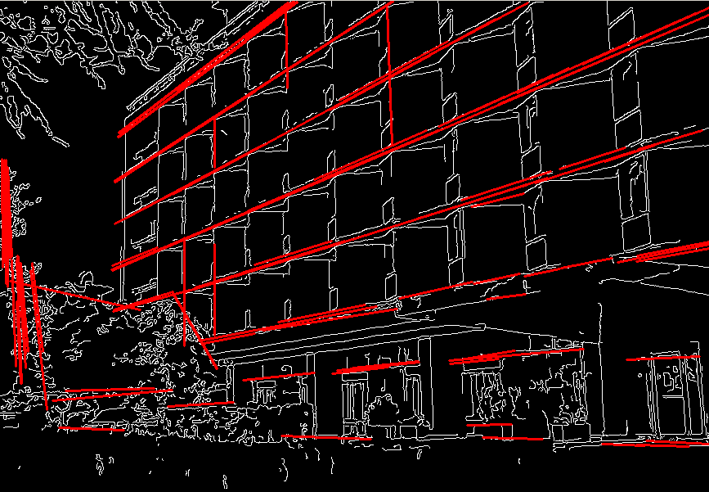
Figure 6. Hough transform results
It was a bit tricky to get everything right so that this would work correctly, but we managed to conduct a series of tests that give a good idea of the complexity of this algorithm. As can be seen below, this method is not a forte of the Computer.

 | 352 by 288 | 640 by 480
Computer | 0.033 ops | 0.015 ops
Desktop | 3.21 ops | 1.42 ops

Table 6. Comparison of Hough transform (in operations per second)

Certainly, even the average Desktop has a hard time keeping up with computational demands of this routine implemented in OpenCV. However, such a calculation probably requires much more resources than the Computer can provide: not only the floating point is a difficulty, but also demands on memory are certainly significant. While the Desktop and the Computer have processors of similar clock rate, the amount of memory on most Desktops of this class is certainly greater than the 64MB currently available on the Computer.

Nevertheless, performing the Hough transform on smaller regions of interest remains a possibility and might actually provide a workable solution, especially if the speed of this particular stage of processing is not the first requirement.

Color Segmentation

This technique is an extension of thresholding, and it allows to locate the coordinates of color blobs of a particular color in the image. There are several reasons why it became a very popular tool for computer vision. Usually when the task is to track a particular object, the object itself is somewhat different from its environment. If the difference of its color is pronounced, then this problem can be solved by simply tracking the color of the object. Provided the frame rate of the color segmentation implementation is faster than motion of the object, the system can easily track the trajectory of the object as long as it is within the field of view.

Indeed, quite fast implementations of this principle have been created, and thus constitute the second reason for its popularity. In our tests, we gave favor to the CMVision library. The most appealing aspect of this particular implementation was its heavy use of bitwise logical operators, which are known to be faster than arithmetic operations as well as logical branches. Certainly, relatively low use of floating point operations was also attractive.

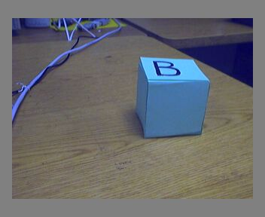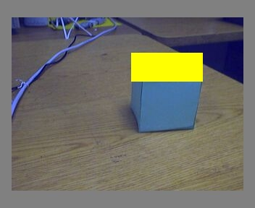

Figure 7. Color segmentation using CMVision

Although setting up correct thresholds for CMVision is a delicate process, once it is done well, the software can recognize the slightest shades of color. As in the example above, the thresholds were tuned to match precisely the top side of the cube, while its other sides (which are of the same color, but happen to be slightly darker due to less reflection of overhead light), and other blue objects all were determined to be different enough in color that they were not selected. CMVision and similar programs have been used, among other things, in systems with overhead cameras such as robotics soccer, systems to record insect behavior, etc.

In our tests, we obtained rather favorable results as well.

 | 352 by 288 | 640 by 480
Computer | 20.83 ops | 6.71 ops
Desktop | 89.67 ops | 24.23 ops

Table 7. Comparison of Color Segmentation (in operations per second)

We were especially pleased to see fairly good performance of the Computer on this test because similar color segmentation forms one of the initial stages of image preprocessing. Thus, it is important to pass through this phase quickly. For example, similar positioning of a color patch can already serve as a delimiter of the region of interest, if we know a priori what colors dominate in the object to which we would like to pay special attention.

Structural Analysis

Now that we have discussed the image analysis techniques that can be utilized in computer vision systems in mobile robotics, the stage is set for consideration of higher level operations. They will enable us to combine the elements that we are already able to extract from images into some knowledge about it. At this point we assume that the information we require for the following discussion is available from previous steps.

Contour Processing

One of the most popular image recognition methods in this category that we have considered involves finding arbitrary contours in images and reporting their coordinates in the image system of coordinates. Having this knowledge about the image is very useful as it allows us to make some definite conclusions about the world as the robot sees it. Contours do not have to be straight lines or any other defined geometrical shapes. What is important is that now we can report to the higher level layer of robot control software all general shapes that are present in the image as well as answer questions about presence or absence of particular shapes. Thus, this is a crucial step that can further enable us to recognize either geometrical objects in the field of view (or things looking like them), or more complex shapes like gestures or faces.

We found that OpenCV contains a far better implementation of this algorithm than other software we tried. Since in our tests we were mostly interested in comparing our special miniature Computer to a generic Desktop of roughly the same CPU clock frequency (albeit all other their features were completely different, including power consumption), it sufficed for us to consider a simple test image. Therefore, we chose an example of a region of interest that contained only one object that looked like a geometrical shape.

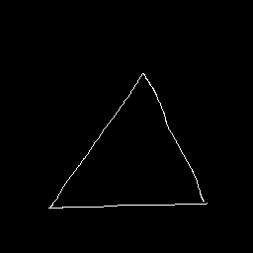

Figure 8. A test example for contour processing.

The size of this test image was 256 by 256 pixels, which again is a generous estimate of a size of region of interest. Note also that the shape above deliberately has been chosen to contain only the rough outlines of the triangle. This is important, as almost always the image preprocessing steps and the image itself are less than perfect, and so even if the robot sees a “correct” shape with straight edges, this can no longer be said of the representation of the image within the memory of the computer. Thus, our algorithms must be able to deal with a certain degree of imperfections. In other words, our conclusions about the image must be invariant of a particular view, camera calibration, image noise, jitter, etc.

The task of this particular stage in contour processing was to identify the image coordinates of major contours in the image. It is probably easiest to demonstrate this concept by showing the results of this processing on our example.

First, we will determine the image coordinates (in pixels) of points of interest, in this case the vertices of the triangle.

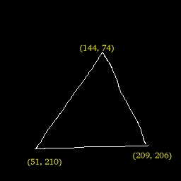

Figure 9. Test image with vertices shown.

This will help us situate our evaluation that follows. When the test program that uses OpenCV implementation of the algorithm for locating the contours completes, we can examine the memory of the program and see the results of the calculation. On the next page we present a screenshot of the debugging environment that we used for this program (ddd). The memory display window (upper center) identifies the coordinates that the program retrieved.

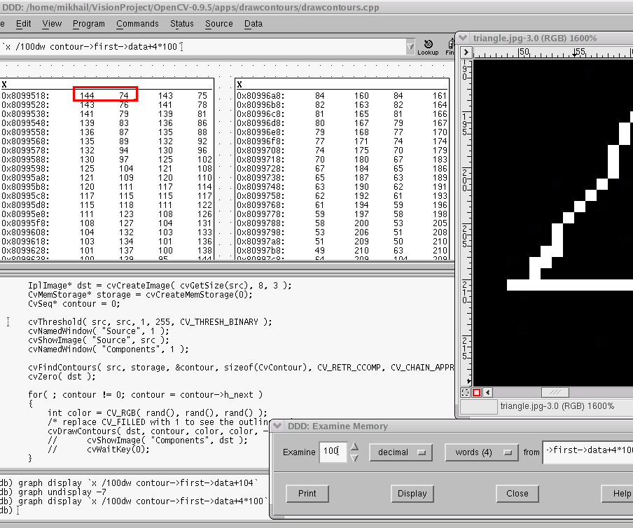

Figure 10. View of memory of contour processing program. The coordinates that were located are displayed, along with a portion of enlarge view of the test object.

This particular algorithm returns coordinates of each non-straight line segment. Since, as was mentioned, the test picture contains very few straight lines, there are quite a few points that the algorithm located (in this particular test we have obtained 383). On the picture, the red box indicates the first coordinate in the memory buffer (width coordinate followed by height). As we can see by comparing to Figure 9, this is exactly the upper vertex of the triangle. The coordinates that follow denote the points that lie on the left side of the triangle.

As we discussed, this is a very useful algorithm in image recognition, and one that is quite well implemented in the OpenCV vision library that we have ported to the Computer and made available for public use through our website. Now let us see how well this algorithm executes on the Computer.

 | 352 by 288 | 640 by 480
Computer | 29.31 ops | 10.11 ops
Desktop | 323.82 ops | 85.21 ops

Table 8. Comparison of Contour Finding (in operations per second).

Clearly, this is again a quite inexpensive operation both on the Computer and the Desktop. As we will see shortly, it will enable us to draw important conclusions about the contents of images quite efficiently.

Polygonal Approximation

In this series of tests, we take further the concepts developed so far, and demonstrate an example of retrieving higher level image information in the form of polygons. This experiment is based entirely on the previous one and uses the same input test image. We again will proceed with demonstration of its operation to quickly get across the idea.

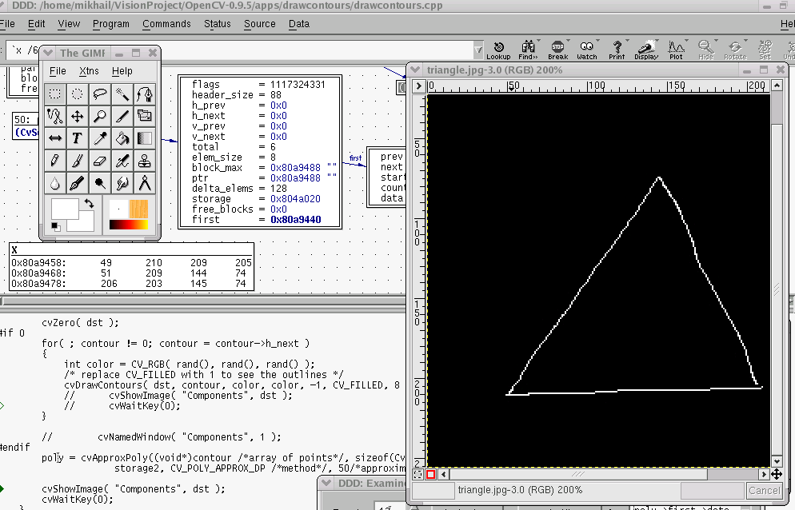

Figure 11. View of memory of polygonal approximation test program (left middle).
The memory output itself is visible in small wide window in the left middle of the screen shot. As we can see, there are exactly 6 points that are represented, which actually are the end points of the three sides. For example, there are two points (144, 74) and
(145, 74), which are exactly the coordinate of the top vertex; there are two points because there are two different lines that begin and end at the same place.

Thus, we see the essence of image recognition: from a magnitude of various pixels, we are able to extract certain knowledge about the image, in this case that there are three interconnected lines, what we call a triangle. From 256*256 points of the entire image, this program reports only 6 points, just the ones that are interesting to us, or in this case to a robot. In this manner, many interesting demonstrations can be constructed, for example a small mobile robot with the Computer on board can roam an area and differentiate between objects that belong to several geometrical shapes.

This sounds like an involved and complex operation of the caliber of the Hough transform. However, the timing tests of this operation show that its implementation in OpenCV that we used is really quite efficient. Below is our test data.

 | 352 by 288 | 640 by 480
Computer | 101.42 ops | 40.57 ops
Desktop | 6330.0 ops | 1710.8 ops

Table 9. Comparison of Polygonal Approximation (in operations per second).

A quick comparison with most of the other tests will show that is indeed a very fast operation. The primary reason for that, we believe, is that the input to polygonal approximation algorithm is no longer a raw image, but the list of contours that were extracted from the method described in the previous section. Thus, there is much less data to go through, and the task of shape recognition is reduced to finding the end points of these contours. What also undoubtedly helps is the relative simplicity of the test image, as it contains only one shape. However, it is not too far removed from reality as with good preprocessing and region of interest extraction, it may be possible to reduce the scope of this algorithm just to the shape in question.

Therefore, image recognition can be done quite efficiently on the Computer. Even though its speed still is less than that of a generic Desktop, the rates of operations per second that we have seen so far suggest that it is possible to pull together many popular tools for image recognition and create a robust vision system based on the Computer. And, of course, the main benefit of this solution that its power consumption is so minute that the entire Compute system can be installed on a mobile robot, and can carry out its operations completely autonomously.

Conclusion

The objective of this work was to demonstrate that embedded processing technology, in particular the latest Intel XScale processor, has developed well enough to make it useable for implementing a computer vision system adequate for mobile robotics. We support our argument with a variety of timing tests of implementations of various algorithms that are important components of vision systems. Each class of these image processing elements is treated separately. At least one of its implementations has been reported in detail and found suitable for the use on the embedded computer devices. Those algorithm implementations that were found to be still too intensive computationally, for example the Hough transform, were also discussed, together with probable causes for such difficulties.

Thus, besides supporting our argument for the availability of suitable computer vision software for the XScale, the present report can also serve as a guide to a vision system designer. Our discussion of popular computer vision software packages like OpenCV, CMVision, and others, in addition to the analysis of their components that work well and those that are still too slow, will help the designer choose just the tools that have been proven to work, and save time by eliminating trial and error on their part. We hope that this aspect of our work will benefit other developers in the open source community, professionals and amateurs alike.

Up until very recently, it was both very difficult and expensive to create a computing device powerful enough to support appropriate image recognition and capable of operating on an autonomous mobile robot. However, the latest advances in technology have created unique computing devices that are small in size and power consumption, yet powerful enough to support modern operating systems and other advanced software. The essence of our contribution was to prove empirically that computer vision is also practical, provide a detailed discussion of how it could be used, and add this category to this list of supported software. It is our hope that recommendations and explanations of the present work will facilitate the application of computer vision in the realm of embedded computing and will further popularize vision and robotics.

Bibliography

“Amigobot.” n. pag. Online: www.amigobot.com. 11 Nov. 2002. Available HTTP: www.amigobot.com

“CMVision.” n. pag. Online. www.cs.cmu.edu. 11 Nov. 2002. Available HTTP: www-2.cs.cmu.edu/~jbruce/cmvision

Earl, L. L., Robinson, H. R. Automatic informative abstracting and extracting. Detroit: Management Information Services, 1970.

“Open Computer Vision Library.” n. pag. Online. sourceforge.net. 22 Aug. 2001. Available HTTP: http://sourceforge.net/projects/opencvlibrary/

“Publications.” n. pag. Online. www.ri.cmu.edu. 11 Nov. 2002. Available HTTP: www-2.cs.cmu.edu/~illah

“Saphira 8.1.” n. pag. Online. www.activmedia.com. 11 Nov. 2002. Available HTTP: robots.activmedia.com/Saphira

“SAPHIRA Robot Control System.” n. pag. Online. www.ai.sri.com. 11 Nov. 2002. Available HTTP: www.ai.sri.com/~konolige/saphira

“VxL Homepage.” n. pag. Online. vxl.sourceforge.net. 12 Jul. 2001. Available HTTP: vxl.sourceforge.net/
Appendix

In this portion we provide code examples that have been utilized in most of the experiments. These samples of code can also be utilized to construct similar tests or to actually be used in construction of mobile robots based on the Computer.

We made our best effort to make the code as readable as possible. Since all of our work is distributed freely within the open source community for the benefit of expansion of interest in robotics, we will value any comments and suggestions. Please forward your requests to mikhail@ece.pdx.edu.
Rotation/Resizing Example

#include <stdio.h>
#include <time.h>
#include <signal.h>
#include "cv.h"
#include "highgui.h"
#include "math.h"

#define REPS 100

int time2quit;

void quithandler(int i)
{
time2quit=1;
return;
}

int main( int argc, char** argv )
{
IplImage* src;
/* the first command line parameter must be image file name */
if( argc==2 && (src = cvLoadImage(argv[1], -1))!=0)
{
IplImage* dst = cvCloneImage( src );
int delta = 1;
int angle = 0;
float m[6];
double factor;
int w, h, i;
time_t then, now;
CvMat M;
time2quit=0;
signal(SIGINT, quithandler);
signal(SIGKILL, quithandler);

cvNamedWindow( "src", 1 );
cvShowImage( "src", src );
// cvNamedWindow( "dst", 1 );
while(!time2quit) {
time(&then);
for(i=0; i<REPS; i++)
{
factor = (cos(angle*CV_PI/180.) + 1.1)*3;
M = cvMat( 2, 3, CV_32F, m );
w = src->width;
h = src->height;

m[0] = (float)(factor*cos(-angle*2*CV_PI/180.));
m[1] = (float)(factor*sin(-angle*2*CV_PI/180.));
m[2] = w*0.5f;
m[3] = -m[1];
m[4] = m[0];
m[5] = h*0.5f;

cvGetQuadrangleSubPix( src, dst, &M, 1, cvScalarAll(0));

// cvNamedWindow( "dst", 1 );
// cvShowImage( "dst", dst );

// if( cvWaitKey(5) == 27 )
// break;

angle = (angle + delta) % 360;
}
time(&now);
printf("%f ops\n", ((float)REPS/(now-then)));
} // end whilex
}
return 0;
}

Color Space Conversion Example

#include <stdio.h>
#include <stdlib.h>
#include <signal.h>
#include <string.h>
#include <getopt.h>
#include <sys/types.h>
#include <sys/stat.h>
#include <sys/ioctl.h>
#include <sys/mman.h>
#include <sys/time.h> /* gettimeofday() */
#include <fcntl.h>
#include <unistd.h>
#include <linux/types.h>
#include <linux/videodev.h>
#include <zlib.h>
//#include <png.h>
#include <jpeglib.h>
#include "v4l.h"

#define QUAL_DEFAULT 80

#define IMAGEFILE "input.dat"
//#define WIDTH 352
//#define HEIGHT 288

#define WIDTH 640
#define HEIGHT 480

int v4l_yuv420p2rgb (unsigned char *rgb_out, unsigned char *yuv_in,
int width, int height, int bits);

void
put_image_jpeg (FILE *out, char *image, int width, int height, int quality, int palette)
{
int y, x, line_width;
JSAMPROW row_ptr[1];
struct jpeg_compress_struct cjpeg;
struct jpeg_error_mgr jerr;
char *line;

line = malloc (width * 3);
if (!line)
return;
//if (verbose)
fprintf (stderr, "writing JPEG data\n");
cjpeg.err = jpeg_std_error(&jerr);
jpeg_create_compress (&cjpeg);
cjpeg.image_width = width;
cjpeg.image_height= height;
if (palette == VIDEO_PALETTE_GREY) {
cjpeg.input_components = 1;
cjpeg.in_color_space = JCS_GRAYSCALE;
// jpeg_set_colorspace (&cjpeg, JCS_GRAYSCALE);
} else {
cjpeg.input_components = 3;
cjpeg.in_color_space = JCS_RGB;
}
jpeg_set_defaults (&cjpeg);
jpeg_set_quality (&cjpeg, quality, TRUE);
cjpeg.dct_method = JDCT_FASTEST;
jpeg_stdio_dest (&cjpeg, out);

jpeg_start_compress (&cjpeg, TRUE);
row_ptr[0] = line;
if (palette == VIDEO_PALETTE_GREY) {
line_width = width;
for ( y = 0; y < height; y++) {
row_ptr[0] = image;
jpeg_write_scanlines (&cjpeg, row_ptr, 1);
image += line_width;
}
} else {
line_width = width * 3;
for ( y = 0; y < height; y++) {
for (x = 0; x < line_width; x+=3) {
line[x] = image[x+2];
line[x+1] = image[x+1];
line[x+2] = image[x];
}
jpeg_write_scanlines (&cjpeg, row_ptr, 1);
image += line_width;
}
}
jpeg_finish_compress (&cjpeg);
jpeg_destroy_compress (&cjpeg);
free (line);
}

int time2quit;

void quithandler(int i)
{
time2quit=1;
return;
}

#define REPS 10000

int main()
{
time2quit=0;
FILE *fin, *fout;
unsigned char yuv_in[WIDTH*HEIGHT*2];
unsigned char rgb_out[WIDTH*HEIGHT*3];
struct video_picture vid_pic;
struct video_window vid_win;
time_t then, now;
int i;
// fin = fopen(IMAGEFILE, "r");
//fprintf(stderr, "starting main");
signal(SIGINT, quithandler);
signal(SIGKILL, quithandler);
int dev = open("/dev/video0", O_RDWR);
if (dev < 0)
return 0;
// fprintf(stderr, "starting main");
//fout = fopen("/var/output.jpg", "w");
// fout = fopen("/usr/local/ahd/htdocs/output.jpg", "w");
// fout = fopen("/var/jpgdump.jpg", "w");
ioctl(dev, VIDIOCGWIN, &vid_win);
ioctl(dev, VIDIOCGPICT, &vid_pic);
fprintf(stderr, "current camera settings: %dx%d, mode %d\n", vid_win.width, vid_win.height, vid_pic.palette);
vid_pic.palette = 15; //YUV420P
vid_win.width = WIDTH;
vid_win.height = HEIGHT;
ioctl(dev, VIDIOCSWIN, &vid_win);
ioctl(dev, VIDIOCSPICT, &vid_pic);
fprintf(stderr, "starting read\n");
//while(!time2quit) {
fprintf(stderr, "read in %d bytes\n", read(dev, (void*)yuv_in, WIDTH*HEIGHT*3));
fprintf(stderr, "end read\n");

// Now starting the test:
while(!time2quit) {
time(&then);
for(i=0; i<REPS; i++) {
v4l_yuv420p2rgb(rgb_out, yuv_in, WIDTH, HEIGHT, 24);
}
time(&now);
printf("%f ops\n", ((float)REPS/(now-then)));
}
// put_image_jpeg(fout, rgb_out, WIDTH, HEIGHT, QUAL_DEFAULT, VIDEO_PALETTE_RGB24);

// fclose(fout);
close(dev);
return 0;
}

Thresholding Example

#include <stdio.h>
#include <stdlib.h>
#include <signal.h>
#include <string.h>
#include <getopt.h>
#include <sys/types.h>
#include <sys/stat.h>
#include <sys/ioctl.h>
#include <sys/mman.h>
#include <sys/time.h> /* gettimeofday() */
#include <fcntl.h>
#include <unistd.h>
#include <linux/types.h>
#include <linux/videodev.h>
#include <time.h>
//#include <zlib.h>
//#include <png.h>
//#include <jpeglib.h>
//#include "v4l.h"
#include "cvcam.h"
#include "highgui.h"
#include "csdemoview.h"

#define QUAL_DEFAULT 80

#define IMAGEFILE "input.dat"
//#define WIDTH 352
//#define HEIGHT 288
#define WIDTH 640
#define HEIGHT 480

int time2quit;

void quithandler(int i)
{
time2quit=1;
return;
}

#define REPS 10000

int main(int argn, char *argv[])
{
time2quit=0;
int i;
time_t now, then;
FILE *fin, *fout;
float threshold=0.4, maxValue=1.0;
unsigned char in_img[WIDTH*HEIGHT*2];
unsigned char out_img[WIDTH*HEIGHT*3];
struct video_picture vid_pic;
struct video_window vid_win;
// fin = fopen(IMAGEFILE, "r");
//fprintf(stderr, "starting main");
if (argv[1]<=0) {
fprintf(stderr, "provide to arguments, threshold1 and threshold2\n");
return 0;
}
threshold = atof(argv[1]);
maxValue = atof(argv[2]);
printf("arguments: %f and %f\n", threshold, maxValue);
signal(SIGINT, quithandler);
signal(SIGKILL, quithandler);
int dev = open("/dev/video0", O_RDWR);
if (dev < 0)
return 0;
// fprintf(stderr, "starting main");
//fout = fopen("/var/output.jpg", "w");
//fout = fopen("rawdump.dat", "w");
ioctl(dev, VIDIOCGWIN, &vid_win);
ioctl(dev, VIDIOCGPICT, &vid_pic);
fprintf(stderr, "current camera settings: %dx%d, mode %d\n", vid_win.width, vid_win.height, vid_pic.palette);
vid_pic.palette = 15; //YUV420P
vid_win.width = 352;
vid_win.height = 288;
ioctl(dev, VIDIOCSWIN, &vid_win);
ioctl(dev, VIDIOCSPICT, &vid_pic);
fprintf(stderr, "starting read\n");

fprintf(stderr, "read in %d bytes\n", read(dev, (void*)in_img, WIDTH*HEIGHT*3));
close(dev);
//v4l_yuv420p2rgb(out_img, in_img, WIDTH, HEIGHT, 24);
//Image available here.
//Do canny edge detect.

// make IplImage out of raw data:
// IplImage *image = icvVideoGetImage(cameraid);
{
IplImage *image, *edges;
// IplImage *image, edges[WIDTH*HEIGHT*3];
CvSize size;
int depth = 8; //for monochrome?

size.width = WIDTH;
size.height = HEIGHT;
image = cvCreateImageHeader(size,IPL_DEPTH_8U,depth/8);
edges = cvCreateImageHeader(size,IPL_DEPTH_8U,depth/8);
cvSetImageData(image, in_img, size.width*(depth/8));
cvSetImageData(edges, in_img, size.width*(depth/8));
// IplImage should be ready at this point.
// ration of threshold1 to threshold2 should be 2 (or 3) to 1
// fprintf(stderr, "before canny\n");
// cvCanny(image, edges, threshold1, threshold2, 3); //to call Canny Edge detector
//void cvThreshold( const CvArr* src, CvArr* dst, double threshold,
// double maxValue, int thresholdType );

while(!time2quit) {
time(&then);
for(i=0; i<REPS; i++) {
cvThreshold(image, edges, threshold, maxValue, CV_THRESH_BINARY);
}
time(&now);
printf("%f ops\n", ((float)REPS/(now-then)));
}

// cvSaveImage("/var/edges.jpg", edges);
}

//write out jpeg of resulting image:
// put_image_jpeg(fout, out_img, WIDTH, HEIGHT, QUAL_DEFAULT, VIDEO_PALETTE_RGB24);
// fwrite((void*)in_img, 1, WIDTH*HEIGHT*1.5, fout);

//fclose(fout);

return 0;
}

Edge Detection Example

#include <stdio.h>
#include <stdlib.h>
#include <signal.h>
#include <string.h>
#include <getopt.h>
#include <sys/types.h>
#include <sys/stat.h>
#include <sys/ioctl.h>
#include <sys/mman.h>
#include <sys/time.h> /* gettimeofday() */
#include <fcntl.h>
#include <unistd.h>
#include <linux/types.h>
#include <linux/videodev.h>
#include <time.h>
//#include <zlib.h>
//#include <png.h>
//#include <jpeglib.h>
//#include "v4l.h"
#include "cvcam.h"
#include "highgui.h"
#include "csdemoview.h"

#define QUAL_DEFAULT 80

#define IMAGEFILE "input.dat"
//#define WIDTH 352
//#define HEIGHT 288
#define WIDTH 640
#define HEIGHT 480

int time2quit;

void quithandler(int i)
{
time2quit=1;
return;
}

#define REPS 300

int main(int argn, char *argv[])
{
time2quit=0;
int i;
time_t now, then;
float threshold1=50, threshold2=70;
FILE *fin, *fout;
float threshold=0.4, maxValue=1.0;
unsigned char in_img[WIDTH*HEIGHT*2];
unsigned char out_img[WIDTH*HEIGHT*3];
struct video_picture vid_pic;
struct video_window vid_win;
// fin = fopen(IMAGEFILE, "r");
//fprintf(stderr, "starting main");
if (argv[1]<=0) {
fprintf(stderr, "provide to arguments, threshold1 and threshold2\n");
return 0;
}

threshold1 = atof(argv[1]);
threshold2 = atof(argv[2]);
printf("arguments: %f and %f\n", threshold, maxValue);
signal(SIGINT, quithandler);
// signal(SIGKILL, quithandler);
int dev = open("/dev/video0", O_RDWR);
if (dev < 0)
return 0;
// fprintf(stderr, "starting main");
//fout = fopen("/var/output.jpg", "w");
//fout = fopen("rawdump.dat", "w");
ioctl(dev, VIDIOCGWIN, &vid_win);
ioctl(dev, VIDIOCGPICT, &vid_pic);
fprintf(stderr, "current camera settings: %dx%d, mode %d\n", vid_win.width, vid_win.height, vid_pic.palette);
vid_pic.palette = 15; //YUV420P
vid_win.width = WIDTH;
vid_win.height = HEIGHT;
ioctl(dev, VIDIOCSWIN, &vid_win);
ioctl(dev, VIDIOCSPICT, &vid_pic);
fprintf(stderr, "starting read\n");

fprintf(stderr, "read in %d bytes\n", read(dev, (void*)in_img, WIDTH*HEIGHT*3));
close(dev);
//v4l_yuv420p2rgb(out_img, in_img, WIDTH, HEIGHT, 24);
//Image available here.
//Do canny edge detect.

// make IplImage out of raw data:
// IplImage *image = icvVideoGetImage(cameraid);
{

IplImage *image, *edges;
// IplImage *image, edges[WIDTH*HEIGHT*3];
CvSize size;
int depth = 8; //for monochrome?

size.width = WIDTH;
size.height = HEIGHT;
image = cvCreateImageHeader(size,IPL_DEPTH_8U,depth/8);
edges = cvCreateImageHeader(size,IPL_DEPTH_8U,depth/8);
cvSetImageData(image, in_img, size.width*(depth/8));
cvSetImageData(edges, in_img, size.width*(depth/8));
// IplImage should be ready at this point.
// ration of threshold1 to threshold2 should be 2 (or 3) to 1
fprintf(stderr, "before canny\n");
// cvCanny(image, edges, 0.3, 0.3*2, 3);
// cvCanny(image, edges, 0.9, 0.95, 3); //kills the board!
while(!time2quit) {
time(&then);
for(i=0; i<REPS; i++) {
cvCanny(image, edges, threshold1, threshold2, 3);
}
time(&now);
printf("%f ops\n", ((float)REPS/(now-then)));
}
// cvSaveImage("/var/edges.jpg", edges);
}

//write out jpeg of resulting image:
// put_image_jpeg(fout, out_img, WIDTH, HEIGHT, QUAL_DEFAULT, VIDEO_PALETTE_RGB24);
// fwrite((void*)in_img, 1, WIDTH*HEIGHT*1.5, fout);

//fclose(fout);

return 0;
}

Hough Transform Example

#include <stdio.h>
#include <stdlib.h>
#include <signal.h>
#include <string.h>
#include <getopt.h>
#include <sys/types.h>
#include <sys/stat.h>
#include <sys/ioctl.h>
#include <sys/mman.h>
#include <sys/time.h> /* gettimeofday() */
#include <fcntl.h>
#include <unistd.h>
#include <linux/types.h>
#include <linux/videodev.h>
#include <time.h>
//#include <zlib.h>
//#include <png.h>
//#include <jpeglib.h>
//#include "v4l.h"
#include "cvcam.h"
#include "highgui.h"
#include "csdemoview.h"

#define QUAL_DEFAULT 80

#define IMAGEFILE "input.dat"
#define WIDTH 352
#define HEIGHT 288
//#define WIDTH 640
//#define HEIGHT 480

int time2quit;

void quithandler(int i)
{
time2quit=1;
return;
}

#define REPS 10

int main(int argn, char *argv[])
{
time2quit=0;
int i;
time_t now, then;
signal(SIGINT, quithandler);
IplImage* src;
if( /*argc == 3 &&*/ (src=cvLoadImage(argv[1], 0))!= 0)
{
IplImage* dst = cvCreateImage( cvGetSize(src), 8, 1 );
IplImage* color_dst = cvCreateImage( cvGetSize(src), 8, 3 );
CvMemStorage* storage = cvCreateMemStorage(0);
CvSeq* lines = 0;
int i;
cvCanny( src, dst, 50, 200, 3 );
printf("starting cvCvtColor\n");
cvCvtColor( dst, color_dst, CV_GRAY2BGR );
printf("done...\n");

printf("Starting test sequence\n");
while(!time2quit) {
time(&then);
for(i=0; i<REPS; i++) {
lines = cvHoughLines2( dst, storage, CV_HOUGH_STANDARD, 1, CV_PI/180, 150, 0, 0 );
}
time(&now);
printf("%f ops\n", ((float)REPS/(now-then)));
}
}

return 0;
}

Color Segmentation Example

#include <unistd.h>
#include <stdio.h>
#include <stdlib.h>
#include <string.h>
#include <getopt.h>
#include <sys/types.h>
#include <sys/stat.h>
#include <sys/ioctl.h>
#include <sys/mman.h>
#include <fcntl.h>
#include <pthread.h>
#include <semaphore.h>

#include <linux/types.h>
#include <linux/videodev.h>
#include <signal.h>

#include <sys/time.h>

#include <math.h>
#include "cmvisiontest.h"

#include <sys/io.h>
typedef unsigned char uchar;

//#define IMAGE_WIDTH 352
//#define IMAGE_HEIGHT 288

//unsigned int IMAGE_AREA;
//unsigned int HALF_IMAGE_AREA;
//char version[] = "0.0"; //VERSION;

//extern vision_analyse_frame

void init_cam(struct Camera *camera)
{
camera->greyscale = 0;
camera->pic = NULL;
camera->picbuff = NULL;
camera->draw = 0;
// camera->pixmap = NULL;
camera->frozen = 0;
camera->update_camera = 0;
camera->saving = 0;
// camera->savetype = PNG;
camera->capture = 1;
camera->dev = 0;
strcpy(camera->devname, "/dev/video");
camera->docked = 1;
camera->dump=0;
camera->speed_fastest = 0;
// camera->currentsavepage = NULL;
camera->timeout = 100;
camera->on_timer = 0;
// camera->timer_struct.unit = SECONDS;
// camera->timer_struct.iscommand = 0;
camera->swapcolors = 0;
}

void set_cam_info(struct Camera *camera)
{
// fprintf(stderr, "In set_cam_info\n");
if (ioctl (camera->dev, VIDIOCSPICT, &camera->vid_pic) == -1) {
perror ("ioctl (VIDIOCSPICT)");
}
if (ioctl (camera->dev, VIDIOCSWIN, &camera->vid_win) == -1) {
perror ("ioctl (VIDIOCSWIN)");
}
camera->vid_mmap.height = camera->vid_win.height;
camera->vid_mmap.width = camera->vid_win.width;
}

//////////////////////////////////////////////////////////////////
void open_cam(struct Camera *camera)
{
if((camera->dev<=0)){
camera->dev = open(camera->devname, O_RDWR);
if (camera->dev < 0) {
perror("/dev/video");
exit(1);
}
}
}

void close_cam(struct Camera *camera, int quiting)
{
int debug = 0;
// pthread_mutex_lock( &camera->iscam_mutex );
if(camera->dev > 0){
close(camera->dev);
camera->dev = 0;
}
}

//////////////////////////////////////////////////////////////////
//This function queries camera parameters and allocates the arrays pic and picbuff!
void get_cam_info(struct Camera *camera)
{
int i;
struct video_clip vid_clips[32];

ioctl(camera->dev, VIDIOCGCAP, &camera->vid_caps);
ioctl(camera->dev, VIDIOCGWIN, &camera->vid_win);
ioctl(camera->dev, VIDIOCGPICT, &camera->vid_pic);

// printf("brightness = %d\n", camera->vid_pic.brightness);

for (i = 0; i < 32; i++) {
vid_clips[i].x = 0;
vid_clips[i].y = 0;
vid_clips[i].width = 0;
vid_clips[i].height = 0;
}
camera->vid_win.clips = vid_clips;
camera->vid_win.clipcount = 0;

}

void AVERAGE(uchar *target_hi, uchar *target_lo, uchar source)
{
if(*target_hi<=source)
*target_hi=source;
if(*target_lo>=source)
*target_lo=source;
}

void create_threshold(struct Camera *camera)
{
image_pixel *cur_pixel, *cur_image;
int IMAGE_WIDTH = camera->vid_win.width;
int THRESH_Y1,THRESH_Y2, THRESH_X1, THRESH_X2;
unsigned char y_hi=0, y_lo=255, u_hi=0, u_lo=255, v_hi=0, v_lo=255;
FILE *fin = fopen("boundaries.txt", "r");
fscanf(fin, "%d", &THRESH_X1);
fscanf(fin, "%d", &THRESH_Y1);
fscanf(fin, "%d", &THRESH_X2);
fscanf(fin, "%d", &THRESH_Y2);
printf("%d, %d, %d, %d\n", THRESH_X1, THRESH_Y1, THRESH_X2, THRESH_Y2);
// size of yuyv image is half the size of real one: 144 x 176
cur_image = camera->image_yuv;
printf("Image pointer: 0x%0.8X\n", camera->image_yuv);
// for (int y = THRESH_Y1; y < THRESH_Y2; y++)
for (int y = THRESH_Y1; y < THRESH_Y2; y++)
{
// printf("offset = %d\n", (y*(IMAGE_WIDTH>>1) + (THRESH_X1>>1)));
cur_pixel = cur_image + (y*(IMAGE_WIDTH>>1) + (THRESH_X1>>1));
for (int x = THRESH_X1; x <= THRESH_X2; x+=2)
// for (int x = THRESH_X1; x <= THRESH_X2; x++)
{
// this code finds averages:
AVERAGE(&y_hi, &y_lo, cur_pixel->y1);
AVERAGE(&y_hi, &y_lo, cur_pixel->y2);
AVERAGE(&u_hi, &u_lo, cur_pixel->u);
AVERAGE(&v_hi, &v_lo, cur_pixel->v);
// printf("px=0x%0.8X ", cur_pixel); // if this line is uncommented, it prints AFTER the Average line outside of the loop!
++cur_pixel;
}
}
fprintf(stderr, "AverageX: %d-%d, %d-%d, %d-%d\n", y_lo, y_hi, u_lo, u_hi, v_lo, v_hi);
}

void convert(struct Camera *camera)
{
unsigned int area = camera->vid_win.height * camera->vid_win.width, i;
unsigned char *pY = camera->picbuff;
unsigned char *pU = camera->picbuff + area; // U values begin after Y values
unsigned char *pV = pU + (area>>2);
unsigned char *dest = camera->pic;
for(i=0; i<area; i++) {
*dest = *pY++;
dest += 3;
}
return;
}
///////////
int time2quit;

void quithandler(int i)
{
time2quit=1;
return;
}
#define REPS 250
///////////////

//////////////////////////////////////////////////////////////////
void vision_analyze_frame( struct Camera *camera, struct Output *output, CMVision *Vision, char d)
{
time2quit=0; //
//int i;//
time_t now, then;//
signal(SIGINT, quithandler); //

image_pixel *yuv_pixel = camera->image_yuv, *next_line_pixel;
int yuv_count = 0, len, i, j;
unsigned char *temp = camera->picbuff, cur_line;

unsigned char *pY = camera->picbuff; //, *temp;
unsigned char *pU = camera->picbuff + camera->frame_area; // U values begin after Y values
unsigned char *pV = pU + (camera->frame_area>>2);
struct region *cur_regions;
int width = camera->vid_win.width, height = camera->vid_win.height;
int half_width = width >> 1, half_height = height >> 1;
if( camera->dev ) {
len = read (camera->dev, camera->picbuff, camera->numberbytes);
}

for (i=0; i<(camera->frame_area>>1); i++) {
yuv_pixel->y1 = *pY++;
yuv_pixel->y2 = *pY++;
++yuv_pixel;
}

yuv_pixel = camera->image_yuv;
// printf("halfwidth=%d, halfheight=%d\n", half_width, half_height);
for (i=0; i<half_height; i++) {
for (j=0; j<half_width; j++) {
yuv_pixel->u = *pU;
yuv_pixel->v = *pV;
(yuv_pixel + half_width)->u = *pU++;
(yuv_pixel + half_width)->v = *pV++;
++yuv_pixel;
}
yuv_pixel += half_width;
}

// printf("u=%d, v=%d\n", camera->image_yuv[176*100+100].u, camera->image_yuv[176*100+100].v);
// printf("u=%d, v=%d\n", camera->picbuff[camera->frame_size

if (d=='d') { //if only image dump,
FILE *fout;
printf("Dumping the YUV image...\n");
fout = fopen("dump.dat", "w");
camera->pic = (unsigned char*)malloc((size_t)(camera->frame_area * 3));
pY = camera->pic;
yuv_pixel = camera->image_yuv;

for (i=0; i<camera->frame_area; i+=2) {
*pY++ = yuv_pixel->y1;
*pY++ = yuv_pixel->u;
*pY++ = yuv_pixel->v;
*pY++ = yuv_pixel->y2;
*pY++ = yuv_pixel->u;
*pY++ = yuv_pixel->v;
++yuv_pixel;
}

len = fwrite((void*)camera->pic , 1, (camera->frame_area * 3), fout);
fprintf(stderr, "Wrote %d bytes to file\n", len);
fclose(fout);
free((void*)camera->pic);
}
else if (d=='t') //only create thresholds..
create_threshold(camera);
else {
printf("Starting test sequence\n");
while(!time2quit) {
time(&then);
for(i=0; i<REPS; i++) {
Vision->processFrame((image_pixel*)camera->image_yuv);
/*
cur_regions = Vision->getRegions(0);
if (cur_regions) {
printf("X=%f, Y=%f, Area=%d\n",cur_regions->cen_x, cur_regions->cen_y, cur_regions->area);
printf("x1=%d, y1=%d, x2=%d, y2=%d\n",cur_regions->x1, cur_regions->y1, cur_regions->x2, cur_regions->y2);
}
*/
}
time(&now);
printf("%f ops\n", ((float)REPS/(now-then)));
}

cur_regions = Vision->getRegions(0);
if (cur_regions) {
// printf("X=%f, Y=%f, Area=%d\n",cur_regions->cen_x, cur_regions->cen_y, cur_regions->area);
// printf("x1=%d, y1=%d, x2=%d, y2=%d\n",cur_regions->x1, cur_regions->y1, cur_regions->x2, cur_regions->y2);
output->cenX = cur_regions->cen_x;
output->cenY = cur_regions->cen_y;
output->area = cur_regions->area;
output->x1 = cur_regions->x1;
output->y1 = cur_regions->y1;
output->x2 = cur_regions->x2;
output->y2 = cur_regions->y2;
}
}

return;
}

void vision_init(struct Camera *camera, CMVision *Vision)
{
init_cam(camera);
open_cam(camera);
get_cam_info(camera);
// Actually, let's try to keep it the default:

camera->vid_win.width = 352; //camera.vid_caps.maxwidth;
camera->vid_win.height = 288; //camera.vid_caps.maxheight;

set_cam_info(camera);
get_cam_info(camera);
// ioctl(camera.dev, VIDIOCGMBUF, &camera.vid_mbuf);
camera->frame_area = camera->vid_win.height * camera->vid_win.width; // the number of pixels
camera->numberbytes = (((camera->frame_area * camera->vid_pic.depth) >> 3) + 1); // (pixels * bits per pixel) divide by 8 + 1
camera->picbuff = (uchar*)malloc((size_t)camera->numberbytes);
camera->image_yuv = (image_pixel*)malloc((size_t)((camera->frame_area>>1)*sizeof(image_pixel)));
Vision->initialize(camera->vid_win.width, camera->vid_win.height);
Vision->loadOptions("colors.txt");
return;
}

void vision_close(struct Camera *camera, CMVision *Vision)
{
Vision->close();
close_cam(camera, 1);
free((void*)camera->picbuff);
return;
}

/*
////////////////////////////////

//////////////////////////////////////////////////////////////////
int main(int argc, char *argv[])
{
static struct Camera camera;
struct Output output;
CMVision Vision;

vision_init(&camera, &Vision);

vision_analyze_frame( &camera, &output, &Vision);
vision_close(&camera, &Vision);

return 0;
}
*/

Contour Processing Example

#include <stdio.h>
#include <stdlib.h>
#include <signal.h>
#include <string.h>
#include <getopt.h>
#include <sys/types.h>
#include <sys/stat.h>
#include <sys/ioctl.h>
#include <sys/mman.h>
#include <sys/time.h> /* gettimeofday() */
#include <fcntl.h>
#include <unistd.h>
#include <linux/types.h>
#include <linux/videodev.h>
#include <time.h>
//#include <zlib.h>
//#include <png.h>
//#include <jpeglib.h>
//#include "v4l.h"
#include "cvcam.h"
#include "highgui.h"
#include "csdemoview.h"

#define QUAL_DEFAULT 80

#define IMAGEFILE "input.dat"
#define WIDTH 352
#define HEIGHT 288
//#define WIDTH 640
//#define HEIGHT 480

int time2quit;

void quithandler(int i)
{
time2quit=1;
return;
}

#define REPS 100000

int main(int argn, char *argv[])
{
time2quit=0;
int i;
time_t now, then;
signal(SIGINT, quithandler);
IplImage* src;
if( /*argc == 3 &&*/ (src=cvLoadImage(argv[1], 0))!= 0)
{
IplImage* dst = cvCreateImage( cvGetSize(src), 8, 3 );
CvMemStorage* storage = cvCreateMemStorage(0);
CvMemStorage* storage2 = cvCreateMemStorage(0);
CvSeq* contour = 0, *poly=0;

cvThreshold( src, src, 1, 255, CV_THRESH_BINARY );

printf("Starting test sequence\n");
while(!time2quit) {
time(&then);
for(i=0; i<REPS; i++) {
cvFindContours( src, storage, &contour, sizeof(CvContour), CV_RETR_CCOMP, CV_CHAIN_APPROX_SIMPLE );

}
time(&now);
printf("%f ops\n", ((float)REPS/(now-then)));
}
poly = cvApproxPoly((void*)contour /*array of points*/, sizeof(CvContour)/*header size of approximated curves*/,
storage2, CV_POLY_APPROX_DP /*method*/, 50/*approximation accuracy*/, 1 /*?*/);

}

return 0;
}

Polygonal Approximation Example

#include <stdio.h>
#include <stdlib.h>
#include <signal.h>
#include <string.h>
#include <getopt.h>
#include <sys/types.h>
#include <sys/stat.h>
#include <sys/ioctl.h>
#include <sys/mman.h>
#include <sys/time.h> /* gettimeofday() */
#include <fcntl.h>
#include <unistd.h>
#include <linux/types.h>
#include <linux/videodev.h>
#include <time.h>
//#include <zlib.h>
//#include <png.h>
//#include <jpeglib.h>
//#include "v4l.h"
#include "cvcam.h"
#include "highgui.h"
#include "csdemoview.h"

#define QUAL_DEFAULT 80

#define IMAGEFILE "input.dat"
#define WIDTH 352
#define HEIGHT 288
//#define WIDTH 640
//#define HEIGHT 480

int time2quit;

void quithandler(int i)
{
time2quit=1;
return;
}

#define REPS 100000

int main(int argn, char *argv[])
{
time2quit=0;
int i;
time_t now, then;
signal(SIGINT, quithandler);
IplImage* src;
if( /*argc == 3 &&*/ (src=cvLoadImage(argv[1], 0))!= 0)
{
IplImage* dst = cvCreateImage( cvGetSize(src), 8, 3 );
CvMemStorage* storage = cvCreateMemStorage(0);
CvMemStorage* storage2 = cvCreateMemStorage(0);
CvSeq* contour = 0, *poly=0;

cvThreshold( src, src, 1, 255, CV_THRESH_BINARY );
cvFindContours( src, storage, &contour, sizeof(CvContour), CV_RETR_CCOMP, CV_CHAIN_APPROX_SIMPLE );

printf("Starting test sequence\n");
while(!time2quit) {
time(&then);
for(i=0; i<REPS; i++) {
poly = cvApproxPoly((void*)contour /*array of points*/, sizeof(CvContour)/*header size of approximated curves*/,
storage2, CV_POLY_APPROX_DP /*method*/, 50/*approximation accuracy*/, 1 /*?*/);
}
time(&now);
printf("%f ops\n", ((float)REPS/(now-then)));
}
}

return 0;
}

