QUANTUM BREITENBERG VEHICLES
AND QUANTUM BREITENBERG FACES

Marek Perkowski, Akashdeep Aulajkh, Indudhar Devanath,
Martin Lukac, and Jacob Biamonte

Portland Quantum Logic Group

Electrical & Computer Engineering Department, Portland State University, Portland, OR 97207-0751, USA, mperkows@ee.pdx.edu

Abstract

Quantum circuits are already used commercially for secure communication and Einstein Podolsky Rose experiment has been successfully proved. It is believed that quantum computing will begin to have an impact around year 2010. Sooner or later robots controlled by quantum brains will appear and they will be using entanglement, superposition and quantum parallelism, as well as Heisenberg’s Principle. But how? What will be their abilities? Much work is done on physical realization and synthesis of quantum circuits, but not much on quantum learning. Here we propose an approach to learning robot behaviors based on quantum logic.

1. Introduction
Valentino Braitenberg wrote a revolutionary book called “Vehicles, experiments in synthetic psychology” (Publisher: Cambridge, Mass. MIT Press). In the book he describes a series of thought experiments. It is shown in these experiments how simple systems (the vehicles) can display complex life-like behaviors far beyond those which would be expected from the simple structure of their ‘brains’. He describes the law called the “law of uphill analysis and downhill invention”. The law explains that it is far easier to create machines that exhibit complex behavior than it is to try and build the structures from the behavioral observations. By connecting simple motors to sensors, crossing wires and making some of them inhibitory, we can construct simple robots that could show fear, aggression, love, affection, and other feelings. Now, these vehicles use simple Boolean Logic. It is easy to generalize these ideas to multiple-valued, fuzzy or probabilistic logic. But so far, no attempt has been made to generalize the vehicles to quantum logic.
The paper is organized as follows. Section 2 presents the quantum gates that will be used in circuits for which we will generate tests. Section 3 discusses fault models. Section 4 presents testing of reversible and quantum circuits. Section 5 discusses generalization to ternary reversible and quantum circuits. Section 6 discusses generating complete test sets and localizing faults and section 7 concludes the paper. Although we tried to make the paper self-contained, the reader interested in more details may need to consult basic textbooks about test generation and fault localization (at least [8]) and quantum textbooks like [11], as well as paper [15].

1.2 Braitenberg Vehicles

ar Love, Fear and A

and Aggression
The vehicle has two sensors and two motors, right and left. The vehicle can be controlled by the way the sensors are connected to the motors.
Braitenberg defines three different basic ways we could possibly connect the two sensors to the two motors.

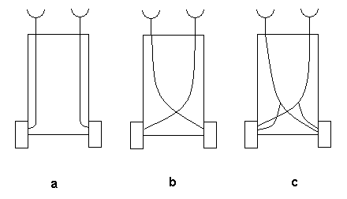

Figure 1. The simplest Breitenberg Vehicles with analog control, (a) each sensor is connected to the motor on the same side, (b) each sensor connected to the motor on opposite side, (c) both sensors connected to both the motors.

- Each sensor connected to the motor on the same side.
- Each sensor connected to the motor on the opposite side.
- Both sensors connected to both the motors.

Type (a) vehicle will spend more time in places where there is less of the stuff that excites its sensors and will speed up when it is exposed to higher concentrations. If the source of the light (for light sensors) is directly ahead, the vehicle may hit the source unless it is deflected from its course. If the source is to one side, one of the sensors, the one nearer to the source, is excited more than the other. The corresponding motor turns faster. As a consequence, the vehicle will turn away from the source. Turning away from the source is illustrated with the following figure.

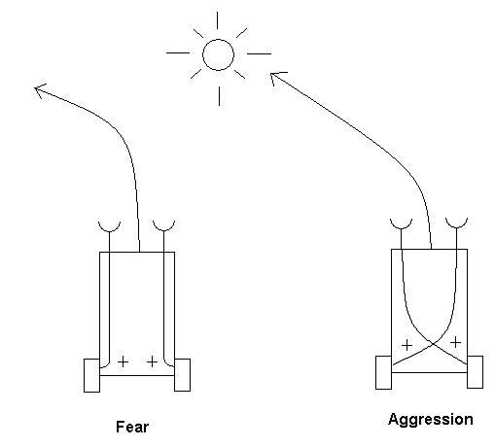
Figure 2.

We can observe another type of vehicle, type (b) vehicle with positive motor connection. No change if the light is straight ahead, a similar reaction as seen in type (a). If it is to a side, then we observe the change. Here, the vehicle will turn towards the source and eventually hit it. As long as the vehicle stays in the vicinity of the source, no matten how it stumbles and hesitates, it will hit the source frontally, in the end.
If the two vehicles are let loose in an environment with sufficient stimulus sources, then their characters emerge. Their characters are quite opposite. The type (a) with positive connection will become restless in their vicinity and tends to avoid them, escaping until it safely reaches a place where the influence of the source is scarcely felt. The feelings of fear displayed by this vehicle. Vehicle of type (b) with positive connection turns towards the source of light. They resolutely turns towards them and hits the source with high velocity, as if it wanted to destroy them. The aggressive feelings displayed clearly.
When we introduce some kind of inhibition to the stimulation, we observe a slightly differing behavior but very interesting behavior. It is some what relaxing and soothing type of trend in the behavior is observed.
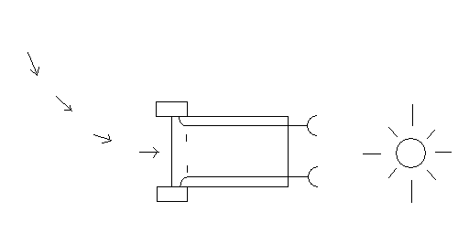
In the above example, we notice that when we switch the sensors excitation to the motors from positive excitation to negative excitation, we notice the following behavior. The negative excitation slows down the motor when the particular sensation is activated. The vehicle will spend more time in the vicinity of the source. The vehicle will orient itself towards the source and then approaches the source slowly, since the oblique course the sensor nearer to the source will slow down the motor on the same side, producing a turn toward that side. The vehicle with straight connections will come to rest facing the source. The vehicle with crossed connections for analogous reasons will come to rest facing away from the source and may not stay there very long, since a slight perturbation could cause it to drift away from the source. This would lessen the source’s inhibitor influence, causing the vehicle to speed up more and more as it gets away. This behavior is illustrated in the below diagram.

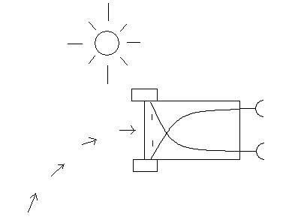

Building Braitenberg Vehicles
Type 1 Braitenberg Vehicles:

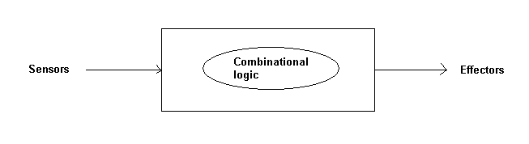
The sensors generate input to the combinational logic circuit and the output of the circuit is used to trigger the effectors of the Braitenberg Vehicle.

Type 2 Braitenberg Vehicle:
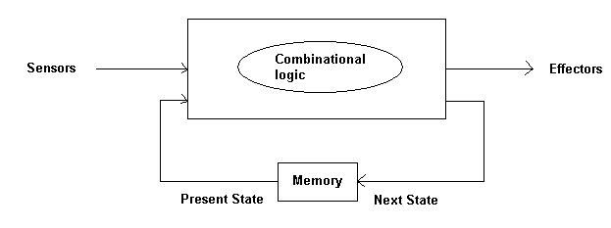
The combinational logic circuit will use sensors and present state from RAM and generate output and next state to control the effectors.

Type 3 Quantum Braitenberg Vehicle:
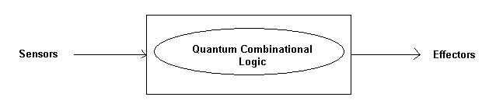
The sensors help generate input to the Quantum combinational logic and the output generates discrete data that help control the effectors.

Type 4 Quantum Braitenberg Vehicle:
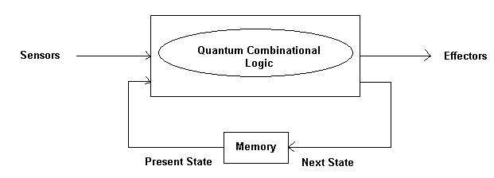
Sensors help generate input in the form of discrete data. The logic also borrows present state input from the memory. Output generated is in the form of discrete data that will be used to trigger the effectors of the vehicles.
To start with, we will be using light sensors and servo motors that control the wheels of the robot will be our target effectors. The motion of the motors will define the behavior of each type of the vehicle. The combinational logic and Quantum logic will be designed using VHDL and will be implemented using an available XILINX FPGA chip. This chip will be mounted on the robot and will be tested for its behaviour.
Quantum Logic:
Qubits are quantum bits, derived from photons, electrons or ions. Electrons with 2 possible spin rotation +1/2 and -1/2 are represented as |01> and |1> respectively.
Wavefunction of a particle p₁ is given by ψ = α |0> + β |1>
α and β are complex eigen values.
|α|² = probability of p₁ in state |0>
|β|² = Probability of p₁ in state |1>

The properties of these probability are
- |α|² and |β|² have nonzero positive values
- |α|² + |β|² = 1
- Particle p₁ and ψ₁ addedd to p₂ with ψ₂ we have
|ψ₁ψ₂> = α₁α₂ |00> + α₁β₂ |01> + β₁α₂ |10> + β₁β₂ |11>
In a quantum system n qubits represent a superposition of 2^{n} states. Operations over a set of qubits are defined as matrix operations. Quantum gate will be a matrix having vector of complex coefficients of the waveform as input and producing vector of complex coefficients as output.

Example of a quantum gate

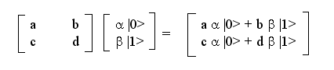
a,b,c,d = Complex coefficients of the matrix indicating complex probability to transit from one state to another.
α |0> , β|1> = complex waveform coefficients to be propagated through the matrix operator.

General Purpose Controller Gate

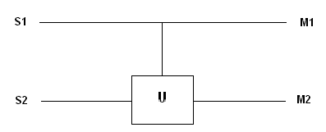

if S1 = 0 then M2 = S2
if S1 = 1 then M2 = U (S2)

Here ‘U’ is the Quantum Logic that will be designed and implemented for our Quantum Braitenberg Vehicles.
Fundamentals of Quantum Logic Gates
Quantum gates in parallel with another Quantum Gate will increase the dimensions of the quantum logic system which is represented in the matrix form. This is because the mathematical Kronecker product of Matrices is applied to the system. This Kronecker Matrix Multiplication is the one responsible for Qubit states to grow such that N bits corresponds to superposition of 2^{N} States where as in other digital systems N bits corresponds to 2^{N} distinct states.

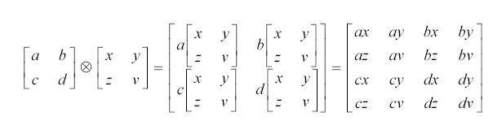

Kronecker Matrix Product
Quantum gate in series of another quantum gate will retain the dimensions of the quantum logic system.
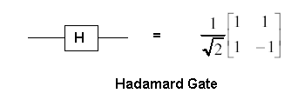
Hadamard gate has a unitary matrix. Example of unitary matrix and also a permutation matrix is a Feynman gate. Permutation matrix is a matrix is a matrix which has only one ‘1’ in every row or column.

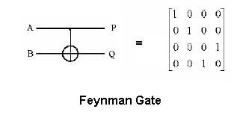

Analyzing Quantum Logic Circuits
Example 1:
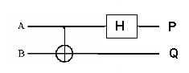

The above quantum circuit can be split into 3 circuits as shown below.
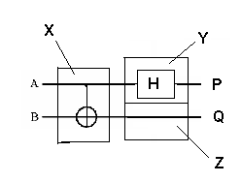
Here gate X (Feynman gate) is in series with gates H (Hadamard gate) and Z (Wire) which are themselves in parallel.

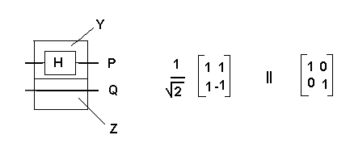
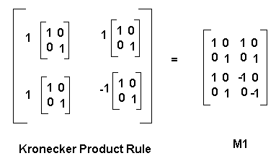

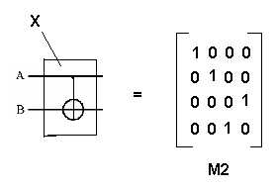
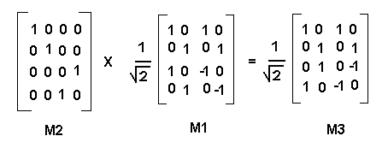

From this result we note that if the input is ‘00’ the output will be either ‘00’ or ‘10’. If the output is connected to servo motors then the vehicle would move either backwards or towards right. Similarly if the gates are re arranged as follows, the results are seen accordingly.

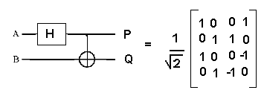
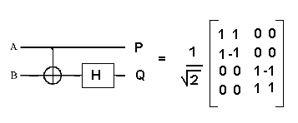
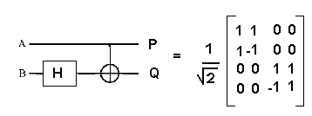

Pauli-Z gate example
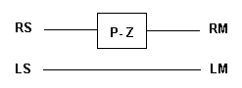

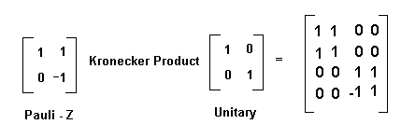

V Gate (Root of Not Gate) Example

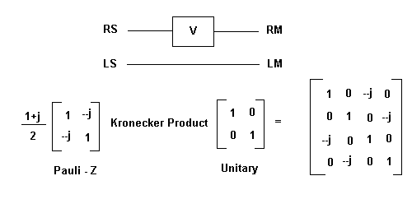
V* Gate (Inverse of Root of Not Gate) example:

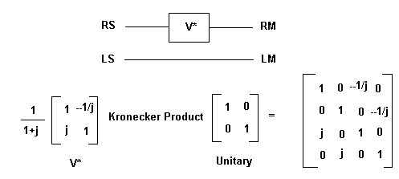

Pauli-X gate example

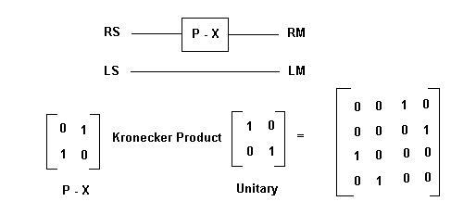

Combination of Feynman and V* Gate
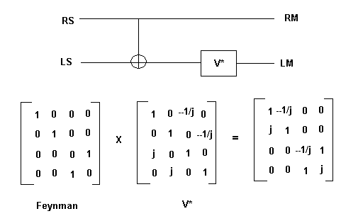

Combination of Hadamard, Pauli-X and Feynman gate

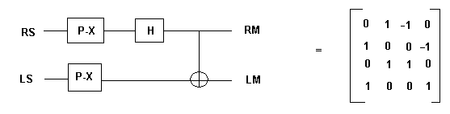

By using these combination of gates, we could build a Quantum logic that we can use to implement on the Braitenberg Vehicle. After the choice of the gates, then it is input into a compiler which then converts the Quantum Logic into VHDL code that can be directly downloaded into the FPGA style circuits to generate its equivalent Binary Logic which behaves exactly like that of the designed Quantum Logic.
Quantum computers will reach a lower limit as to how much heat the computing device can generate. They will be super-fast and super-small in size. Quantum logic gate [1,3,4,5,6,7,9,10,11,13,17,18] is a device which performs an operation described by a unitary matrix on selected qubits (quantum bits, [11]). Binary quantum gates process qubits which can have either a |0> or |1> or both |0> and |1> at the same time to varying extents and hence exhibit a superposition state α|0>+|β> where |α|² + |β|² = 1, α and β are complex numbers such that measurement probability of |0> is |α|² and measurement probability of |1> is |β|². |X|² is a result of multiplication of complex number X and its conjugate. When the qubit state is observed or measured, it becomes invariably either |0> or |1>. Ternary quantum gates [2,3,7,10] process qutrits which can be pure state |0>, |1> or |2> or any combination of |0>, [1> and |2>, a superposition state α|0> + |β> + |γ> where |α|² + |β|² + |γ|² = 1, α, β and γ are complex numbers such that measurement probability of |0> is |α|^{2,} measurement probability of |1> is |β|² and measurement probability of |2> is |γ|², [10,11]. When the qubit state is observed or measured, it becomes either |0>, |1> or |2>. Quantum gates and circuits exhibit the additional property of reversibility as their mechanism of action is through Schrödinger’s evolution (which is reversible by virtue of being unitary). Thus, methods developed for permutative (reversible) circuits [12,15] are helpful for quantum circuits as well. Matrices of all quantum operations are unitary (and usually have complex numbers as entries). Matrix X is unitary when X * X⁺ = I, where I is an identity matrix and X⁺ is a hermitian matrix of X. Hermitian matrix of X is conjugate transpose matrix of X. Permutative circuits have only pure states and their matrices are permutative [11].

The reversibility property notably changes the design problems and thus influences behaviors of machines that operate according to reversible principles. The basic quantum gates that are used in quantum circuits in this paper are Toffoli, Feynman, CV (controlled square root of NOT) and CV⁺ (controlled square root of NOT Hermitian gate). These gates are selected for explanation only, since they are truly quantum and allow to create all permutative binary quantum gates. However, the test generation and fault localization methods [8,15] outlined here are for arbitrary (binary or ternary) quantum gates and for broad fault models (including stuck-at pure states, stuck-at superposition states, bridging-AND, bridging-OR, shift of value, phase shift, gate change and many others).

2. Quantum Gates and Their Unitary Matrices.

Toffoli Gate.
Toffoli gate (C²NOT) [11,16] is a 3-qubit universal permutative gate that has the most central role in quantum computing. As the alternative name implies, this gate only negates the third qubit if the first two qubits are in the |1> state. One use of this gate is as a reversible AND gate: when the third qubit is set to |0>, it is only flipped to |1> if both the first and the second inputs are true. Likewise, by setting the third qubit to |1>, we get NOT-AND (NAND) functionality (Figure 1a).
The unitary operation matrix of this gate is shown in Figure 2a. As we see, it is a permutation matrix; in every row and column there is only one “1” and all other entries are “0”, meaning a permutation of states.

Feynman Gate.
Feynman gate (CNOT) gate takes two qubits as input, |x> and |y>. The result is the |x> qubit and an XOR of |x> and |y>. If the value of |x> is 0, the value of |y> remains the same, else the value of |y> is flipped to it’s opposite (see Figure 1b). The unitary operation matrix of Feynman is also permutative (Figure 2b).

Square Root of NOT Gate
Connecting two “square root of NOT” gates in series acts as a NOT gate inverting a qubit (that is, the probabilities that the qubit will collapse to pure state |1> is changed to the probability that that the qubit will collapse to |0>, [1]). If one measures the qubit after only one “square root of NOT” gate, the result of the measurement is unknown.

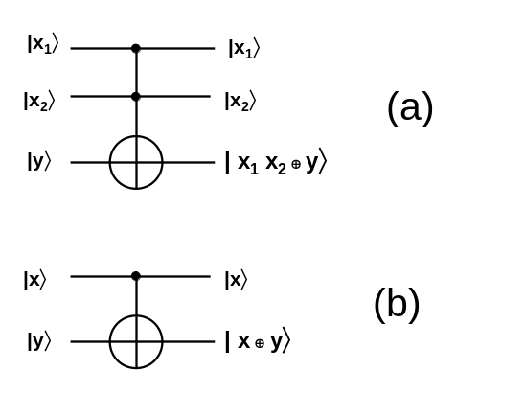
Figure 1 ( a) Toffoli gate, (b) Feynman gate

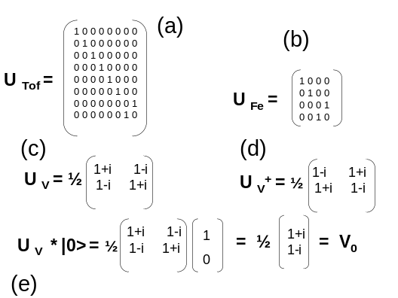
There is however an equal probability of measuring a |0> and a |1>. By V we denote the “square root of NOT” gate. The unitary operation matrix U_{V} of V gate is shown in Figure 2c. As we see, this is not a permutative gate, but a truly quantum gate. It means, applied to pure states it creates superposition states on its output (Figure 2e).
Figure 2. (a) Unitary matrix of Toffoli gate, (b) unitary matrix of Feynman gate, (c) unitary matrix of Square-root-of-Not gate, (d) unitary matrix of Square-root-of-Not-Hermitian gate, (e) calculation of result on output of Square-root-of-Not gate when its input is in pure state |0>

Square Root of Not Hermitian Gate
The conjugated transpose of a unitary matrix X is called the hermitian of matrix X and denoted by X⁺. By V⁺ we denote a gate that has a unitary matrix which is a hermitian of V. Therefore, the hermitian of V is called “square root of NOT hermitian” and has the unitary matrix U_{V+} of gate V⁺ from Figure 2d.

Operation of V and V⁺ Gates.
Design of many permutative gates is based on (controlled) cascading of V and V⁺ gates. Cascading two square root of NOT gates acts as a basic inverted gate (see Figures 3 and 4a).

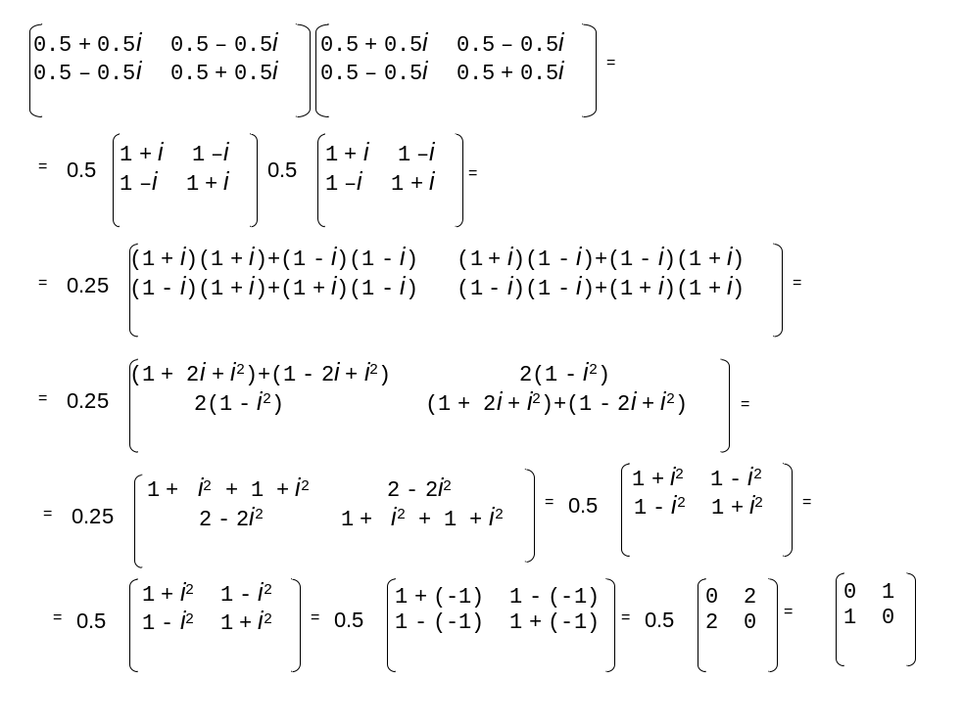
Figure 3 (from [1]). Step-by-step calculation of unitary matrix of an inverter gate created by multiplication of unitary matrices of Square-root-of-Not gates connected in series (standard matrix multiplication).

The operation of the circuit from Figure 4a can be explained by the matrix equations from Figure 3. Multiplying the unitary matrix U_{V} by the input state we obtain the vector ½ [1+i 1-i]^{T} = V₀, Figure 2e. By multiplying V by this vector we obtain vector [0 1]^{T} = |1>.

Let us now try to find, by matrix/vector multiplication, all possible states that can be created by applying all possible serial combinations of gates V and V⁺ to states |0> , |1> and all states created from these pure states (Figure 5). A qubit |0> given to a “square root of NOT” gate (Figures 2e and 5a) gives a state denoted by |V₀>. After measurement this state gives |0> and |1> with equal probabilities ½. Similarly all other possible cases are calculated in Figure 5b – h.

As we see, after obtaining states |0>, |1> |V₀> and |V₁> the system is closed and no more states are generated. Therefore the subset of (complex, continuous) quantum space of states is restricted with these gates to a set of states that can be described by a four-valued algebra with states { |0>, |1>, |V₀>, |V₁> }. We assume here for simplification of explanation that only faults s-a-0, s-a-1, s-a- V₀, and s-a-V₁ are possible, but many other fault models can be defined.

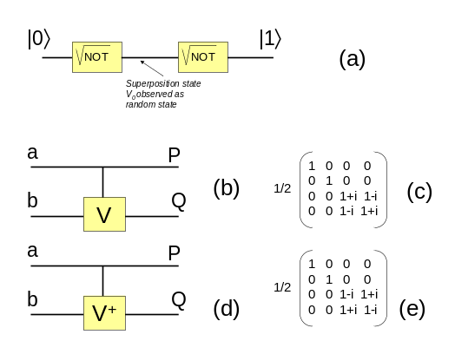
Figure 4. (a) Cascading V gates creates an inverter. Measurement of intermediate state would give |0> and |1> with equal probabilities, (b) Controlled-V gate, (c) its unitary matrix, (d) Controlled-V⁺ gate, (e) its unitary matrix.

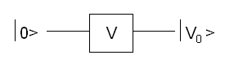
(a)
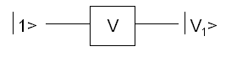
(b)
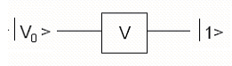
(c)
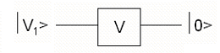
(d)
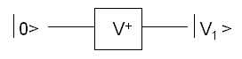
(e)
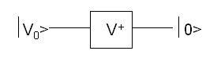
(f)
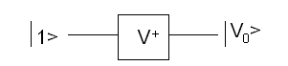
(g)
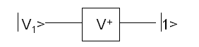
(h)
Figure 5. Calculating all possible superposition states that can be obtained from pure states |0> and |1> using V and V+ gates.

Controlled gates
Figure 4b shows a Controlled-V gate (Controlled-Square-Root-of-Not) and Figure 4c its unitary matrix. The gate operates as follows. Control signal a goes through the gate unaffected, i.e. P = a. If the control signal has value 0 then the qubit b goes through the controlled part unaffected, i.e. Q = b. If a = 1 then the unitary operation that is inside the box is applied to the input signal b, it means Q = V(b) in our case. This operation is general for all binary controlled gates, for instance the Controlled-V-hermitian (Controlled-Square-root-of-Not-hermitian). This gate is shown in Figure 4d and its unitary matrix in Figure 4e. Ternary controlled gates are described in [3,7,10] and their fault models in [14].

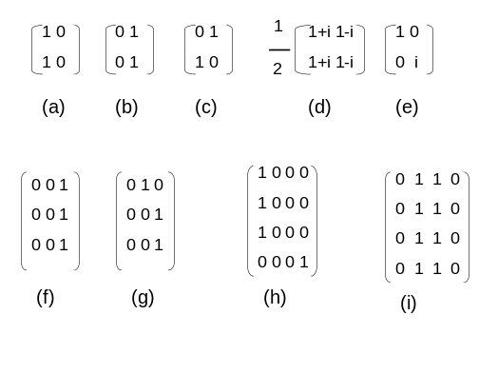
Figure 6. Matrices of faults. (a) stuck-at-0 in binary quantum circuit, (b) stuck-at-1 in binary quantum circuit, (c) inverter in binary quantum circuit, (d) stuck-at-V₀ in binary quantum circuit, (e) phase fault in binary quantum circuit, (f) stuck-at-2 in ternary quantum circuit, (g) truncated plus 1 in ternary quantum circuit, (h) AND-bridging fault in binary quantum circuit, (i)stuck-at-entangled-state-01-10 of two quantum wires.

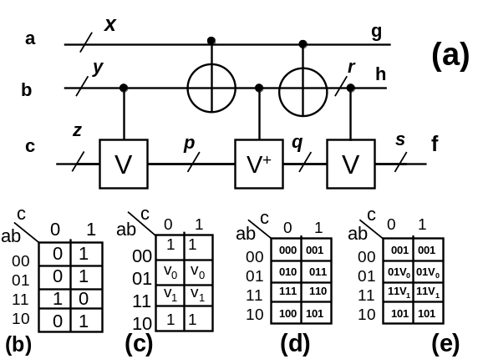
Figure 7. (a) Realization of a Toffoli gate from Controlled V, Controlled V⁺ and Feynman gates.Places of faults are denoted by small italic letters.(b) Kmap of the fault free output f for circuit from Figure 6, and the Kmap of the same output f when there is a stuck-at-1 fault in quantum wire p, (c) symbolic output for function f for stuck-at-1 fault in wire p, (d) binary output signals of a correct circuit, (e) symbolic faulty outputs with probabilistic tests for the same fault.

If the outputs are “deterministic”, we apply test vectors and detect the fault using standard deterministic approach to testing. If the outputs are “probabilistic” (complex numbers denoted by symbolic values like V₀ and V₁ in our case), we calculate the probability of occurrence of the observed output as explained in the following sections. We give priority to deterministic tests. Observe that a deterministic fault in quantum circuit can be observed on the output probabilistically. There are also probabilistic faults that are observed probabilistically.

4.1. Probability calculation of the random output

By iteratively applying the same input test vector (a probabilistic test) we are calculating the probability of getting the observed output. The input vectors are always vectors of pure states. Each successive ite

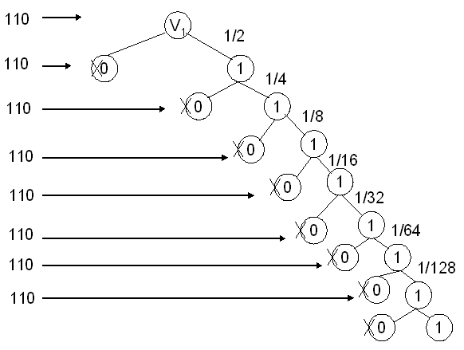
Figure 8. Probabilistic Supernode – a tree for calculating the probability of obtaining a sequence of n signals “1” from a gate which has probability ½ of output “1”.
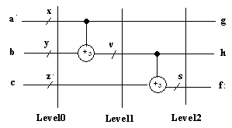

Figure 9. Ternary reversible circuit

trolled-V with control up. B3 = B1. B4 = I ⊗ I ⊗ S-a-0, where S-a-0 is non-unitary matrix of the stuck-at-0 fault. B5 = B2. B6 = Fe ⊗ I. B7 = I ⊗ CV⁺ where CV⁺ is a matrix of Controlled-V⁺ with control up. B8 = B6. The final matrix with the inserted fault is B8 * B7 * B6 * B5 * B4 * B3 * B2 * B1. For every fault the set of all corresponding output vectors is calculated using the respective resultant transition matrix of the faulty circuit.

Figure 10. The block diagram of the system for test generation and fault localization in binary and ternary quantum circuits.
For each test, the output vectors of the faulty and non-faulty circuits (Figure 7d,e) are compared to create a column of the Fault Table. This is iterated for all fault models in all locations. A part of Fault Table for a correct circuit and a column for fault S-a-1 in location p is shown in Figure 13. It was created from Figure 7. The Fault Table is a starting point to both the minimal test sequence generation and adaptive tree generation. The entries in the table for a quantum circuit are more general than for a

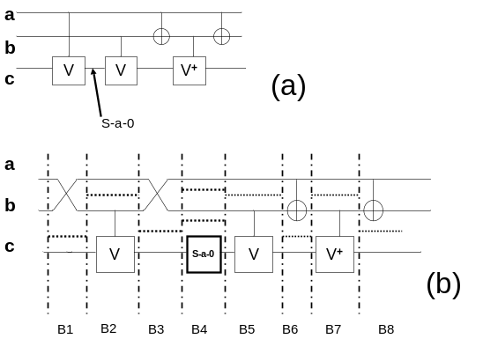

7. Conclusion
The presented paper presents the first attempt at the test generation and fault localization for both permutative and non-permutative quantum circuts. With powerful enough fault model the approach can be used to arbitrary quantum circuits. In software, we used standard realization of matrix operations to implement matrix and Kronecker multiplications on unitary and non-unitary matrices [9]. Because these operations are repeated many times, the speed of the program suffers and we cannot handle larger functions. Currently we can work only with 3-qubit and 4-qubit binary and ternary circuits. A better approach, that we are working on, is to use a new technique for gate-level simulation of quantum circuits that was recently proposed by Viamontes et al [17,18]. It is based on a new data structure called Quantum Information Decision Diagrams (QuIDDs), which are generalizations of Binary Decision Diagrams, well-known for their ability to efficiently represent many problems. We are going to use these new diagrams in synthesis problems as well [3,4,7,9].

In the proposed method we repeat the same test several times in supernodes, used both for test sequence generation and for fault localization in adaptive trees. It can be observed, however, that statistical information can be obtained also from various different tests [14], thus shorter test sequences can be perhaps build for the same circuits and with the same error probability than the sequences generated according to the presented algorithm.

Future works include developing more efficient test generation and fault localization algorithms for binary, multi-valued and mixed (binary-ternary) quantum circuits composed of arbitrary permutative and non-permutative gates [14]. We will also use all fault models that are necessary in real quantum computing, such as NMR.

Use of Building such amazing Quantum Braitenberg Vehicles
- They can be used to solve maze games
- They can be tested for their performance in the Robot Soccer Competitions
- The Quantum circuits could be implemented into public entertainment robots
- They can also be used to build commercially viable Robot Pets.

References

- V. Braitenberg, “Vehicles, experiments in synthetic psychology” Publisher: Cambridge, Mass. : MIT Press, 1984
- A. Buller, Quantrix: Toward Automated Synthesis of Quantum Cascades, Technical Report TR-HIS-00-*, ATR Human Information Processing Laboratories, Kyoto, 2003. 03.15.
- H.F. Chau, Correcting quantum errors in higher spin systems. Physical Review A, Vol. 55, R839-R841, 1997.
- E. Curtis, and M. Perkowski, Minimization of Ternary Reversible Logic Cascades using a Universal Subset of Generalized Ternary Gates, submitted to International Journal on Multiple-Valued Logic and Soft Computing, Svetlana Yanushkevich, editor
- W. Hung, X. Song, G. Yang, and M. Perkowski. Reachability Analysis for reversible minimization. Proceedings of DAC 2004.
- http://www.dhushara.com/book/quantcos/qcompu/qc2/qc2.htm
- http://www.themilkyway.com/quantum/FinalReport/QuantumGates.html
- M. H. A. Khan and M. Perkowski, Genetic Algorithms Based Synthesis of Multi-Output Ternary Functions Using Quantum Cascade of Generalized Ternary Gates, submitted to special issue of International Journal on Multiple-Valued Logic and Soft Computing, Tatjana Kalganova, editor.
- Z. Kohavi, Switching and Finite Automata Theory, Mc Graw-Hill, 1978.
- M. Lukac, M. Perkowski, H. Goi, M. Pivtoraiko, Ch-H. Yu, K. Chung, H. Jee, B.G. Kim, and Y-D. Kim, Evolutionary approach to Quantum and Reversible Circuits synthesis, Artificial Intelligence Review Journal, Special Issue on Artificial Intelligence in Logic Design, S. Yanushkevich guest editor, 2003.
- A. Muthukrishnan and C. R. Stroud Jr., “Multivalued Logic Gates for Quantum Computation,” Physical Review A, Vol. 62, pp. 052309.1-8, 2000.
- G. Negovetic, M. Lukac, M. Perkowski, A. Buller, “Evolving Quantum Circuits and an FPGA-based Quantum Computing Emulator,” Proceedings of Symposium on Boolean Problems. September, 2002, Freiberg, Germany

- M. Nielsen, and I. Chuang, Quantum Computation and Quantum Information, Cambridge University Press, 2000.
- B. Patterson, http:www.cs.iastate.edu/~patterbi/cs /quantum.fp/FinalPaper.pdf
- T. Toffoli, „Reversible Computing”, in Automata, Languages and Programming (edited by de J. W. Bakker and J. van Leeuwen), Springer Verlag, pp. 632-644, 1980.
- G.F. Viamontes, M. Rajagopalan, I.L. Markov and J.P. Hayes, Gate-Level Simulation of Quantum Circuits, quant-ph/0208003.
- G. F. Viamontes, I. L. Markov and J. P. Hayes, ``Improving Gate-Level Simulation of Quantum Circuits'' (quant-ph/0309060), to appear in Quantum Information Processing, 2004


