CHAPTER 9

MULTI-VALUED CIRCUITS, HYBRID LOGIC AND OPTICAL GATES

Maher Hawash, Marek Perkowski, and Anu Rajendran

9.1. SHORT REVIEW OF SOME NEW BINARY QUANTUM GATES

Currently, investigation on synthesis of binary quantum circuits is based on methods developed by John Smolin and Adriano Barnenco [ref]. The troubles with the methods from Smolin and Barnenco are that the complexity of their circuits grows quadratically. This increases the cost of the circuits drastically and makes them less effective. However, after 15 years of continuous research by many teams worldwide, Australian researchers GIVE THEIR NAMES [ref] have discovered a new method of designing quantum circuits that prevents this drastic growth. This new method is called hybrid logic.

These researchers, however, have only shown the new method in reference to a 3 and 4 qubit Toffoli gates. This chapter will explore the implications of hybrid logic for other fundamental gates. Finally, by investigating possible local reductions of these new quantum circuits, we will introduce transformations that will simplify arbitrary quantum circuits by using this hybrid technology. The reduction of resources and costs can then be observed by comparing the new circuits to the old circuits.

In order to explore the path to efficient ways of optimizing quantum circuits with hybrid technology, we must first review some facts about quantum gates.

9.1.1. Control Phase Gate (Z gate or Controlled Sign Gate)

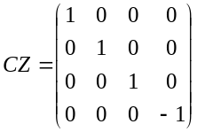
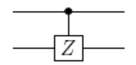

Figure 5.1.1: Controlled Phase gate and its unitary matrix.

9.1.2. Toffoli-Sign Gate (TS)

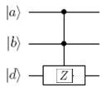
Figure 9.1.2: Toffoli Sign Gate

The Toffoli-sign (TS) is a three-qubit gate that applies a sign shift to one logical input state and is equivalent to a Toffoli if surrounded by Hadamard Gates. The simplest decomposition of a TS gate when restricted to qubits throughout the calculation requires five two-qubit gates. This gate will be referred to in a later section.

9.2 Ternary Gates

Unlike the binary logic of 0 or 1, the ternary logic uses logic values 0, 1, or 2. There are five different ternary gates on a single qudit (qudit is a quantum bit that is not necessarily binary, but can have more than two values after measurement). The sixth permutation is the identity gate that changes nothing. The truth tables are shown for each ternary gate. For ternary quantum circuits the qudit is called qutrit.

9.2.1 X_{a} Gate
input
output
0
1
2

2
1
0

Xa

9.2.2 +1 Gate
+1
input
output
0
1
2

1
2
0

9.2.3 +2 Gate
input
output
0
1
2

2
0
1

+2

9.2.4 1 → 2 Gate
1,2

input
output
0
1
2

0
2
1

9.2.5 0→ 1 Gate
input
output
0
1
2

1
0
2

0,1

9.3 Reduction Rules

Some of the reduction rules mean that one can shift left or right pulses or gates for which the above rule holds. If gates (circuits) are not affecting one another, we can change their order in a parallel connection. If the output of gate A would control gate B, we would be not able to execute this transformation. Other transformations mean that a gate can be rewritten to simpler gates in order to reduce these simpler gates with other neighbor gates. This is illustrated in Figures 25, 26 and 27. Many more such transformations can be found in papers on quantum circuits [ref], but here only a few are showed that were applied or tried to apply in circuits which were analyzed by us based on the Australian invention[ref].

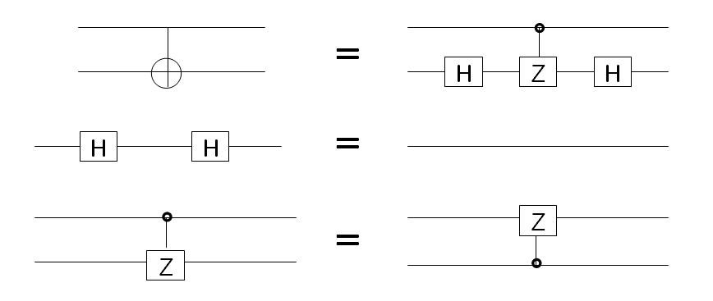
a)

b)

c)

Figure 25: (a) The Controlled-NOT gate realized by controlled-Z gate surrounded by Hadamard gates, (b) two serially connected Hadamard gate are together equal to a quantum wire and (c) for controlled Z we can interchange the control qubit and the target qubit in the control-Z gate.

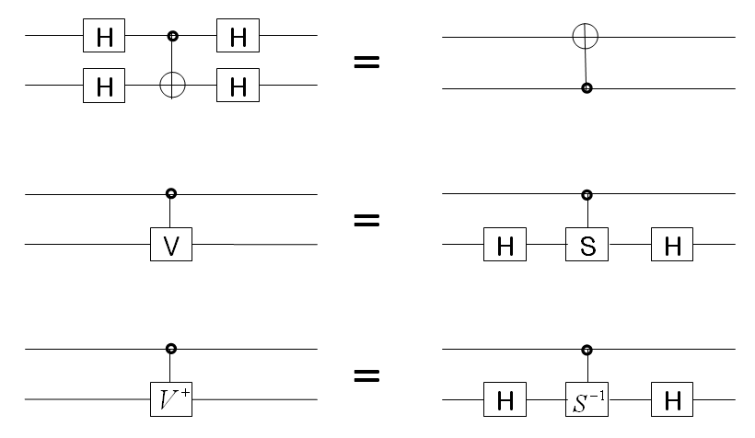
a)

b)

c)
Figure 26: a) Identities for Feynman gate surrounded by Hadamard gate. b) construction of CV and CV† from Hadamard gate (H) , Phase gate(S) and its inverse(S⁻).

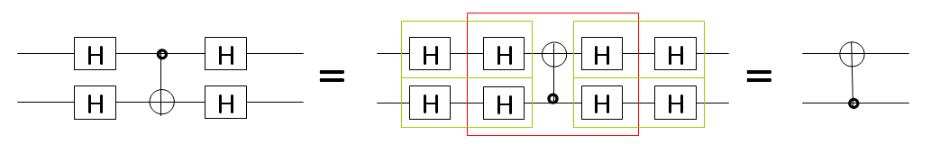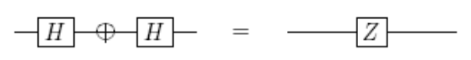
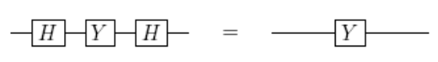
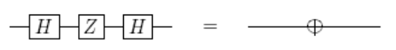

Figure 27: (a) Example of transformation for Feynman gate surrounded by Hadamard gates, (b) Hadamard gate used as serial connection creates Z gate, (c)Y gate surrounded by Hadamard creates Y gate, (d) Z gate surrounded by Hadamard gates creates NOT gate. These rules can be used to prove the correctness of the Grover Algorithm.

9.4. Cost of Quantum Gates

The cost of the most frequently used gates in quantum computation is estimated by counting the sequence of basic physical operations required for implementation on a quantum computer. These operations are usually some electromagnetic or laser pulses, different for each quantum technology and their physical nature is not of our interest here. Our interest is only to count these basic operations to evaluate the cost of each circuit after applying optimizing transformations to it. The sequence of physical operations comprising each gate is minimized using a software algorithm based on commutation and other rules.

Table below gives the costs of gates realized using classical binary quantum technology according to methods of Smolin and Barenco [ref]. These are the costs of most of the current gates used by universities and research groups in existing quantum computers. Although these costs are given only for NMR technology, the costs for Ion Trap, optical and other technologies are similar. These costs are therefore the base of comparison for my new costs that are calculated using new gates based on the Australian Method.

Gate | Cost
NOT | 1
Phase | 1
Hadamard | 2
CNOT | 5
SWAP | 11
Peres | 12
Toffoli | 13
Fredkin | 19
Miller | 24

9.5. Efficient Gates Using Hybrid Logic

Like previously mentioned, Australian researchers, T.C. Ralph, K.J Resch, and A. Gilchrist [ref], have discovered a new method of designing quantum circuits that prevents the drastic increase in cost and resources. This method is known as hybrid logic. Hybrid logic uses both binary logic and other multi-valued logic, such as ternary. They build these circuits physically and confirmed their proper operation, but they were not interested in optimization of larger circuits built from these gates.

Ralph, Resch, and Gilchrist show that by using multi-valued logic internally and binary logic externally, the complexity of their circuits only grows linearly. This linear growth allows the circuits to include less quantum gates and be thus cheaper, faster, and more effective. As we already know, a key quantum circuits is the Toffoli Gate. This gate will be used as an example to explain this new method.

Currently, the most efficient Toffoli gate, using only three qubits, involves five 2-qubit gates. This was shown in Figure 10. It is well known from literature that for Toffoli gates with more controls, the cost grows quadratically, or even more from practical point of view [Perkowski book], However, this number can be reduced by the Australian method to only three gates by making one of the qubits in the circuit a qutrit (In general, the method uses arbitrary qudits). The qutrit is a 3-level, or ternary system which has 3 basis states, denoted as |0⟩ , |1⟩, and |2⟩.

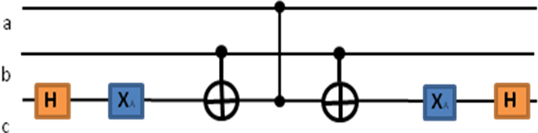
Figure 28: Toffoli Gate using 2 qubits and a qutrit.

The Figure 28 above shows the arrangement to implement a Toffoli-Sign Gate and Toffoli gate. The internal circuit of five gates is Toffoli-Sign. By adding two Hadamard gates on input and output the standard Toffoli gate is created (with small difference that is not important practically). It will be explained below in more detail of why this gate produces a reduction of resources and is more effective.

In the diagram above, each of the qubits are labeled as a, b, or c. The orange box labeled H is a Hadamard gate, Xa is also a gate (that was introduced earlier and will be explained later), then we have a Controlled NOT gate, followed by a Controlled-sign gate. The same pattern was shown by Australians for Toffoli gate with 4 qubits. It is shown below that it can be continued for circuits of any size, and not only for Toffoli gates of increased sizes.

Let’s look closely at the diagram below. Two Hadamard gates surround the entire circuit. As previously mentioned, the increased efficiency is achieved by using a third level of one of the qubits during computation. This qubit, c, becomes the target qubit, while qubit a and b are the control qubits. The third qubit becomes a qutrit with logical states 0, 1and 2. The action of the first Xa gate is to move information encoded in the logical 0 state of this qutrit into its third level (2 state), which then bypasses the other two-qubit gates. If the Controlled sign and Controlled NOT gate act on a qutrit in the state 2, then both gates implement the identity regardless of the value of the control qubit.
Xa →, Xa→, Xa →
This means that when the Xa gate is one, it will continue to be implemented as one. A flip only occurs if the Xa gate recognizes a 0 or a 2.

The final Xa gate then brings this information back into the 0 state, reconstructing the logical qubit. This qutrit nature will only manifest during the gate; however, after the gate, only qubit levels will be occupied. A qutrit also exists in a superposition of the three basis states. The addition space given by this one qubit allows a significant reduction in the resource requirements.

This shortcut through a higher dimension allows the two-qubit gates to operate on a subspace of the original target qubit and implement the Toffoli sign gate with a reduced number of gates. This technique can be generalized to implement higher- order n-control-qubit Toffoli gates by using a single (n+1) level qubit during computation and only (2n+1) standard two-qubit gate.

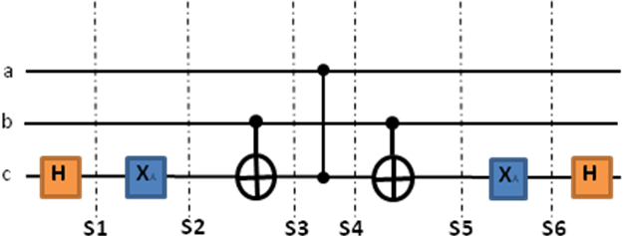
Figure 29 : Toffoli Gate using 2 qubits (a,b) and a qutrit (c )

In order to be able to create new gates, we have to understand the operation of the gate from Figure 29 in full detail. Thus a modified Karnaugh Maps is used to analyze this circuit. This analysis was very important to the success of my project as it allowed me to understand not only how the given circuit from Figure 29 works but what is the principle of using hybrid logic to create binary gates. These methods are next used for other gates and their transformations. The reader can always use this technique to verify each of his quesses of how to build a quantum circuit or even to verify that his circuit results from Matlab or Mathematica software are correct.

So the KMaps for Toffoli Gate in Figure 29 have been drawn according to the location on the circuit. For example, S1 Kmap will have the implementation of the gate after one Hadamard gate. S2 Kmap will have the implementation of the gate after one Hadamard and one Xa (Ternary) gate and so on.
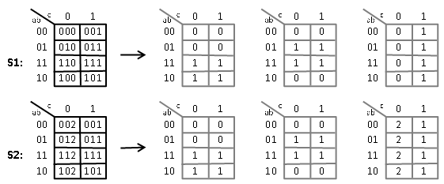
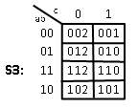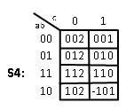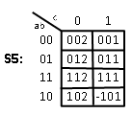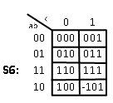
Figure 30: The complete process is shown in S1 and S2 Kmaps. The arrow points to the Kmaps of each outcome. S3-S6 are the rest of the Kmaps.

If this same method were used to evaluate Toffoli gates with 4, 5, and 6 qubits, a general pattern could be found. We will discuss how to create larger gates for more inputs by analyzing these gates with Kmaps and Matrices.

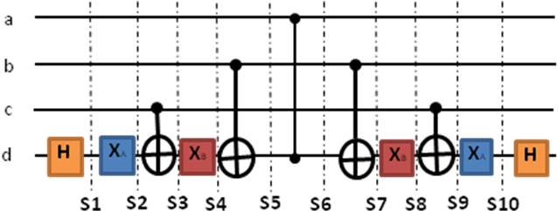
Figure 31: Toffoli gate for 4 qubits: 3 qubits (a, b, and c) and a ququit (d)
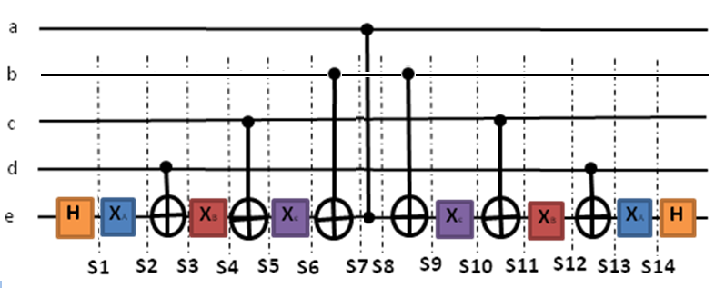
Figure 32: Toffoli gate for 5- qubits: 4 qubits (a, b, c, and d) and a multi-valued qubit (e)

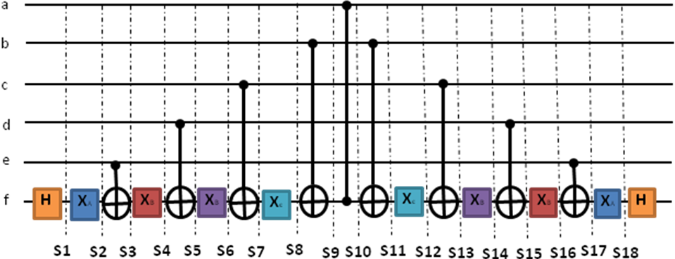
Figure 33: Toffoli gate for 6- qubits: 5 qubits (a, b, c, d, and e) and a multi-valued qubit (f)

This way, one is able to calculate costs of Toffoli gates, the basic building blocks of all quantum circuits.
Cost:
3 bit Toffoli: 17= [(2(H)x2)+ (2(Xa)x1)+ (2(CNOT)x5)+ (1(CS)x1)]
4 bit Toffoli: 29= [(2(H)x2)+ (4(Xa)x1)+ (4(CNOT)x5)+ (1(CS)x1)]
5 bit Toffoli: 41=[(2(H)x2)+ (6(Xa)x1)+ (6(CNOT)x5)+ (1(CS)x1)]
6 bit Toffoli: 53= [(2(H)x2)+ (8(Xa)x1)+ (8(CNOT)x5)+ (1(CS)x1)]

As the number of bits increase, the cost increases each time by 12 pulses because 2 CNOT (Cost: 5) and 2 Xa (Ternary Gate, Cost: 1) are added. Therefore, we can calculate the cost of n-bit Toffoli by using this recursive formula:
C₁ = 17
C_{n}= C_{n-1} + 12

As the number of bits increases, the number of gates necessary increases as well. A recursive formula can be derived to calculate the number of gates also.

Number of Gates:
3 bit Toffoli: 7
4 bit Toffoli: 11
5 bit Toffoli: 15
6 bit Toffoli: 19

Each higher bit Toffoli has 2 CNOT gates and 2 Xa Gates added. Here is the recursive formula:
G₁ = 17
G_{n}= G_{n-1} + 4
With these formulas, quantum cost is calculated for every quantum circuit. First one calculates this cost for the old method of Smolin and Barenco, one that is popularly used. Next we can calculate the cost with the new method invented by Australians and for larger gates created by my recursive method and using my recursive formulas as above. This will tell me how much is a new circuit cheaper and faster than the classical quantum realization.

In this chapter some well known quantum circuits, such as Oracles for Grover Algorithm and compare quantum costs for the old and the new method will be in detail discussed.

9.6. New Transformations

The next several pages will be transformations created based on hybrid logic. The cost will also be displayed for each step as the gate is reduced and transformed (number above gate will be cost of that specific gate).
Key:
- Hadamard Gate (Cost: 2)
- Xa Gate (Cost :1)

The cost of Hadamard gate is assumed to be 2, because it is two Pauli rotations in binary quantum circuits. Assume cost 1 for Xa gate as it is a single rotation. This is however a rotation in other space than binary rotations such as Pauli rotations, so perhaps a careful analysis will show that the cost of this gate is higher. We have however so far not enough knowledge to calculate the cost of this gate exactly, so we use the lower bound of its cost here. Next work in this chapter will to calculate accurate quantum costs based on rotations in Hilbert Space.

9.6.1. Transformation Rules

As one can see in the transformations in the previous section, many of the gates can be canceled when they are next to each other on the same bit. Why? How can we cancel two Hadamard gates? In order to answer this question, we must use the unitary matrixes of these gates.

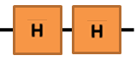
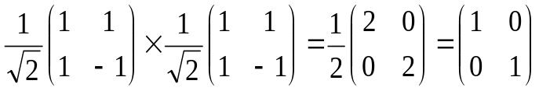

When two Hadamard gates are used in a sequence, their unitary matrices are multiplied by one another, the end result is an identify matrix, which is equal to a quantum wire. This means no gate at all, We cancelled two gates to nothing. This is the main principle of reducing quantum circuits. It is the same as reducing two inverters in Boolean logic to a wire. However, to apply this rule one has first to shift some gates to make the reduction possible. How to shift them is not know. Just like the Hadamard gate, the other gates cancel out when placed next to one another because they form the identity matrix as well. In some cases the gates do not cancel out completely but create simpler gates.

So far, we were able to find the following rules.
Rules:
- When two Hadamard Gates are placed next to one another, they will be canceled out.
- When two Xa Gates (or any of the same single-qutrit Ternary Gates – see section 4.2.) are placed next to one another, they will be canceled out.
- When two CNOT gates are placed next to one another, they will be canceled out.
- When two CS (Controlled Sign) gates are placed next to one another, they will be canceled out.

These rules were shown by me to be useful to minimize the costs of several quantum circuits. However, it is not yet known if more rules are needed and we have to prove that similar rules exist for 4-valued, 5-valued and 6-valued logics. If yes, then we can formulate a hypothesis for any number of values of the hybrid logic that combines binary control with multiple-valued target qudit.

9.7. Conclusions

The paper by T.C. Ralph, K.J Resch, and A. Gilchrist introduces a new way of building binary quantum circuits. Here we extended it to any size of Toffoli gates. Next, because we already showed in previous chapters how to realize other than Toffoli gates, we will be able to apply the new methods to create hybrid realizations of other binary quantum gates. Finally, when the student can play with various circuits, replacing the many-input Toffoli gates with the quantum primitives introduced by Australians. This way, many new transformations will be found, similar to those already discussed in the literature [Perkowski book] can be applied to these other circuits. The new method that generalizes the invention of the Australians can be applied to any circuit and we can optimize this circuit, possibly inventing new transformations of hybrid circuits. Next we can calculate the cost of this optimized circuit and compare to the old cost. The plan is to simulate these circuits and write software to optimize them using Mathematica. Finally the book will design a big oracle for Grover-based combinatorial algorithm to solve some new problem, design the circuit for this oracle in detail and calculate the cost with the new method to see how much the hybrid circuits will practically speed up and reduce the costs of quantum algorithms .

LITERATURE

Perkowski book
Grover
Australians
Smolin
Barenco
Nielsen Chuang

