CHAPTER 15

Oracle for the Graph Coloring Problems.

15.1. The Graph Coloring Problem.

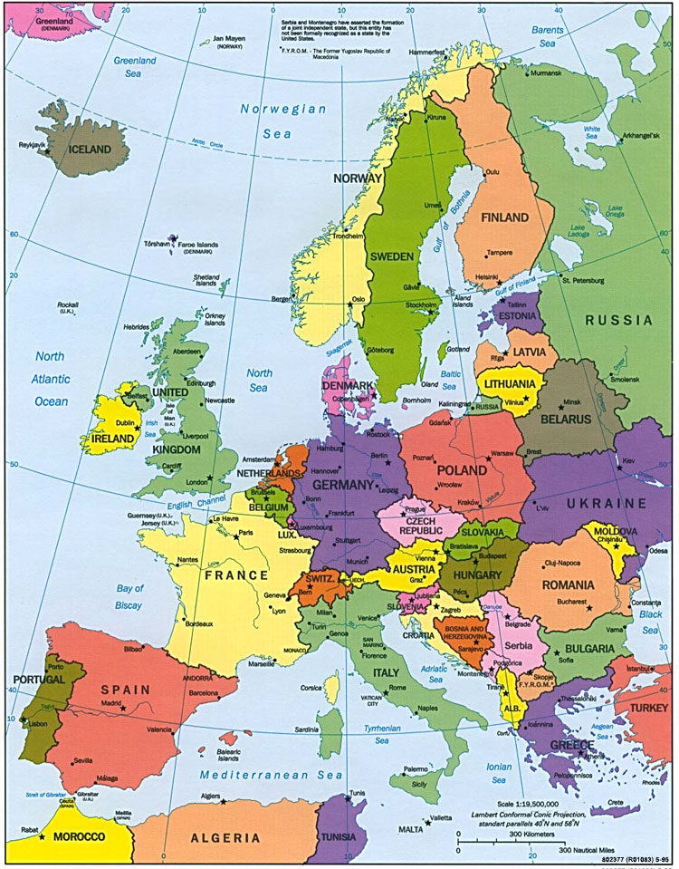

Figure 15.1: Map of Europe.

Graph coloring problem is to find the minimal number of colors to color nodes of a graph in such a way that every two nodes linked by an edge have different colors. Graph coloring is an easy problem to formulate, but finding exact solution is extremely difficult for large graphs on a standard computer. Thus this problem is a good candidate for quantum computing. The problem of using a quantum computer to find the exact minimum solution to the graph coloring problem is of interest because there is no literature on this subject, although much is known about graph coloring on standard computers. Many practical Constraint Satisfaction problems (CSP) can be reduced to graph coloring, which makes our considerations here useful in future CAD, scheduling and allocation problems, to mention just a few of these problems. The main result to be expected from the Grover Algorithm was that the optimal (exact) solution could be found in a number of steps proportional to the square root of N, where N is 2^{n*log c} , where n is the number of nodes and c is the upper bound of the number of colors. The classical algorithm would require an order of N steps. Thus, assuming the time of single operation to be 10⁻⁴ second, a classical computer would take 10⁴* 10⁴ * 10⁻⁴ = 10⁴ seconds to solve certain instance of the graph coloring problem, the Grover Algorithm would take 10⁴ * 10⁻⁴ =1 second.
The relative speedup of quantum computing is only quadratic in Grover case, while the speedup of the quantum factorization algorithm is exponential. Although smaller, this quadratic speedup is still dramatic in many real-time robotic applications. As an example one can think about a CSP problem such as human face recognition for an antiterrorist automatic camera located at an airport gate. In this case the quadratic speedup is very important, 10⁴ seconds versus 1 second will make a life-or-death difference – a fast decision can help to locate a terrorist and save lives of hundreds. There are many other practical combinatorial problems like this in communication, logistics, CAD and robot vision.

In the simplest formulation of graph coloring, a graph is denoted as a standard graph (not a multi-graph) with a certain number of edges and nodes. Every node is connected to at least one other node, by means of an edge. Every node may also obtain a color, which is represented as a bit string. A solution to a graph coloring problem consists of having no uncolored nodes, and having no edges connecting 2 nodes of the same color. We want also to minimize the number of colors used (this leads to finding the chromatic number of the graph). A rather popular branch of graph coloring is called “Map Coloring”. Maps, for easy distinction between countries in them, tend to have different, adjacent countries colored differently. For those whose eyesight is not perfect, the distinction between 2 shapes of different colors is far more easily recognized than a thin black borderline. In graph coloring, each country is represented as a node, and borders are represented as graph edges, (see Figure 15.1). The interest in Map Coloring was started by Francis Guthrie, who in the 1850’s formulated a problem involving coloring a map with only 4 colors. The problem remained unsolved until 1976, when after hundreds of computer-hours of calculation, Kenneth Appel and Wolfgang Haken proposed a solution that, as of yet, has not been disproven and mathematicians agree that the solution is correct. Map coloring is thus the first and easy variant of graph coloring and constraint satisfaction problems that we explain and simulate in this book. Since it was proved that every map can be colored with 4 colors, our oracle is greatly simplified, especially if one would try to apply it to a very big map.

  - Decision Oracle for Graph Coloring Problem using Grover’s Algorithm

In this section, we introduce the first architecture for finding the minimum coloring using Grover Algorithm.
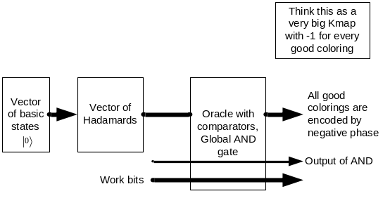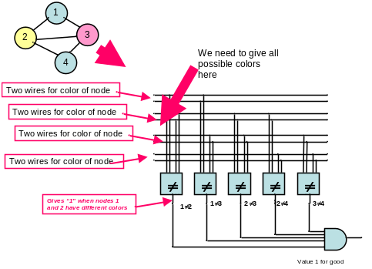
Fig. 15.2.1: Block Diagram of Decision Oracle that creates superposed quantum states with negative phase for all good colorings of a map.
Fig. 15.2.2: A simple graph coloring problem: the color comparators correspond to the borders of the countries or the edges of the graph.

Fig. 15.2.1 gives the basic idea of using Grover for graph coloring. Nodes (countries) are represented as groups of neighbor input variables. Coloring of a node is represented as a binary encoding of the set of qubits corresponding to this node. All possible colorings are created at the oracle’s inputs by the vector of Hadamard gates, one gate on each input. Hadamard gates create superposition of all input states for n inputs. All these gates are initialized to state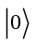 each. Observe that information whether a given coloring is correct is seen by the output “1” of AND gate in the oracle. But in a quantum circuit the argument vector of input values for which the oracle is satisfied is shown in negative phase of the respective binary combination (minterm) of the color encoding variables. For instance the superposition after the oracle with solution a’b is ½ |00⟩ - ½ |01⟩ + ½ |10⟩ + ½ |11⟩, in which basic state |01⟩ corresponding to a’b is marked by a negative phase. So the measurement executed just after the oracle would lose this information, because every basic state from the superposition would be measured with equal probability 1/4. Grover algorithm rotates the vector in Hilbert space to convert the phase information to magnitude information that can be measured – see [Nielsen00]. Fig. 15.2.2 gives the example of a classical (Boolean) logic oracle for coloring a particular graph (left top corner) with inequality comparators and a global AND gate. The global AND produces a logic one when all neighbor nodes have different nodes. Observe that although the graph is 3-colorable, a coloring with 4 colors is given here as a good coloring because this simple oracle is not trying to minimize the number of colors used for the coloring (i.e., this is a Decision Oracle, not an Optimization Oracle). The first solution out of many can terminate if the standard Grover algorithm is run. Another variant of Grover would find all solutions – good colorings. Fig. 15.2.2 shows also that all primary inputs are repeated to the outputs and forwarded to the next stages together with the output bit(yes/no) of the oracle. Observe that this oracle can be used not only in quantum but also in reversible and classical technologies, but in such cases it would require sequential inputs and not parallel superposed inputs as created by the Hadamard gates located at inputs of quantum oracles (Fig. 15.2.3). The power of quantum computing is seen here through parallel processing of all superposed inputs.

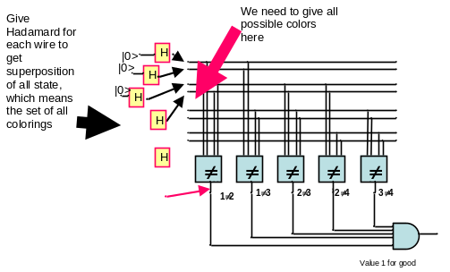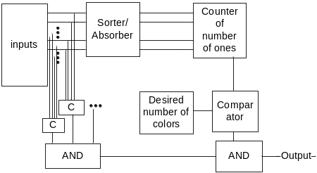
Fig. 15.2.3: A simple quantum graph coloring problem: here all the input states are created using zero-initialized Hadamard gates in all variable qubits. The circuit should be converted to reversible logic with ancilla bits.
Fig. 15.3.1: Simplified schematic of our optimization Graph Coloring Oracle. This oracle is composed from the Decision Oracle and color number minimization scheme, combined with the global AND.

  - Optimization Oracle for Graph Coloring Problem using Grover’s Algorithm

15.3.1. Block Diagram of Grover’s Oracle

The blocks for the complete Optimization Oracle for Graph Coloring and how they are connected together are illustrated (for the first variant mentioned below) in Fig. 15.3.1. This oracle is quantum as it is comprised solely of quantum gates. The quantum circuit of the oracle is a permutative circuit, it is described by a permutative unitary matrix. It includes the Decision Oracle from sect. 15.2 as one of its blocks. Thus all the gates from Fig. 15.2.3 are replaced with their quantum gate equivalents built from quantum primitives (details in [Hossain09]).

There are two variants of providing inputs to Optimization Grover’s Oracle for graph coloring with unknown number of colors. In the first variant the user sets the desired number of colors to certain high numerical value, say k. If there is a solution with k colors the Grover algorithm (not shown) finds the solution. Then the user can set a new value of k, for instance k-1 or k/2 and run Grover algorithm again to find the solution. Several strategies of selecting subsequent values for k can be used. In the second variant the number k is created as a superposition of all numbers from certain interval using Hadamard gates. This is done in exactly the same way as creating superposed inputs that encode mappings of nodes to colors in the decision oracle from sect. 15.2. The numbers of colors in a solution in the second variants are measured in a similar way as in the first variant. This variant of Grover‘s Algorithm creates many solutions together with their costs [Cerf00].

15.3.2. The Quantum Oracle Specification Problem.

One very important topic should be discussed at this point as it is crucial to the design of oracles; we call it the Oracle Specification Problem. Some authors create oracles from truth tables or equivalent to them permutative matrices. This may be useful as a didactic tool but has absolutely no application in practical uses of Grover Algorithm. Why? Because if a human creates a truth table the creator can see in this table if there is an output value 1 for some input combination and where is this “1” located. Similarly, a CAD tool on a classical computer that creates a unitary matrix in order to design a quantum circuit for Grover’s oracle would “know” what is the solution and the use of the quantum computer to solve this problem would be not necessary! The solution to the oracle is never known in the data created by the CAD tool when the description of the oracle is loaded to the quantum computer. The quantum circuit of the oracle is constructed without ever creating its unitary matrix. The unitary matrix is “created” only implicitly in the Hilbert Space of the real quantum computer.

This explanation shows that in a realistic situation one never has a permutative (reversible) function represented as a permutation vector or a truth table or a permutative matrix. One never has an explicit data specifying the problem. What is available is only an implicit specification which describes the solution or its lack. This can be compared to a SAT logic circuit which is created from the SAT formula. The tool that creates this circuit schematic for FPGA does not know if this SAT formula has a solution or not, or what is the input combination that satisfied the formula. In other words, SAT solver never creates the Kmap of the function tested for SAT.

The conclusion of this discussion is that from the practical point of view the methods for reversible circuit synthesis that design blocks specified by irreversible specification and next compose these blocks to the overall reversible specification of an oracle are more practical than the methods that assume a reversible specification based on some kind of a “truth table” and next decompose it to gates. These introduced by us “composition methods” use however more ancilla qubits than the decompositions of reversible truth tables to reversible gates [Maslov04]. We apply composition methods here and in [Hossain09]. The rough explanation of blocks from Fig. 15.3.1 which shows a Grover’s optimization oracle follows.

15.3.3. Blocks of the Oracle.

15.3.3.1. The C blocks – Inequality Comparators.

Reversible Inequality Comparators are synthesized in [Hossain09]. As we know, they act upon sets of two inputs. Those two inputs are representative of connected nodes’ color encoding. If these two inputs binary strings are the same, then they violated coloring rule and output of the C block will be “0”. The quantum oracle is to run through every possible color configuration of inputs (see Figs 15.2.2 and 15.2.3); only a small subset are solutions. In order to determine whether it is a solution, we run the representative inputs through the comparators. The C comparators outputs are then forwarded into an AND gate at the bottom left to determine whether the configuration is a solution. This part is the same as in the decision oracle.

15.3.3.2. The Sorter/Absorber Circuit SAP.

One block of sorter/absorber is presented in Fig. 15.3.2. In the entire sorter/absorber circuit the inputted color encodings are sorted. If two inputs are the same for different nodes (same color used more than once), then only one will be outputted and all other same input colors will be “absorbed” (removed). This combinational circuit sorts and absorbs colors such that all inputs will be sorted from the “smallest” to the “largest” and each color will appear only once at the output of Sorter/Absorber. This is a general circuit to convert a list of items with repetitions to a set with no repeated elements, designed in full detail in [Hossain09]. It has several applications in other quantum oracles to solve constraint satisfaction problems. The entire circuit is large and complicated. Here we give only some of the blocks and we do not show the complete layout that includes CNOT gates for copying and SWAP gates to be able to combine all blocks together. The block from Fig. 15.3.2 is repeated two times in the odd column, one time in the even column, and next these two columns are repeated 2 times. Many mirror circuits are also necessary, as discussed in sect. 15.4. Order of inputs a, b should be changed according to the order from oracle. This is done using SWAP gates.
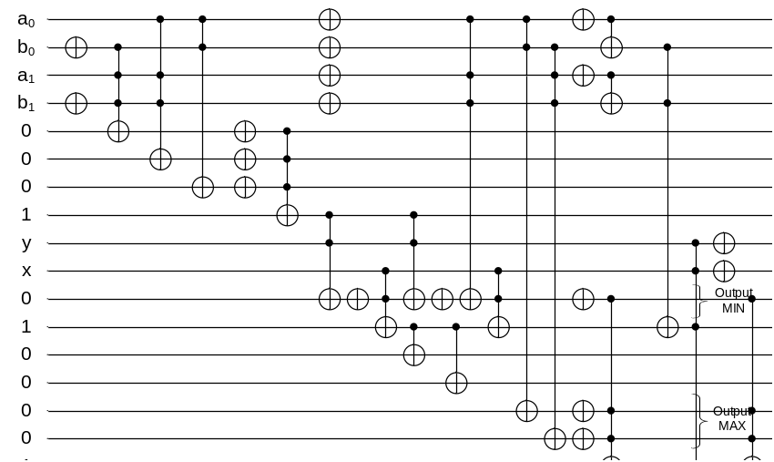(a) 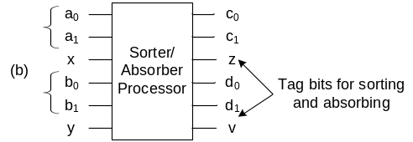
Fig. 15.3.2: (a) One block of sorter absorber. We call it sorter/absorber processor. (b) The schematics illustrating the use of SWAP gates.

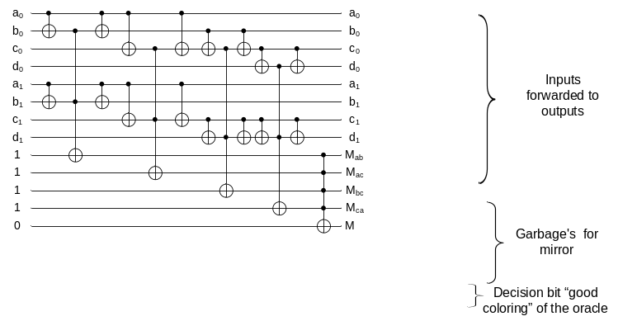

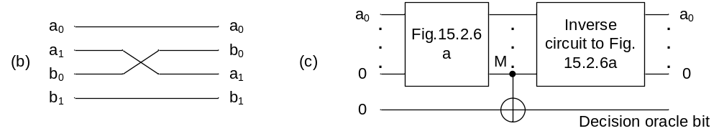
Fig. 15.3.3: (a) Graph coloring oracle – decision part. Order of inputs a, b should be changed according to the order from oracle. This is done using SWAP gates. (b) Preprocessing of the circuit from Fig. 15.3.3a using SWAP gates to change order of variables, (c) Inverse circuit-mirror for the decision oracle part.

15.3.3.3. The counter of the number of colors.

This block counts the number of colors in the outputs of the Sorter/Absorber [Hossain09]. It is transformed to counting ones. We called it the “Ones Counter”. This circuit is important as it occurs in most of the optimizing oracles [Hossain09] for other problems.

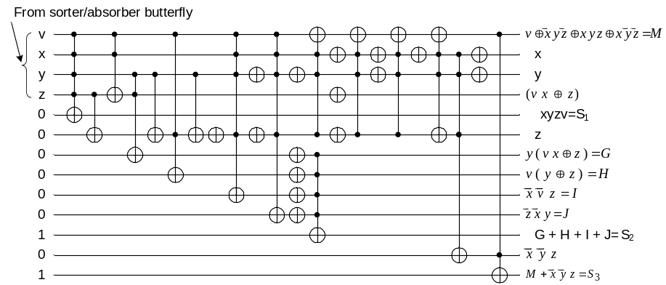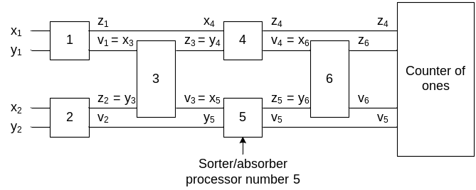
Fig. 15.3.4: (a) Graph coloring oracle – counter of ones circuit. Order of inputs x, y, z, v, should be changed according to the order of sort/absorb blocks from sorter/absorber. This is done using SWAP gates. (b) Explanation of symbols of signals for six blocks of the sorter/absorber butterfly to Fig. 15.3.4a.

Figure 15. 3.4 presents simplified blocks of the sorter/absorber circuit. This is an iterative circuit. Iterative circuits are used in adders, comparators, multipliers and many other standard computing blocks. However, as we will see below in section 15.4, they are a big trouble in reversible/quantum design.

15.3.3.4. The Cost Comparator circuit:

This block acts upon the “number” of colors that was generated by the counter. By using a greater/equal predicate (relation), it can repeatedly compare the number of colors to fixed numbers of expected costs [Hossain09]. This circuit occurs in all optimizing oracles.
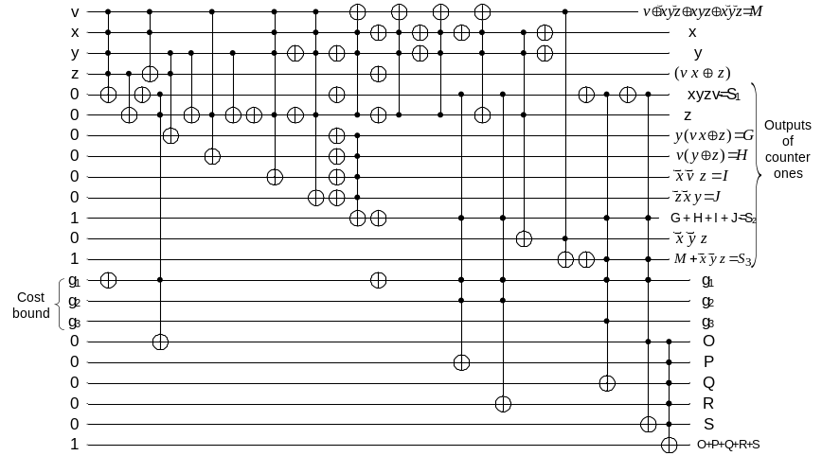
Fig. 15.3.5: Graph coloring oracle – complete right part of the oracle optimization circuit from Fig. 15.3.1. It includes the Counter of Ones, the Cost Comparator Circuit, and the global AND gate.

Order of inputs x, y, z, v, in Figure 15.3.5 should be changed according to the order of sort/absorb blocks from sorter/absorber. This is done using SWAP gates. The useful qubits are denoted by the explained symbols. Other symbols are garbage qubits.

The output of the Cost Comparator Circuit will be AND-ed with “color rule checker” output (output from a big AND gate). This AND gate output is our Oracle output. If it is “1”means that both coloring rules are followed and the number of colors in the configuration is lower than the desired cost threshold (cost bound). This is the search result that we are looking for. If it is zero means that either color rule (no two adjacent notes in same color) is violated, or that the desired color number is not achieved or that both these conditions violated. Then the new coloring arrangement should start until we get this “oracle” output one, thus solving the problem of “proper” Graph Coloring. The question still remains however, how the inputs are generated. The answer is: all colorings are generated with Hadamard-based superpositions and the desired values are generated in a decreasing order by an external standard computer for which the Grover Algorithm quantum computer is an accelerator [Li06, Hossain09].

15.4. Problems that exist to design the Quantum Layout.

Quantum Layout Problem occurs when we compose smaller blocks to larger architectures assuming that the resulting circuit must be reversible (quantum permutative). Solving this problem is a necessity in our methodology of designing quantum circuits based on composing rather than decomposing. For explanation of the quantum layout problem let us assume four stages of the sorter/absorber circuit from Fig. 15.4.1. The question of combining these blocks together is of our only interest in sect. 15.4, we are not concerned with detailed optimized design. The registers (rectangles with numbers) in the Data flow Graph are shown for the explanation purpose only. SAP is the sorter/absorber processor.
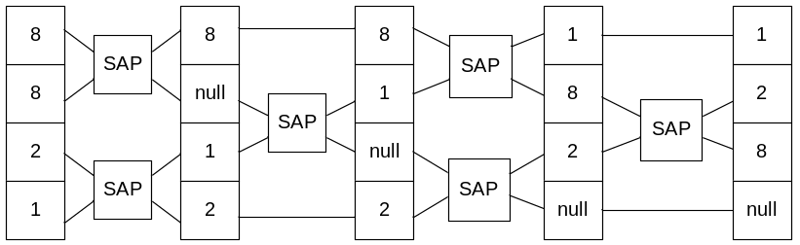
Fig. 15. 4.1: Butterfly iterative circuit for sorting/absorbing to be used as a single regular block in the Cost Optimizing Oracle. In left top corner observe absorption of number 8 while sorting

Fig. 15.4.2: Butterfly iterative circuit for sorting/absorbing to be used as a block in cost optimizing oracle from Fig. 15.3.1.

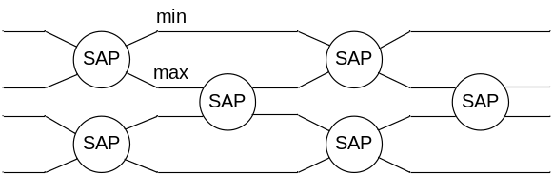

All these blocks are designed in [Hossain09] and shown schematically in Fig. 15.4.2. Layout of the butterfly, which is a completely combinational logic is executed. Circles represent sorting absorbing blocks. Appreciate the regularity of connection patterns in this butterfly combinational logic. To simplify the explanation of the final quantum layout creation process, we assume that we use a sorting block instead of a sorting/absorbing block and that this is only a one-bit circuit. So MIN becomes AND gate and MAX becomes OR gate in the sorter block.
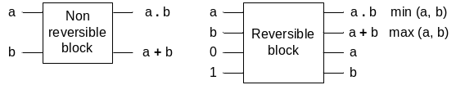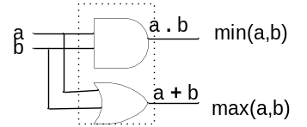
Fig. 15.4.3: Single non-reversible block of the Butterfly iterative circuit for sorting/absorbing.
Fig. 15.4.4: Single non-reversible block of the Butterfly iterative circuit for sorting/absorbing that shows the internals of the block at left from Fig. 15.4.3.

Fig. 15. 4.3 presents a simplified non-reversible block of the sorter and next its reversible counterpart. External view of a non-reversible and reversible versions of this block is to be used in quantum layout of the reversible sorter circuit with mirror circuits. The internals of the block from left in Fig. 15.4.3 are redrawn, assuming the width of one bit for every color, to the diagram from Fig. 15.4.4. The circuit from Fig. 15.4.5 shows classical circuit for the first and second column of the sorter.
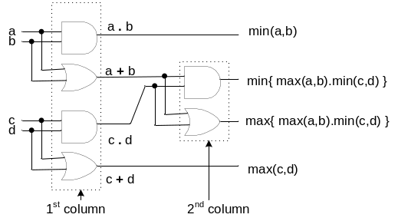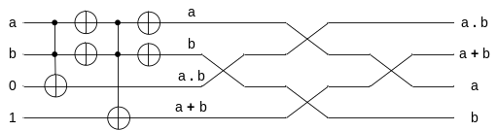
Fig. 15.4.5: Three non-reversible blocks of the Butterfly iterative circuit for sorting/absorbing that together correspond to the first and second columns of processors SAP from Fig. 15.4.1
Fig. 15.4.6: The single reversible block of the Butterfly iterative circuit for sorting/absorbing with its order of inputs and outputs as required for quantum layout created by adding four SWAP gates at the right.

The final quantum array for the single block of sorter is shown in detail in Fig. 15.4.6. Now we can draw the rough schematic of the first three columns of the sorter in block notation – Fig. 15.4.7. It was created by adding SWAP gates, but without final delineation of every qubit of the layout. The mirror circuits of all blocks are also not yet created. Each block’s internals should be replaced by the circuit from Fig. 4.6. Mirror circuit for the first two columns is added in Fig. 15.4.8.

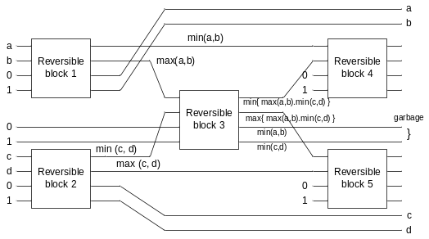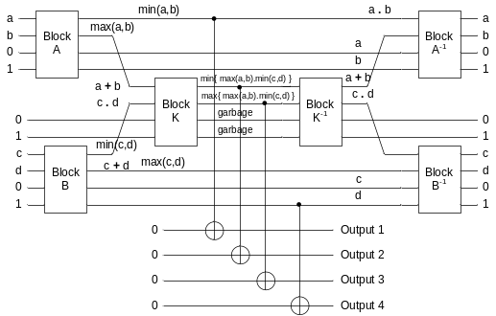
Fig. 15.4.7: The block diagram of the first three columns of sorter architecture with its order of inputs and outputs as required for the final quantum layout.
Fig. 15.4.8: The final reversible blocks of the Butterfly iterative circuit for sorting/absorbing with 2 columns and with its order of inputs and outputs and mirror circuit.

The circuit from Fig. 15.4.8 can be now rewritten to the form of standard quantum array. Each block A, B and K should be replaced by the circuit from Fig. 15.4.6. Each block A⁻¹, B⁻¹ and K⁻¹ should be replaced by the mirror of the circuit from Fig. 15.4.6.

The final circuit as a quantum array with 14 qubits can be created by redrawing Fig. 15.4.8 to a standard quantum array format with standard notation of SWAP gates and the same distances between any two neighbor qubits. The circuit from Fig. 15.4.8 is for simplification drawn for only the first two columns from Fig. 15.3.1. If we replace now the circuit from Fig. 15.4.6 with the circuit from Fig. 15.3.2 (with added SWAP gates) we will obtain the entire quantum array of the oracle, which is a circuit of a very large size and difficult to draw. As the next stage we can draw in similar way the complete circuit from Fig. 15.3.1. This however results in a very big quantum array diagram that cannot be reproduced here. The simple example discussed in this section illustrates that the quantum composition/layout problem is not trivial, although it has not yet raised much interest in literature. The existence of this problem points out to the necessity of creating a CAD software tool that would compose, and lay–out such arrays for large oracles. The tool should also be able to draw and simulate such arrays. Although we did not present complete composition/layout algorithms here, we hope, however, that we presented the idea of creating quantum layout for multi-level (iterative) circuits by adding mirrors, SWAP gates and Feynman gates [Shivgand05].

15.5. Conclusions

We presented synthesis of two types of quantum oracles for Grover Algorithm; (1) the Decision Oracle and (2) the Optimization Oracle. Oracles of this type exist [Li06] and were designed and simulated by us on quantum simulators for several Constraint Satisfaction Problems [Hossain09]. In many of these oracles the iterative circuits and circuits such as SAP, Ones Counter or Cost Comparator circuit are used. While synthesizing oracles and their sub-blocks from smaller blocks, as in the “iterative circuit based methodology” simplifies significantly the design, it leads to the increase in the complexity of quantum layout problem and to many ancilla bits. The number of these bits may be in some cases clearly excessive. The oracle synthesis examples analyzed by us demonstrate the importance of not only minimizing each reversible block but also synthesizing optimally the entire architecture of the oracle. Such methodology requires to solve the problem of the layout of all the blocks. In turn the layout requires to add mirror blocks and copying gates such as the Feynman (CNOT) gate.

The proposed in this chapter “composition” methodology to synthesize quantum oracles is also a necessity, because of the above introduced “Quantum Oracle Specification Problem”. However, even taking into account the need to add ancilla bits because of this problem, we could theoretically still reduce in several problems the number of logic levels (and thus the number of ancilla bits) by, for instance, realizing two-level AND/EXOR logic for iterative circuits such as comparators. For larger graphs this would be, however, beyond the capabilities of all current CAD reversible circuit synthesis tools [Alhagi10, Sanaee10].

Concluding, we proposed in this chapter two important ideas to quantum synthesis research community:
- From the very principle of Grover [Grover96] and Grover-like [Sanaee] algorithms it is not possible to specify realistic oracles by single truth-table –like specifications, whether these specifications are reversible or not.
- the emphasis of reversible synthesis algorithms and respective CAD tools should be not on synthesizing single blocks but on synthesizing entire systems, which require investigating tradeoffs between ancilla bits and block sizes, and using tools to solve the quantum layout problems.

References

[Hossain09] Hossain, S., “Classical and Quantum Search Algorithms for Quantum Circuits and Optimization of Quantum Oracles”, Ph.D. Dissertation, 2009, Portland State University, USA.
[Nielsen00] M. Nielsen and I. Chuang, Quantum Computation and Quantum Information, Cambridge University Press, 2000.
[Li06] L. Li, M.A. Thornton, M.A. Perkowski, “A Quantum CAD Accelerator Based on Grover's Algorithm for Finding the Minimum Fixed Polarity Reed-Muller Form,” Proc. ISMVL 2006, pp. 33.
[Grover96] L. Grover, “A fast quantum mechanical algorithm for database search,” Proceedings of the 28th Annual ACM Symposium on Theory of Computing 1996, pp. 212-219 1996.
[Maslov04] Maslov, D. and Dueck, G. W. 2004. Reversible cascades with minimal garbage. IEEE Trans. Comput. Aid. Des., 23, 11, pp. 1497-1509.
[Alhagi10] N. Alhagi, M. Hawash, M. Perkowski, “Synthesis of Reversible Circuits with No Ancilla Bits for Large Reversible Functions, Proc. ISMVL 2010.
[Sanaee10] Y. Sanaee, G.W. Dueck, “ESOP-based Toffoli Network Generation with Transformations”, Proc. ISMVL 2010.
[Shivgand05] V.S. Shivgand, A. Aulakh, M. Perkowski, “Quantum layout,” Proc. RM 2005, Tokyo, Sept. 2005.
[Cerf00] N. J. Cerf, L. K. Grover, and C. P. Williams, e-print quant-ph/9806078; Phys. Rev. A 61, 032 303 ~2000.

