CHAPTER 16

Oracles for Constraint Satisfaction Problems

Constraints Satisfaction Problems have many applications in computer science, physics, engineering, astronomy, biology and other areas. The problem is formulated by a set of constraints and a cost function.
The problem is formulated as a graph G = <NO, ED> with NO being a set of nodes and ED ⊂ NO x NO x … NO being a set of constraints. Constraints can be on any subset of nodes from NO. The nodes can have values such as symbolic or numeric. Any node can have some set of values V(Ni). The simplest constraints are edges from NO x NO. The constraints can be of any type, for instance EQUAL (N1, N3), NOT-EQUAL (N2, N5), SMALLER-THAN (N3, N0).
There are two formulations: Constraints_Only and Constraints_And_Cost_Function.
Problem 16.1. Given is Graph G of constraints. Find such assignment of values to variables that all constraints are satisfied.
Problem 16.2. Given is Graph G of constraints. Given is cost function defined on G with integer of real values. Find such assignment of values to variables that all constraints are satisfied and the cost function is maximized.
In this chapter we will show few applications of Constraint Satisfaction.

16.1. Constraints Satisfaction Problems that are also Equational Logic Problems.
Many Constraint Satisfaction problems can be reduced to a set of logic equations and next to a single equation. This idea comes from Raymon Lullus who lived in thirteen century and was next generalized and formalized by Descartes and finally applied to “Boolean data” by George Boole. The operators in these equations can be of many types such as: arithmetic (+,*,/,-, etc), relational (predicates < , >, = , ≤ , ≠ , ≥ , etc) and logic (AND, OR, EXOR, etc). The cryptographic puzzle belong to this category of problems. SEND + MORE = MONEY is the famous cryptographical puzzle—see Figure 16.1.1. The letters should be replaced with unique digits 0 ,…., 9 to make the equation valid. Directly from Figure 16.1.1 one can compile the Equation from Figure 16.1.2.

S E N D
+ M O R E
M O N E Y
Figure 16.1.2: Cryptographic problem example. Substitute digits for letters to make the equation to be true.

D + E = 10 C₁ + Y C₁ 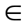 { 0, 1 }
N + R + C₁ = 10 C₂ + E C₂ { 0, 1 }
E + O + C₂ = 10 C₃ + N C₃ { 0, 1 }
S + M + C₃ = 10 C₄ + O C₄ { 0, 1 }
C₄ = M

Figure 16.1.2: Equations compiled from the problem formulation from Figure 16.1.1.

The specification of nodes is given in Figure 16.1.3. Observe that the carries C_{i} are binary single-qubit signals but all letters require four qubits in binary encoding, as shown in Figure 16.1.3. This Figure explains also that only some 4-bit strings are allowed, namely the strings 0000, 0001, 0010, 0011, 0100, 0101, 0110, 0111, 1000, 1001.

S { 0, 1, 2, 3, 4, 5, 6, 7, 8, 9 }
E{ 0, 1, 2, 3, 4, 5, 6, 7, 8, 9 }
N { 0, 1, 2, 3, 4, 5, 6, 7, 8, 9 }
D { 0, 1, 2, 3, 4, 5, 6, 7, 8, 9 }
M { 0, 1, 2, 3, 4, 5, 6, 7, 8, 9 }
O { 0, 1, 2, 3, 4, 5, 6, 7, 8, 9 }
R { 0, 1, 2, 3, 4, 5, 6, 7, 8, 9 }
Y { 0, 1, 2, 3, 4, 5, 6, 7, 8, 9 }

Figure 16.1.3: Constraints for nodes in the graph. Each node is a 4-qubit string. Because we need 4 qubits to represent letters S, E, ..., Y, we need additional constraint to restrict the domain to digits.

S ≠ E, S ≠ N, S ≠ D, S ≠ M etc.

Figure 16.1.4: Inequalities for unique encoding of nodes of the graph. One inequality is created for every pair of letters.

The equations from Figure 16.1.2 correspond directly to the rules of arithmetic addition with carry. Carry signals are denoted by C₁, C₂ , C₃ and C₄ ; C_{i}{ 0 , 1 }. The equations in Figure 16.1.3 state that each symbol S, E,…..Y is a digit from 0 to 9. The equations in Figure 16.1.4 mean that all mappings of symbols S, E, ….Y to digits are unique, i.e. that they are one-to-one mappings. These are all typical equations that lead to typical arithmetic, predicate, logic circuits for a wide class of problems.

C₄ = M C₄ { 0, 1 }
M = 1

S + M + C₃ = 10 C₄ + O
S + M + C₃ = 10 M + O
S + C₃ = 9 M + O
S + C₃ = 9 + O

Figure 16.1.5: Simplified Equations compiled from Figure 16.1.2.

Equations from Figure 16.1.2 can be simplified to the form from Figure 16.1.5. This would simplify the oracle and speed-up the Grover Algorithm but we will not discuss this “intelligent preprocessing” variant here.

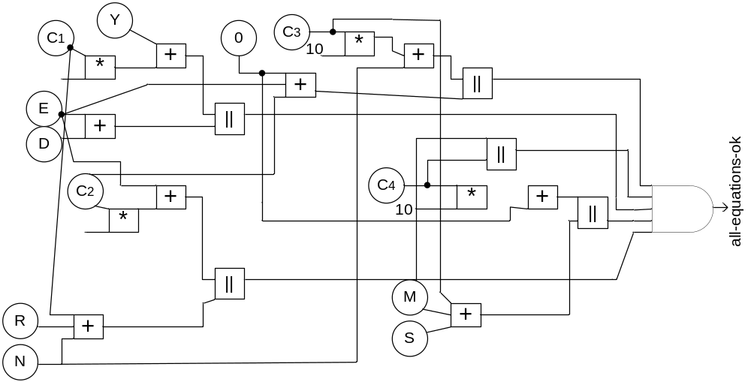

Figure 16.1.6: Graph of constraints for the SEND+MORE=MONEY problem.

Figure 16.1.6 presents the part of the oracle to verify the equations from Figure 16.1.2. The operations of addition, multiplication and equality checking are replaced by logic blocks. Every variable S, E, ….Y has 4 bits. The global AND has output 1 when all equations from Figure 16.1.2 are satisfied. The output of this AND gate is denoted by all-equations-ok. As we see in Figure 16.1.6 we use only the following blocks: arithmetic adder with 2 inputs, arithmetic adder with 3 inputs, multiplier by 1 and 0, equality comparator and AND. Chapter 14 illustrated how to design all these blocks.
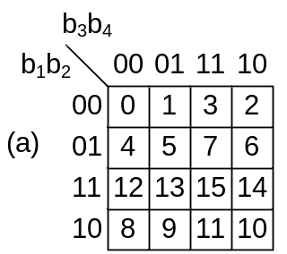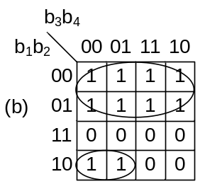

Figure 16.1.7: (a) Enumeration of cells in the M-map, (b) Groups of true minterms in the KMap for the circuit to check each equation from Figure 10.1.3.

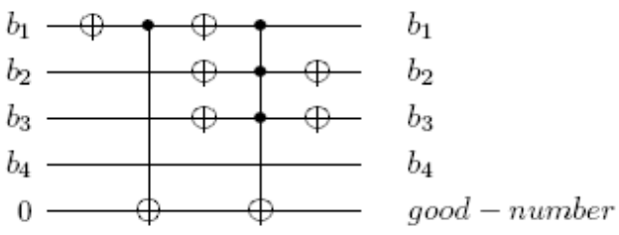

Figure 16.1.8: Realization of circuit GN that checks if an argument is a binary-encoded digit, i.e. that checks if the binary argument is a Good Number, i.e., a digit 0,…, 9.

Figure 16.1.7a presents the method to calculate the circuit to verify that the argument b₁b₂b₃b₄ is a binary encoding of a digit 0 ,……, 9. Figure 16.1.7a presents the numbers of cells of KMap — all cells with values 0 ,…., 9 have output 1. This leads to the KMap will loops 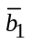 and 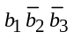 from Figure 16.1.7b and finally to the circuit from Figure 16.1.8 being a part of the oracle GN. When the binary input combination b₁b₂b₃b₄ corresponds to a digit 0 ,….., 9 then the output good-number = 1.

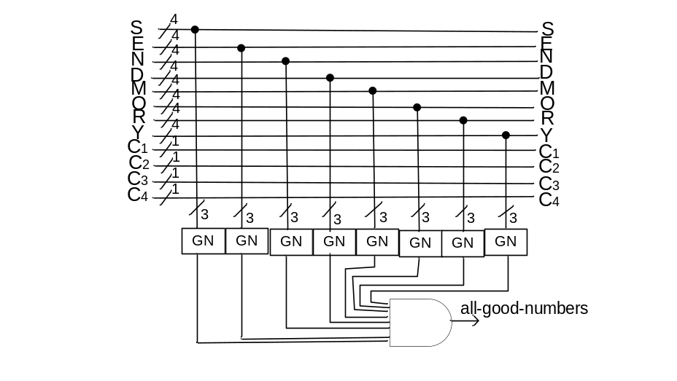
Figure 16.1.9: The remaining part of the oracle All-Good-Number for the SEND+MORE=MONEY problem. This checks the encoding of each symbol S, E, …, Y. It has 8 GN blocks from Figure 16.1.8 and the global AND.

The part of the oracle that checks all numbers used in equations from Figure 16.1.2 is shown in Figure 16.1.9. GN is the block from Figure 16.1.8. Each such block uses only 3 qubits out of 4 qubits encoding every symbol S, E, ….., Y. This is marked with symbol “3” in vertical buses on inputs to each block GN in Figure 16.1.9. The output of this sub-oracle is denoted by all-good-numbers. All equations from Figure 16.1.3 are verified in the sub-oracle from Figure 10.1.10. The AND gate produces the signal all-different = 1 meaning that the mapping is a one-to-one mapping. The circuits from Figure 16.1.9 and Figure 16.1.10 are typical for many oracles for extended logic equations.
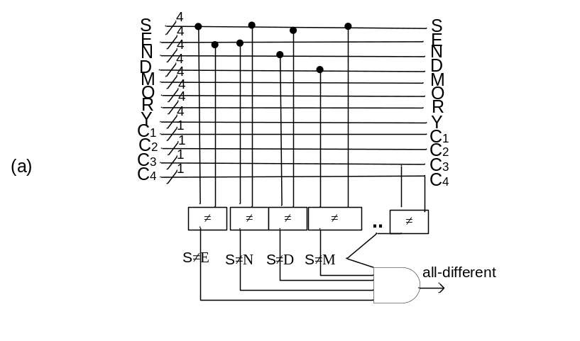
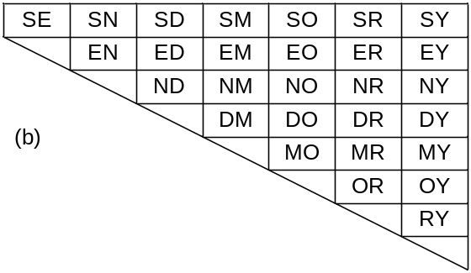
Figure 16.1.10: (a) The part of an oracle All-Different for the SEND+MORE=MONEY problem that checks if the mapping is a one-to-one mapping, (b) systematic method to create all pairs of symbols for pair wise comparisons.

Finally, Figure 16.1.11 shows the entire oracle for the SEND + MORE = MONEY problem that is composed of 3 oracles. The final global AND is the logic AND (conjunction) of answers from the partial oracles:

We just need a single 4×4 Toffoli gate with target bit initialized to 0 to realize this final global AND, see at the bottom of Figure 16.1.11.

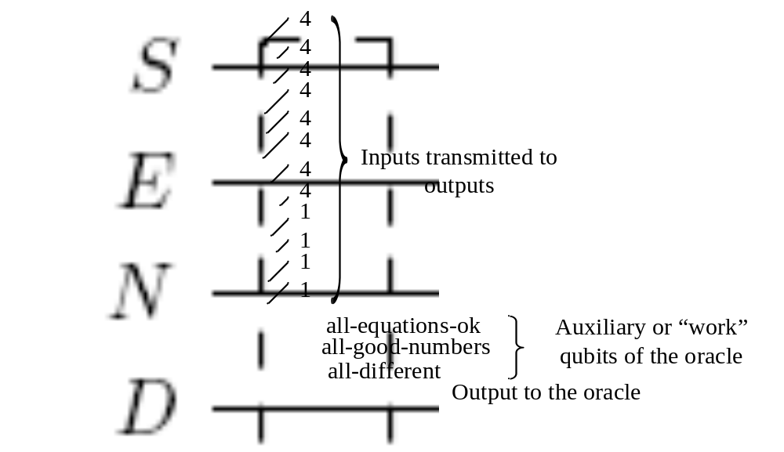

Figure 16.1.11: The complete quantum oracle for the SEND+MORE=MONEY problem. The output is the “solution” qubit at the bottom.

The complete detailed quantum array for the all-good-numbers predicate is given in Figure 16.1.12. It is the checker of All-Good-Numbers from 8 GN blocks. Similarly the whole oracle and HZH circuit is designed.
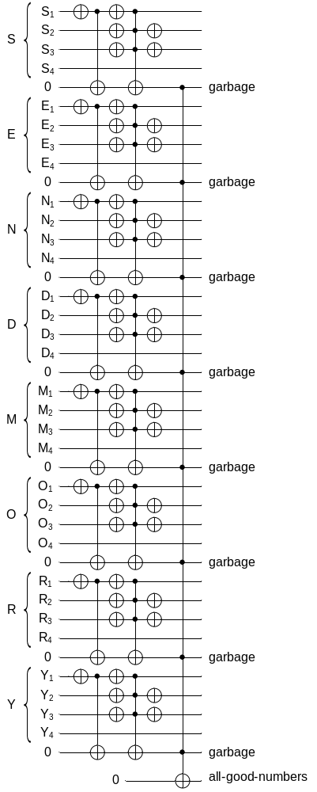

Figure 16.1.12: The part of oracle to calculate the all-good-numbers predicate.

