Robosapien Project
February 14, 2005
ECE 578

My mission this term is to hack a Robosapien IR controlled robot to add RF control to allow the main brain of the robot to be inside a PC. Next term I will convert a KHR-1 robot to also be RF controlled. A PC will control these robots together using RF communication based on what is seen with an overhead camera.

Robosapien is an inexpensive robot that works with an IR remote. Robosapien has many abilities; he can walk forward/backward, turn around, dance and give you a high five, just to name a few. With the remote you can store several functions and then at the press of a button Robosapien will execute all the functions you saved. You can also reprogram the robot to use his sensors differently, for example when Robosapien bumps into something with his foot instead of having him stop and say ouch you can have Robosapien karate chop the object, turn around, burp, and walk away. Although Robosapien is a remarkable toy robot for the price after a couple of hours using the IR remote gets a bit tiresome and I am ready to take a look under the hood and see how we can expand Robosapien’s abilities.

To take Robosapien apart all that is needed is a small screw driver. He comes with a small cup that he uses to pick things up and this is great to hold all the small screws. Once Robosapien’s “clothes” are taken off a glorious discovery is made, all the wire connections to the main circuit board are socketed! This is true for everything except for the microphone and the speaker with are soldered down. The second amazing discovery is that all the connections are labeled so that if you completely dismantle Robosapien you can easily put him back together. The designer Mark Tilden did this specifically because he too liked to hack toys to increase their useful life.

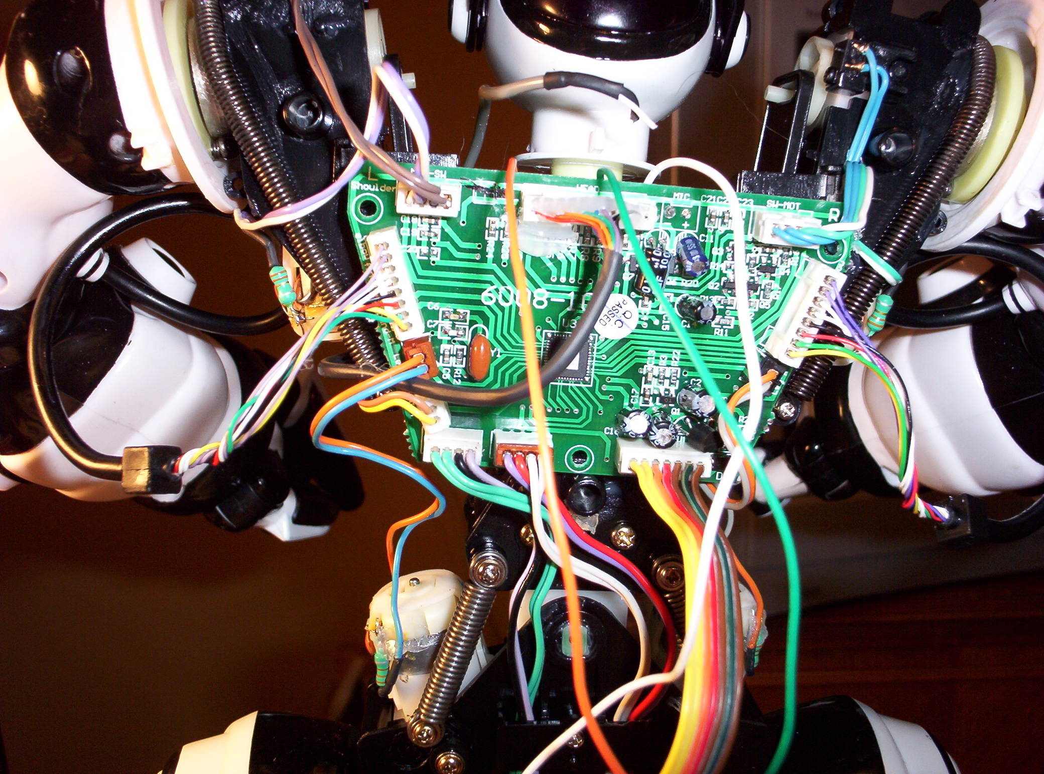

The first step here is to figure out how Robosapien works. Most of this I found from the internet. There are a couple of links that are very useful:

ROBOSAPIEN.tk - Unofficial Robosapien hacks and mods site
Tom's Chips and Code
http://homepages.strath.ac.uk/~lau01246/robot/hackrobos.shtml

Then of course there is the official Robosapien site:
http://www.wowwee.com/robosapien/robo1/robomain.html

So now, let’s dig in. What I need to do is bypass the IR receiver and send the signal from the PC directly to Robosapien over RF. The best way I can think to do this is by putting a microcontroller on Robosapien and store all the 67 commands that Robosapien has. Then a signal will come over the RF and tell the microcontroller which command to execute and send it directly to the Robosapien controller board. So the high level sequence of events is this: the camera will watch Robosapien, an event will trigger in the PC software written by my partner. The software will decide what action Robosapien should do based on what it sees with the camera. A command will be sent from the PC to a microcontroller development board which houses a RF transceiver. The microcontroller will send a code for the command from development board transceiver to another transceiver on the Robosapien. The microcontroller on the Robosapien will get the code and execute the appropriate command function and send it to the Robosapien controller board. OK, so let me break this down into smaller steps.

Step 1 – Understanding Robosapien Protocol
Inside Robosapien’s head is an IR receiver. The IR receiver gets the signal from the remote and then sends it to the controller board. If I want to bypass the IR receiver I need to know the commands it sends to the controller board so that I can reproduce this with a Microcontroller. On the controller board is a pin labeled IRout. If I put a scope on this signal I can see the signals going from the IR receiver to the controller board. From many sources on the internet I know that there are 2 HEX numbers for each command, for example to move Robosapien’s right arm inward you send code $85. As you can see below it is a little more complicated than a simple 8 bits.
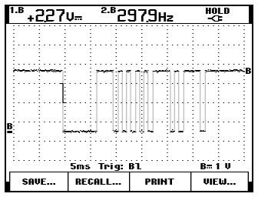
The IRout signal is held high until a signal is sent. Then a string of five zeros is sent to signify a command is coming. Then the hex code is sent but instead of sending a ‘1’ a ‘1110’ is sent and rather than a ‘0’ a ‘10’ is sent. So $85 looks like this:
Binary: 1 0 0 0 0 1 0 1
Robosapien: 1110 10 10 10 10 1110 10 1110

Each ‘1’ and ‘0’ is held for 0.833ms.

Step2: Reproduce the Robosapien protocol using a microcontroller
Since we have Parallax 418MHz RF transceivers in the lab I will use these for the project. These cards require a BS2 so I will use a BS2sx (also available in the lab) for the microcontroller on the Robosapien and on the development board connected to the PC.

I need to be able to send a ‘1’ or a ‘1’ on pin 0 (I could have picked any I/O pin) for 0.833ms. My first idea was to use the Pulsout command. This command generates a pulse by inverting an I/O Pin for a defined time. The resolution for a BS2sx is 0.8us. So I first need to set the pin high. Then send a pulse of 1041 (0.8 us X 1041 = 0.833ms).
HIGH 0
PULSOUT 0 1041

This command worked great for the first strobe low but didn’t work for back to back pulses because there is a short glitch in-between pulses. I also tried the SEROUT command which also didn’t work because it only allows you to send 8 bits at a time and it surrounds the 8 bits with some extra coding.

What I ended up doing was just using the basic high and low commands with for/next loops. Each instruction takes ~0.1ms. I have a subroutine for a ‘1’ execution:

strobe_high:
FOR loop = 1 TO 6
HIGH 0
NEXT
FOR loop = 1 TO 1
LOW 0
NEXT
RETURN

And one for ‘0’ execution:
strobe_low:
FOR loop = 1 TO 1
HIGH 0
NEXT
FOR loop = 1 TO 1
LOW 0
NEXT
RETURN

Then there is one special subroutine for the beginning set of zeros:
strobe_start:
HIGH 0
PAUSE 100
FOR loop = 1 TO 9
LOW 0
NEXT
RETURN

I use these to put together another subroutine for each HEX value 0 to E (F is not used in any of the Robosapien commands). For example ‘A’

HEX_A:
GOSUB strobe_high
GOSUB strobe_low
GOSUB strobe_high
GOSUB strobe_low
RETURN

Each Robosapien command requires the strobe_start and two HEX number subroutines, for example $85:

command85:
'right arm in
GOSUB strobe_start
GOSUB eight
GOSUB five
RETURN

I tested the Robosapien BS2sx program by connecting the IRout signal from Robosapien to pin 0 on the microcontroller and I connected the Robosapien GND to the BS2sx GND. I tested many of the commands by calling each function individually and the Robosapien responded as desired.

One other thing to note, the Robosapien runs on 3.3V whereas the microcontroller runs on 5V. So I will need to add an additional battery source to Robosapien and divide down the microcontroller signal before it goes to Robosapien.

Step 3 – Getting the RF transceivers in place and working
First I need to take a look at the pinout for the transceiver.
Pin 1 – GND
Pin 2 – 5V
Pin 3 – Switches between switch and serial mode
Pin 4 – Serial TX data input pin (enter data for transmitter to send)
Pin 5 – Serial flow control pin (optional: used to pace the data for max efficiency)
Pin 6 – Serial receive data pin (outputs serial data received by receiver)
Pin 7 – No connect
Pin 8 – Switch input 1
Pin 9 – Switch input 2
Pin 10 – Switch input 3
Pin 11 – Switch output 1
Pin 12 – Switch output 2
Pin 13 – Switch output 3
Pin 14 – Address input 1
Pin 15 – Address input 2
Pin 16 – Address input 3
Pin 17 – Address input 4

So based on this I will only need to connect power/gnd. Assert pin 3 to 5V to use serial mode. Then I will send data on pin 4 and receive data on pin 6. We’ll see if pin 5 is necessary after a few sample runs.

So now we need the protocol for sending the data:
Byte 1 – Packet# and data count
The packet # is the ID of the packet relative to the previously transmitted packet.
The data count is the number of data values in this packet
Byte 2 – Data value 1
Byte n+1 – Data value n
Byte n+2 – Checksum
Byte n+3 – Checksum 2
Two kinds of checksums can be used. The first simply XORs byte 1 through byte n+1 together to come up with a 1 bit checksum and checksum 2 is ignored. The second is a cyclic- redundancy-check algorithm but it is more complicated so I do not plan to use it. The XOR method will catch 90% of the faults.

More work will need to be done to write a sample program for each BS2sx.

Step 4 – Add Speech
I plan to use Parallax speech to text SIP module. This step will be implemented if I have enough time. This module also uses the serial out command. With this module you can send any text to the BS2sx. The text will be determined by the software in the PC and sent over the RF transceivers. I also would like to add a better speaker for Robosapien but I have not had a chance to research the best choice for this. Worst case the simple built in speaker Robosapien comes with can be used.

Step 5 – Put it all together
The final step is to altogether. I am planning to build a kind of backpack for Robosapien so that he can keep his balance. There aren’t many connects so I might use a plain perf board from Radio Shack. A simpler solution would be to use a Parallax development board or possibly a Next Step controller board. More documentation is needed when final board connections are made.

